2025 INSTRUCTIONS FOR DSSL TEAM STATISTICIANS

Table of Contents

Section 1 INSTALLING AND SETTING-UP TEAM MANAGER 8.0 1
1.1 INSTALLING TEAM Manager 8.0 1
1.2 New statisticians 2
1.3 Setting-up team manager 8.0 3
1.4 entering team information 5
1.5 entering athlete information 6
1.6 printing team roster 7
1.7 entering meet information 9
1.8 entering events 10
Section 2 DSSL Statistician Procedures Before and After Meet 10
2.1 BEFORE THE MEET 10
2.2 DURING/After the Meet 11
Section 3 Reporting Duties for Team Statisticians 11
3.1 REPORTING MEET RESULTS 11
Section 4 DSSL LISTING OF EVENTS 13

INSTALLING AND SETTING-UP TEAM MANAGER 8.0

INSTALLING TEAM Manager 8.0
There is no change to the TEAM MANAGER 8.0 software for 2025.
From the main screen, click “Check for Updates” and follow the instructions. If this does not work, go to https://hytek.active.com/downloads.html, click on update under 8.0. Then save that file, open TEAM MANAGER, go to file then install update.
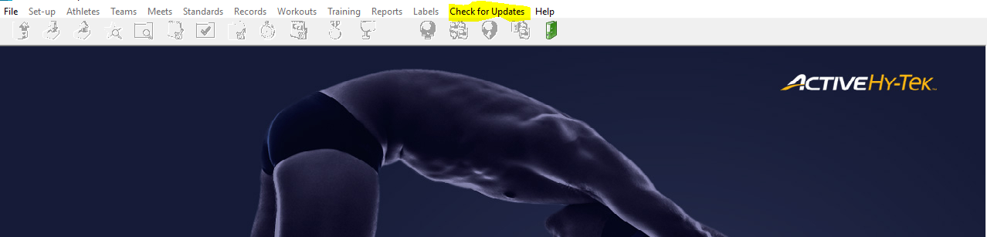
You will always see the version of Team Manager in the lower left hand corner of the main screen.
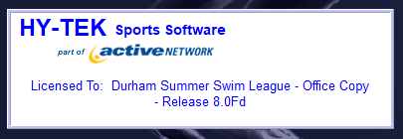
When you check for updates, you will see a pop up asking if you wish to download the update.
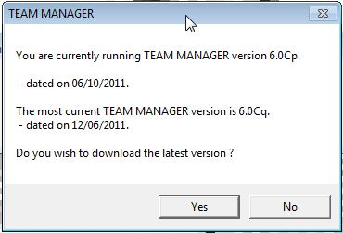

The update will download and you should install (the application will automatically restart).
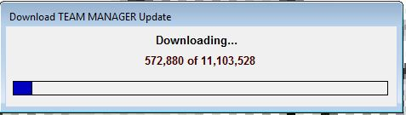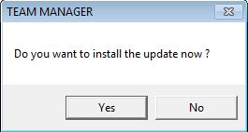

For First-time Installation or Upgrade to TEAM MANAGER for Swimming 8.0.

If you are in need of you team’s license code (check with former statisticians or your parent reps first), you will need to purchase a product replacement at https://hytek.active.com/store/swim/TM8.html, in order to get a new install link and individual team license code. Hytek has documentation to see that each team listed under the DSSL league license. The fee is only $25.

Be sure to share this license code with your parent reps so that it can be saved with team documents and then shared as needed to add the program on other computers for your team.

Once you’ve gotten the new link and imported it, you should be able to print labels for cards, ribbons, etc.

- Download Setup file here - https://hytek.active.com/webdelivery/swtm8/setup.exe
- Once download finishes, double-click the setup file to start installation
- After the installation is complete, click finish to launch program
- When program launches, select Web Delivery
- When prompted, enter your team’s license code:
- Once you have installed or upgraded the license, please close and re-open the program.

New statisticians
If you are a new statistician, have last year’s statistician give you a backup database from last year’s Team Manager for Windows and then restore it to Team Manager 8.0.
- Click on File on the Main Menu, then click on Restore.
If a backup file is not available, you will have to start from scratch this year. It’s a little more work, but not a problem.

Setting-up team manager 8.0
Set-up the Team Manager System defaults and personal preferences. When you open a new database, Team Manager will automatically route you to the System Preference screen. To change System Preferences after your database is established, click on Set up on the Main Menu, and then click on System Preferences. In this screen you can customize your team’s reports.

There are some boxes that all teams should check (also see screenshot below):
Sex Designation – Boys/Girls
Athlete Browser Options:
√ Show ages
√ Show birthdate
√ Last name first
Default Registration - USS
Default Team Type – Age group
Default Country – USA
Default LSC – NC
Default State – NC
System Age up Date – 06/01/2025 (current year)

The Meet Age-Up Date and the System Age-Up Date should be set to June 1st of the current year. So, for example, the Summer of 2022 would be 06/01/2022 whereas the Summer of 2025 would be 06/01/2025. THIS NEEDS TO BE UPDATED EVER YEAR.

By using the USS Default Registration, each swimmer will have a unique ID number in the League database. This means that no two swimmers with the same name will be differentiated from each other as long as they swim for different teams. You will need to manually create an ID for each swimmer if things have not carried over from the previous year’s database for your team.

The screenshot below shows the selections you need to make for your DSSL team. Be sure to have the Meet Age-up Date and System Age-Up Date to June 01, 2025.
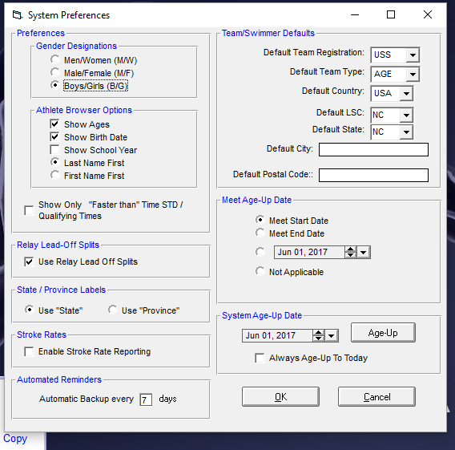

The next screen is optional.
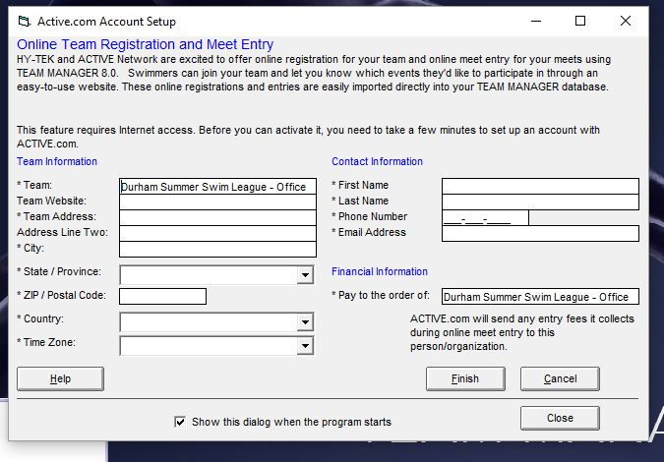

**Unclick the “Show this dialog…”, if you do not want to see it each time you open the program.

entering team information
To enter Team information: Click on Teams on the Main Menu across the top of your screen. This will open a new screen. Click Add (or the paper icon). A popup will open. Enter your team’s information and click OK.
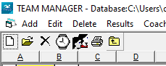

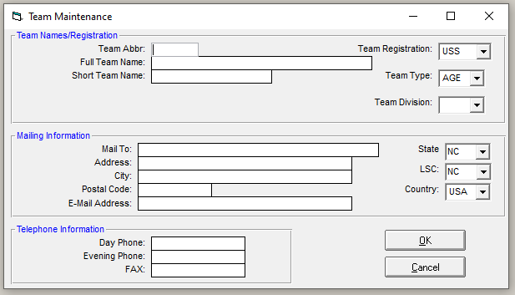

Here’s a helpful YouTube video for generally creating a Team in Team Manager. Please note that you need to refer to the above screenshots for the DSSL requirements to be selected for your team. https://youtu.be/SxJPGcVNrp8

entering athlete information
If you are using swimmers’ information from the previous season:
If you are wanting to save your 2024 athletes and move them into 2025, start by opening your 2024 team database and then selecting “save as”. I recommend using a new file name that includes the year so that you can easily differentiate.

Once the new 2025 database is saved, go to the ‘file’ menu in the top left of the screen. Choose ‘purge’ and then ‘purge meets.’ A popup will appear. You will want to click the ‘select all’ button on the right and then click ‘purge selected meets’ and then click ‘close.’

This allows you to keep all the athletes but removes meets and results to start fresh for this season.

For athletes that are not returning to swim this season, you can simply go into the Athlete menu and double click on an athlete that you wish to deactivate. A popup will appear. Simply tick the box in the bottom right quadrant of popup that says ‘inactive’ and then click ‘ok.’ Repeat this step with each athlete you wish to deactivate.

If you are starting from scratch and/or enter new athletes:

To enter Athlete information: Click on Athletes on the Main Menu across the top of your screen.
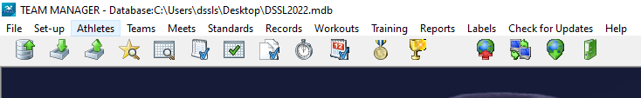

Click Add (or the paper icon), Edit or Delete to update this year’s team roster.
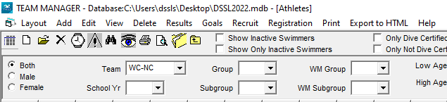

Each swimmer will have a unique ID number in the League database. This means that no two swimmers with the same name will be differentiated from each other as long as they swim for different teams.

The software helps you with creating these ID #s as long as you’ve entered the athlete’s first and last name, as well as their birth date. Click ‘Build ID’ once those fields have been entered.
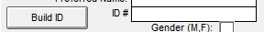

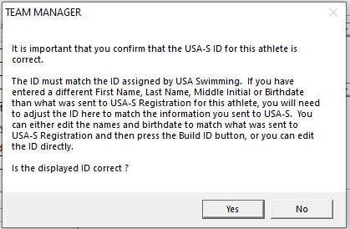

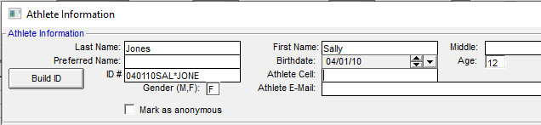

As an FYI the format for creating this ID is: 6-digit birth date followed by capital first 3 letters of their first name, the first letter of their middle name (an asterix is used if no middle name is entered "*"),then capital first 4 letters of their last name. So for an example of swimmer Sally Jones born on April 1, 2010, the ID would be 040110SAL*JONE.

printing team roster
Print the team roster to make sure you have everyone entered correctly. In the Main Menu, click on Reports, then Administrative, then Athletes to print your team roster.
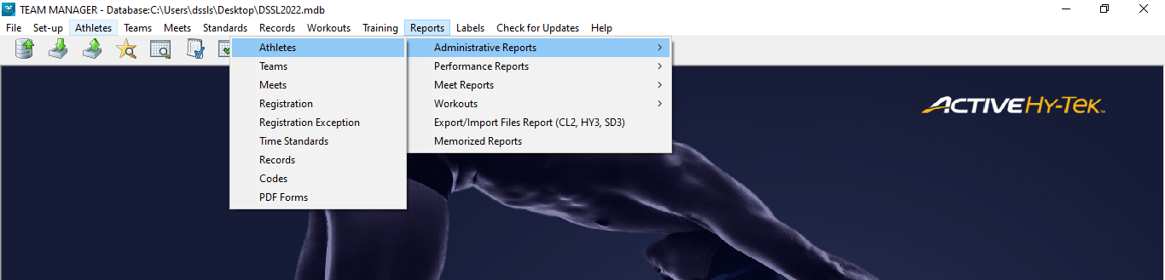

Select your team from the Group filters and then click Create Report.
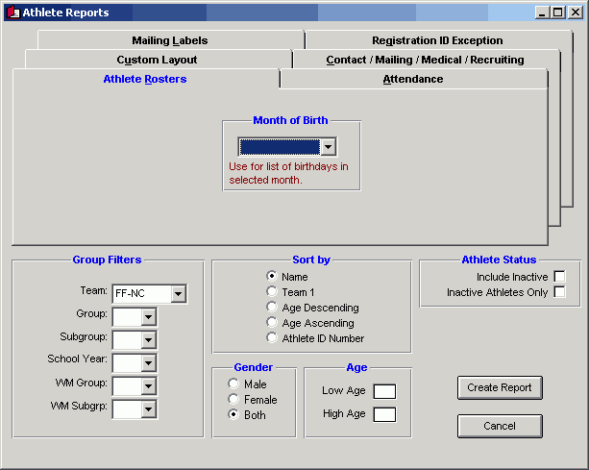

A pop-up will open with the report.

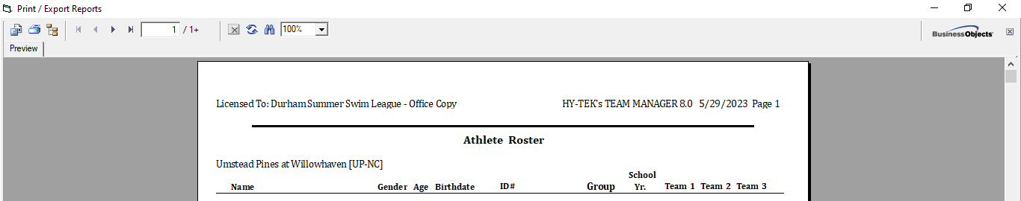

Click on the export or printer icons in the upper left corner to save the report or print it. 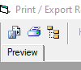

You can then choose the file format and where to save/print the file.
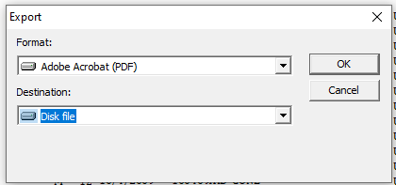

entering meet information
Enter Meet information: Click on Meets on the Main Menu at the top of the screen.
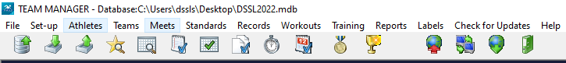

Click on Add (or the paper icon)
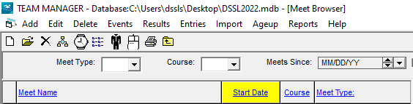

Set up each of your team’s meets with a unique name. Put your team’s name first:
YOUR TEAM name abbreviation vs. OPPOSING TEAM name abbreviation, and include the scheduled date of the meet. (e.g., CCC vs GF 6/3/25)

Enter your meet information, date (start & end), Course YO, and Age-up Date (June 01 of the current year – for example in Summer 2025 it would be Jun 01, 2025). Click OK when complete.

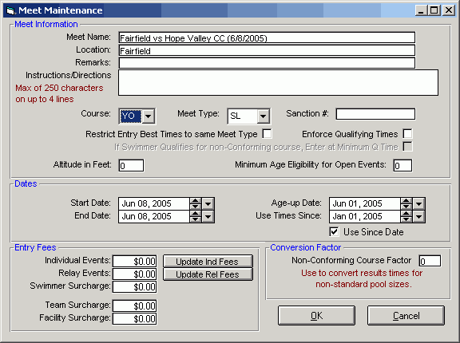

entering events
Enter events by highlighting a 2025 meet, clicking Events, and adding events from the list in Section 4 in Instructions for DSSL Team Statisticians. If you have meet information from last year, highlight a 2024 meet, click Events and then Copy Events From and pick a past meet from the drop-down list.

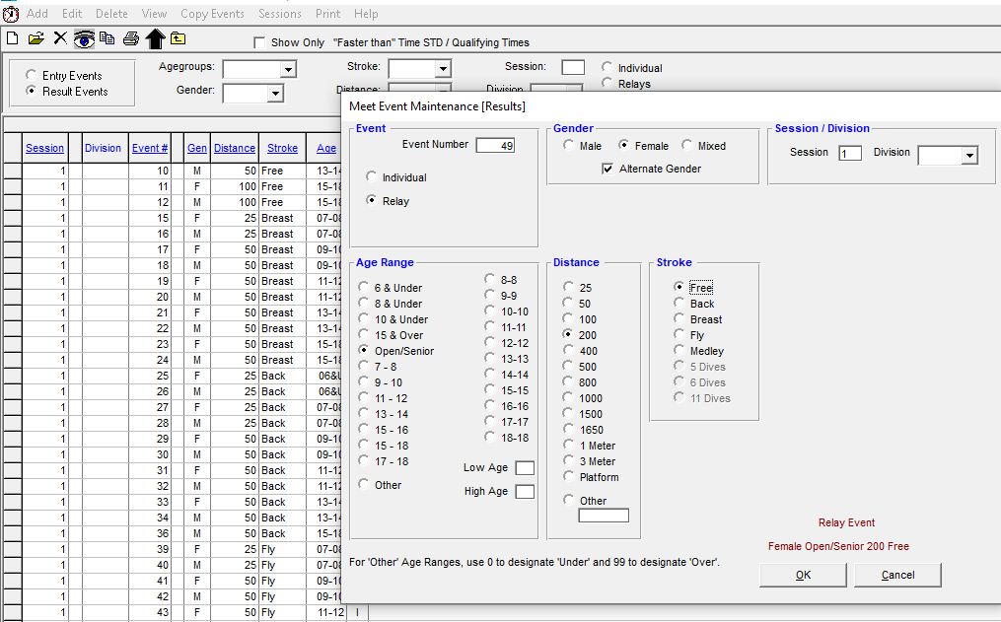

DSSL Statistician Procedures Before and After Meet

BEFORE THE MEET
- Set up the meet by giving it a unique name and date.
Always name your team first: (e.g., BHR vs TREY 6/3/23)
- Give to Coach 2 days before the meet:
A blank team roster sheet for meet entries. Get it back the day before meet.
- Enter team entries into computer for the meet.
- Perform a backup and copy the backup file to a USB Flash Drive. From the main screen select File->Backup
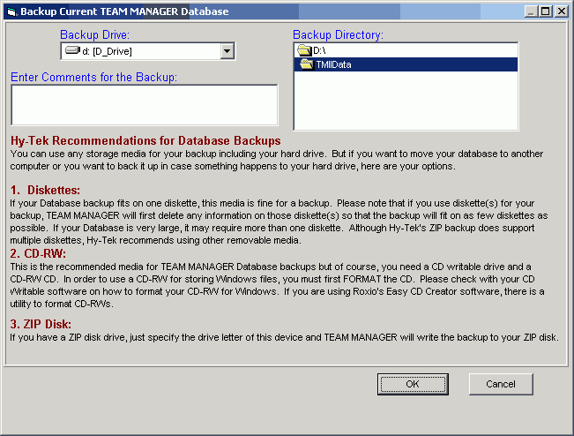
- Give to Coach morning of the meet:
Deck labels with team entries on them. Use Avery Dennison labels #5160. Go to Labels on the main menu, then click on entry labels.

DURING/After the Meet
- Either you or the Parent Rep should collect Time Sheets from Scorer’s table. Collect time cards (pink & blue).
- Enter meet result times into Team Manager on the computer. Most teams do this in real-time as the meet is going on to cut down on work after the meet has concluded.
- You can do this by clicking on MEETS in the top toolbar. A new screen will open. Select the meet for which you want to enter results on by clicking once. Then click RESULTS and select RESULTS BY EVENT. A new screen will open.
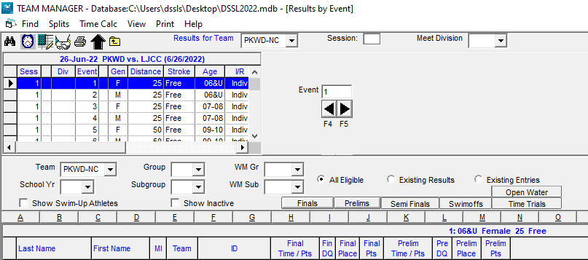
From there be sure that you’ve selected your team name in the “Results for TEAM” dropdown menu, as well as the “TEAM” dropdown. The events will appear in the upper left portion of the screen. Click once on the event you wish to enter results for. The swimmers’ names will populate below. To enter a swimmer’s time, locate that swimmer’s name and click the box for “Final Time/Pts” and enter the time to the hundredths decimal place. Note you do not need to add colons or decimal points. Eg: if the time is 1:01.55, you type 10155 and the program will automatically format the time. If a swimmer is disqualified, simply enter DQ and tick the next box over for “Fin DQ.” You can enter the final place and final points in the respective columns as well. Once you’ve finished entering results in for that event, click to the next one and repeat. Always double check the times, places and points.

- Once the meet has finished, you can make a meet results report for your coaches. Click on Reports on the main menu, then click on Performance, then click on Meet results and follow directions. It’s always best practice to review the results report to make sure there are no erroneous errors that need to be fixed.
- Once again, create a backup.

Reporting Duties for Team Statisticians
PLEASE SEND ALL TEAM ROSTERS AND MEET RESULT INFORMATION IN ELECTRONIC FORMAT TO THE DSSL League Statistician BY THE SEED MEETING
DSSL League Statistician: Kristin Weaver
919-452-4926
dssl_stats@hotmail.com

REPORTING DUAL MEET RESULTS
After each meet every team must email results to the League Statistician (Kristin Weaver) within 48 hours after the completion of the meet:
- Email an electronic file containing the Meet Results from the meet. Note the file name (ending with .zip extension) in the e-mail and the name and date of the meet as you entered it on your computer to dssl_stats@hotmail.com.
  - To do this, click on file, export results, choose the meet and a file will be created and saved to your TM File. It should be a zip file (.zip). Open email and send that file as an attachment.

- Email the initial roster after the first meet, and any additions, deletions, or spelling
changes that effect subsequent meets.
- Separate instructions for Champs entries will be sent by the league statistician closer to Champs.

At or before the seed meeting for CHAMPS each team must email:
- The scanned copy of the hand written Time Record Sheets (or pdf of meet results if using Swimmingly) for each meet.

These are 2 helpful (~20 min each) YouTube videos that will give you a sense of how the Team Manger program works. Please note that they are using a different swim league as the example.
https://youtu.be/mAcc4Xej5t0

https://youtu.be/Dz8SMusiufE

DSSL LISTING OF EVENTS
Event 1 6 & under Girls 25 yd. Freestyle
Event 2 6 & under Boys 25 yd. Freestyle

Event 3 7-8 Girls 25 yd. Freestyle

Event 4 7-8 Boys 25 yd. Freestyle

Event 5 9-10 Girls 50 yd. Freestyle

Event 6 9-10 Boys 50 yd. Freestyle
Event 7 11-12 Girls 50 yd. Freestyle
Event 8 11-12 Boys 50 yd. Freestyle

Event 9 13-14 Girls 50 yd. Freestyle
Event 10 13-14 Boys 50 yd. Freestyle
Event 11 15-18 Girls 100 yd. Freestyle
Event 12 15-18 Boys 100 yd. Freestyle
Event 13 6 & under Girls 25 yd. Breast
Event 14 6 & under Boys 25 yd. Breast

Event 15 7-8 Girls 25 yd. Breast
Event 16 7-8 Boys 25 yd. Breast
Event 17 9-10 Girls 50 yd. Breast
Event 18 9-10 Boys 50 yd. Breast
Event 19 11-12 Girls 50 yd. Breast
Event 20 11-12 Boys 50 yd. Breast
Event 21 13-14 Girls 50 yd. Breast
Event 22 13-14 Boys 50 yd. Breast

Event 23 15-18 Girls 50 yd. Breast
Event 24 15-18 Boys 50 yd. Breast
Event 25 6 & under Girls 25 yd. Back
Event 26 6 & under Boys 25 yd. Back

Event 27 7-8 Girls 25 yd. Back
Event 28 7-8 Boys 25 yd. Back
Event 29 9-10 Girls 50 yd. Back
Event 30 9-10 Boys 50 yd. Back
Event 31 11-12 Girls 50 yd. Back
Event 32 11-12 Boys 50 yd. Back
Event 33 13-14 Girls 50 yd. Back
Event 34 13-14 Boys 50 yd. Back

Event 35 15-18 Girls 50 yd. Back
Event 36 15-18 Boys 50 yd. Back
Event 37 6 & under Girls 25 yd. Fly
Event 38 6 & under Boys 25 yd. Fly

Event 39 7-8 Girls 25 yd. Fly
Event 40 7-8 Boys 25 yd. Fly
Event 41 9-10 Girls 50 yd. Fly
Event 42 9-10 Boys 50 yd. Fly
Event 43 11-12 Girls 50 yd. Fly
Event 44 11-12 Boys 50 yd. Fly
Event 45 13-14 Girls 50 yd. Fly
Event 46 13-14 Boys 50 yd. Fly

Event 47 15-18 Girls 50 yd. Fly
Event 48 15-18 Boys 50 yd. Fly
Event 49 Girls Open 200 yd. Freestyle Relay
Event 50 Boys Open 200 yd. Freestyle Relay

