MEETING OF THE OHSSCA BOARD OF DIRECTORS
Via Zoom virtual meeting- March 16, 2023 8:00 PM Start
https://mmc.zoom.us/j/99964229465?pwd=QjlUS2ZxS2xWNGwzYURzdlRzQzZSUT09
AGENDA
- Remind Rob to record the meeting
- Call to order, roll call
- Review/Approval of Fall 2022 minutes- please review ahead of time: https://www.teamunify.com/rechsohs/UserFiles/Image/QuickUpload/ohssca-board-of-directors-meeting-minutes--september-29-2022_083741.docx
  - Mike motioned, Tom- all approved
- Reports from Chairs
  - Officiating- RJ Van Almen
    - Challenging season this year
    - Unavailability of officials, many cancellations during regular season
    - 6 officials back out of state meet
    - Challenges for sectionals and districts, don’t assign parents
    - Official count went up this year but post season, didn’t volunteer
    - Looking for new process for selecting state diving officials, looking for coach input
      - Want more females
      - Looking for younger officials (8-10 year experience)
      - May need to bring back some veteran officials
      - Looking for coach input
    - 6~ calls over 4 sessions, no real controversy
      - 2 calls that were controversial as they weren’t called
        - Backstroke start
        - Another heat where false start were confirmed but referee called back and restarted
    - Will work more with Ryan to train diving officials
  - Diving- Ryan Wilson
    - Swimposium in fall for officials—good turnout, all districts there, Dan Miller from NE led some conversations, diving demos, showed draft of dive questions related to rulebook. Officials from each district led some conversations. Plan to do it again next season
    - State- positive feedback with new format. Only complaint was open board session- very crowded. May need scheduled time- Ryan to review options. Judging seemed to be good—fewer complaints this year. Don’t plan new proposals. 32 qualifiers was well received.
  - NISCA- Wally Lutkus
  - Awards- Andrea Sorg
    - All is good. all awards handed out at appropriate time, need to send out 1 more CotY.
    - District CotY- all went well with central payment.
  - Financials- Rich Szczepinski
    - All awards paid for except for one CotY
    - $23k balance right now
    - Future expenses this year- scholarships ($1,000)
  - Scholarships- Matt Davis
- New Business
  - Swimposium? ASCA will not have a clinic at OSU this year
    - Combine with fall meeting or keep via Zoom?
    - Mike de Bear will become president
      - President elect nominations needed
    - Let Rob know if you’re interested. Mike de Bear to help- possible host, possible speakers.
  - East district swim coach association status
    - Matt P—association did happen, Nathan Levengood president, Bobby Jo Johnson VP—wanted a voice at sectional (whole District is at Sectional)
      - Sounds like more East focused
      - Did some awards for East district- academics award, swimmer/coach of the year
      - Southeast may create their own association
      - 6 teams from East made it to state. This association is more about local recognition
    - East still has a desire for separate district reps to OHSSCA
District | D2 Girls | D2 Boys | D1 Girls | D1 Boys | Total
Central | 18 | 10 | 37 | 36 | 101
East | 16 | 8 | 2 | 0 | 26
Northeast | 34 | 32 | 60 | 45 | 171
Northwest | 37 | 33 | 17 | 8 | 95
Southeast | 14 | 12 | 1 | 0 | 27
Southwest | 41 | 30 | 42 | 36 | 149

  - 15 Minute rule at all levels across the state
    - Central, SW, NE did follow
    - Andrea thinks the NW did follow it for District
  - Fall training- new coach, software- went well. What else can we do?
    - Mike d—prior to state meet, perhaps a call—prior year comms were better, no one seemed in charge at the state meet—would be good to return to video, have a central contact. Where to get packets, where to get ice, for example.
    - Mark H- Wirthwein award was rescinded from Sam Seiple in 2009-10- need to update state program (Rob to update Tim Stried)
  - OHSSA conversations- resuming soon
    - Discussion on changes this year
      - 32 qualifiers
        - Access gym not as full as it could be
          - Missing video might have impacted
        - Mike d- didn’t seem too much worse, when we had combined divisions
        - Jeff- traffic flow was better when bleachers were closer to poll and walkway was behind
      - Alternates
        - Need to be clear about relay alternates versus alternates due to scratches
    - Survey feedback other than state changes
      - Any new proposals
      - Mark H – new Jersey regional dual meet
    - Relay alternates- alleviate crowding, a lot of “award a senior”, keep alternates in stands,
    - Dedicated coach area at Canton?—more for teams with smaller swimmer counts, perhaps a section in the new plastic bleachers
  - Need new nominations for:
    - Hall of Fame
    - Wirthwein
    - Larry Lyons
    - SEI
    - Process for nominations
  - Open discussion

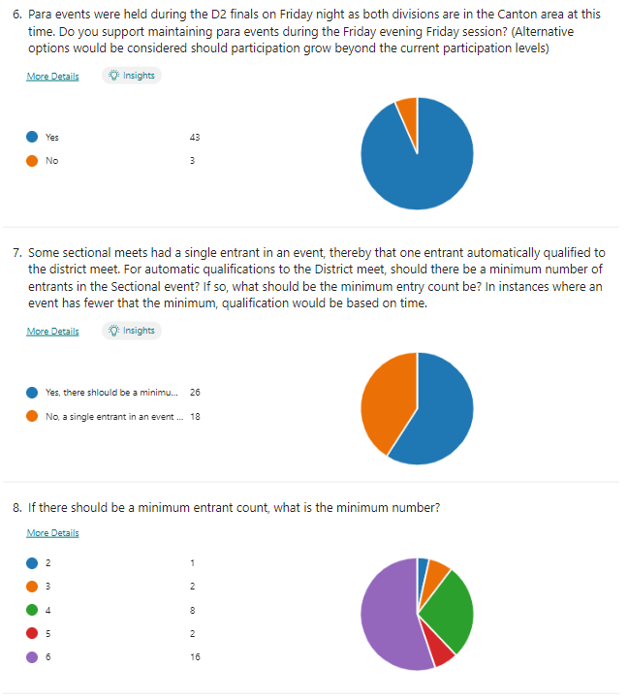

RJ
Andrea
Mark H
Matt H
Tom S
Nick L
Mike d
Rich
Ryan
Chris M
Carlo

