The Ivy Hills Stingrays participate in the Greater
Cincinnati Country Club Swim & Dive League that
consist of swimmers of all skill levels from ages 5-18 years old. The “Stingrays Experience” focuses on swimming development in a fun and social environment. Our coaching staff works very hard to develop the swimming skills for everyone from beginners just learning to swim, to our older and more advanced competitive swimmers.

Practice Schedule
First Day of Practice: Monday, June 2
Last Practice: Friday, July 11
Practice Times are by Child’s age on June 1st.
● 9:00am – 10:00am – 7 & 8 year olds
● 10:00am – 11:00am – 9 to 18
● 11:00am – 11:30pm – 6&U, Junior Stingrays

Typical Meet Schedule (6:15 pm Wednesdays)
● Home warmups are at 5:30 pm – 5:50 pm
● Away warmups are at 5:50pm – 6:10pm
● June 4th – Away Meet AT Hyde Park CC
● June 11th – Home Meet vs. Maketewah CC
● June 18th – Away Meet AT Terrace Park CC
● June 25th – Home Meet vs Western Hills CC
● July 2nd - No Meet, unless rainout reschedule
● July 9th – Home Meet vs Western Hills CC
● July 15th – Tuesday Champs AT Ft. Mitchell CC

Other Important Dates
● Team Photos: TBD during practice, mid June.
● End of Season Banquet – TBD

Equipment Checklist
o Practice Swimsuit (should be comfortable)
o Ladies: one piece, two straps
o Men: Jammers or tighter fitting trunks
o Team Swimsuit for Meets (should be tight)
o Swimville USA, 7714 Montgomery Rd
Unit B, Cincinnati, OH 45236
o Swim Cap (optional but recommended, for
sale as a club charge before/during meets)
o Swim goggles (nicer ones around $20 do best)
o Towel, coverup, sandals, etc

Junior Stingrays
The ‘Junior’ Stingrays program is for our 6 & Under swimmers who are already able to swim (granted, it may be a doggie paddle!), yet are not quite able to swim across an entire length of the pool without taking breaks.

The Junior Stingray program enables our young swimmers to get much more focused attention on swimming basics during daily specific Junior Stingray practices, with a focus on improving swimming endurance and stroke technique. Our coaches expect that everyone who enters the Junior Stingray program will be moved up into the regular Stingray team practices by the end of the season, and will be able to swim in our fun swim meets before the season ends!!

Evaluations for Junior Stingrays will happen the week of May 27th. Time and date to be determined. It is imperative that we note swimmers MUST PASS this evaluation in order to be allowed to swim with the team.

Coaches determine when swimmers are ready to ‘graduate’ to the regular Stingray program, usually based on when they are able to swim one length of the pool without breaks. Even though Junior Stingrays won’t be able to compete in swim meets until they ‘graduate’, they are a part of the Stingray team and are encouraged to attend the swim meets to cheer on their teammates!

Swim Championships
- This is a really important part of the season and highly encouraged to attend!
- Typically, the meet starts around 9:30am
- Warmups will likely be around 8:30am
- This is a daytime meet that will likely last until early afternoon last year it ended at 1:30pm
- Parents are encouraged to attend; if you cannot, we can coordinate carpools, please reach out to friends or to us!
- League rules require swimmers to have participated in a minimum of at least two regular season meets to be eligible to swim in a championship meet. Rainouts still count.

Team Requirements
● Registration Fees o 12 & under – $195 first swimmer o Additional swimmers: $170/swimmer o 13 & older – $60 / swimmer
● All fees will be billed to your club account.
● Parents MUST volunteer with a minimum of 2 meets per family. More information will follow closer to the season.

Frequently Asked Questions
Q: Does my swimmer need to attend every practice?
A: Not every day, what works for you is ok. It’s summer… vacations, sleepovers, camp, etc. happen. It is good to know though that the more practices they attend the more improvement they will see in meets.

Q: What qualifies for Junior Stingrays?
A: The swimmer needs to be able to jump in the pool on their own and swim half the length of the pool. Swimmers must pass this evaluation to be allowed to practice with the team. Junior Stingrays will only swim in meets once the coaches determine he/she is ready.

Q: What does a typical week look like?
A: Monday-Wednesday regular practice, Wednesday night swim meet, Thursday easy practice with donuts and ribbons, Friday practice with pool games typically.

Q: How long is a typical swim meet?
A: Typically, they are around 2 hours depending on the number of swimmers.

Q: What strokes do they learn / swim?
A: Freestyle, back stroke, Butterfly, breaststroke.

Q: What are the volunteer jobs?
A: Timers, ribbons, admin assist, awards, champs, etc.

Registration Instructions

1. Scan this QR code or visit: bit.ly/IvySwim
2. Then at the top click on “Team Registration”

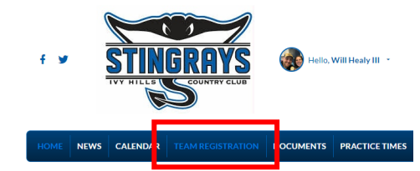
3. This is a new system, start by clicking “Add To Cart” for each swimmer with the appropriate age group.
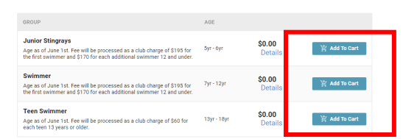
4. Then at the Top click on “My Shopping Cart”
5a. New families will be prompted to create an account and create family & swimmer profiles.
5b. Returning families will be prompted to login.
6. Then click Checkout Now. You will then be prompted to assign swimmers to the appropriate swimmer groups, sign agreements/waivers for each swimmer, and confirm your swimmer information.
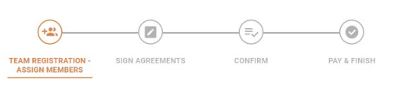
8. In “pay & finish” please populate your billing address and information for the club and click “pay now.” You should then get an email confirmation

