Midlakes Swim League – Fall General Meeting Agenda
Wednesday November 8, 2023 at 7:00 pm

- 2024 Season Calendar
  - Dual Meet Start – June 11th/13th
  - Division Champs – July 13th – July 20th: divisions will choose when to schedule
  - League Champs – July 21ST This schedule allows for dive champs to be on a different weekend. Water polo can then have their full season before school starts.

- Reports:
  - Treasurer Report – Van Brink/Nancy
    - Review proposed increase of per swimmer fee ($12 ->15) & meet host supplement increase ($900. -> $1800)
      - hoping to generate revenue through heat sheet ad sales and tshirt sales. Need to negotiate waiver of merchandise sales percentage to KCAC. Host supplement increasing to make sure there is interest in hosting champs so pools don’t lose money when hosting. Insurance costs are increasing as well
      - If there is a surplus from rate increase. If Midlakes balance sheet is greater than approx. $50k then remainder would be distributed to clubs
- Board Position Status
  - President – Gary Kamikawa (HW)
  - VP – Tracy McDonald (FW)
  - Treasurer – Van Brink (TRI)
  - Secretary – Alyson Francis (PLAT)
  - Past President – Vacant for 2024 season
  - Division I Rep – Open
  - Division II Rep – Tanya Mertel – STC
  - Division III Rep – Jessica Howe (MH)
  - Division IV Rep – Marcy McCorrston (NHST)
  - Division V Rep – Keri Carlson
  - Coaches Reps – Laura Halter – EB; Carrie Nordberg - WR
  - Officials – James Weinrod
  - Awards – Ashley O’Neil OGCC (replacing Corey Raney)
  - Fundraising – Cherelle Bertch
  - Water Polo –
  - Diving – Pauline Fox – PL; Kristen McSherry
  - Past President – Open
  - Communications – Kim Dare
        - Fall 2024 will be voting for new Pres, VP, Treasurer, Secretary

- Division Alignment discussion
  - Suggestions floated: Geographic orientation, Multi-year evaluation, combined valuation across dual meet results, champs results, and team size.
  - There will be no planned changes for division alignment for 2024 unless specific teams reach out to the board. We are looking forward to having a system in place for 2025 season.

- Midlakes Diving topics
  - Dive: fastest growing sport within Midlakes, both with number of divers and clubs wanting to participate. Dive is currently $15 per diver. They are planning increase to $18 per diver. The dive team fee will increase from $60 to $70
    - Historically, If divers were also on swim team, they would not have to pay insurance for dive. Now they must pay insurance for both swim and dive.
    - Dive is updating guidelines for swimwear exemptions. This differs from USA diving rules. There will be a swimwear exception request form on Midlakes website.

- 2023 Fall Operating Plan & Bylaw Considerations
  - Operating Plan A.2 - Swimmer fee increase from $12 to $15: 20 VOTES YES
  - Operating Plan Appendix B – Fee distributed to championship meet host increase from $900 to $1800: 20 VOTES YES
  - Clarification in Section C.2.b (Division Alignments) 17 VOTES YES
    - Current: 3.a The board believes that in order to create equity across the league that ALL officials MUST attend a training session prior to the start of the competition portion of the season. The board believes the additional trainings, even for veteran officials are necessary in order to create consistent application of our mission statement.
    - Proposed: shift to the section Officials for Meets to align all guidance regarding officials into a single section. Additionally add the following language:
      - USA and YMCA Swimming certified officials must demonstrate familiarity with the Midlakes rule differences, and attend training for any position above their USS certification level.
  - Update to Competitive Regulations to include language regarding swim attire:
    - Exemptions from USA swimming rules concerning the attire covering beyond swimsuit guidelines shall allow for the foregoing restriction may be granted to a swimmer with an exception form provided to the Head Official prior to the beginning of the meet. Exemptions will be granted for conflicts due to swimmer’s verified religious beliefs, medical conditions, gender, or other reasons that be in conflict of the spirit of inclusivity, as long as the attire does not provide any competitive advantage (i.e. wetsuits providing buyouncy). 20 VOTES YES
  - Update to Competitive Regulations section E.3
    - Current: 3. A Stroke & Turn briefing will be held with all judges prior to each meet.
    - Proposed: 3. An Officials meeting will be held with all judges prior to each meet. If a Stroke Briefing is missed, the officials shall be provided with a printed copy of the Midlakes Stroke Briefing. 19 VOTES YES
A. The Meet Referee or his/her designee will ensure that all roles are filled with qualified officials, and all jurisdictions are properly defined.
    - Current: 3.a The board believes that in order to create equity across the league that ALL officials MUST attend a training session prior to the start of the competition portion of the season. The board believes the additional trainings, even for veteran officials are necessary in order to create consistent application of our mission statement.
    - Proposed: shift to the section Officials for Meets to align all guidance regarding officials into a single section. Additionally add the following language:
      - USA and YMCA Swimming certified officials must demonstrate familiarity with the Midlakes rule differences, and attend training for any position above their USS certification level. FURTHER DISCUSSION NEEDED

  - Update to Competitive Regulation section E additional language regarding Disciplinary action during meets.
    - Proposed: Disciplinary action during meets: 16 VOTES YES
      - In the event of an incident requiring disciplinary action toward a swimmer, parent, or coach, representatives from both teams shall be included in any decision. These may include team parents or managers, coaches, and officials. An equal representation shall be maintained. Any action or decision impacting a swimmer, must be communicated by coach or team representative to the child’s parent.
      - Any incident or action must be reported to the Midlakes Board within 24 hours. The Board maintains the right to review and adjudicate any decision.
      - Any SafeSport violation must follow all rules for reporting.
  - Shift section M (Officials & Timers for Meets) to be section F to improve flow of information and readability. 18 VOTES YES

  - Update Officials for Meets point 1.5 to include YMCA certified officials.
    - Current: 5. If USA swimming officials are present, the preferred hierarchy….
    - Proposed: 5. If USA or YMCA swimming officials are present, the preferred hierarchy… FURTHER DISCUSSION NEEDED
  - Update Championship scoring:
    - Current: Championship scoring to be consistent with USA swimming guidelines for number of lanes
    - Proposed: elimination of USA Swimming guidelines to replace with clear scoring: 16 VOTES YES
      - Divisional Champs – 12 places: 16-13-12-11-10-9-7-5-4-3-2
      - League Champs – 16 places: 20-17-16-15-14-13-12-11-9-7-6-5-4-3-2-1
  - Update False Start language for League Championships to follow USA rules to eliminate recalls and apply dual confirmation false start disqualification. 13 VOTES YES, 7 VOTES NO
  - Updated Mixed Relay language to indicate that it is a set event and treated and scored like all other relay events regardless of a team choosing to not to enter a relay. FURTHER DISCUSSION NEEDED
  - Ratify the League Champs event lineup. 12 VOTES YES, 3 VOTES NO
  - Update League Champs relay eligibility to allow every club to submit one relay per event and any second relay is required to meet the League Championship time standard. 14 VOTES YES
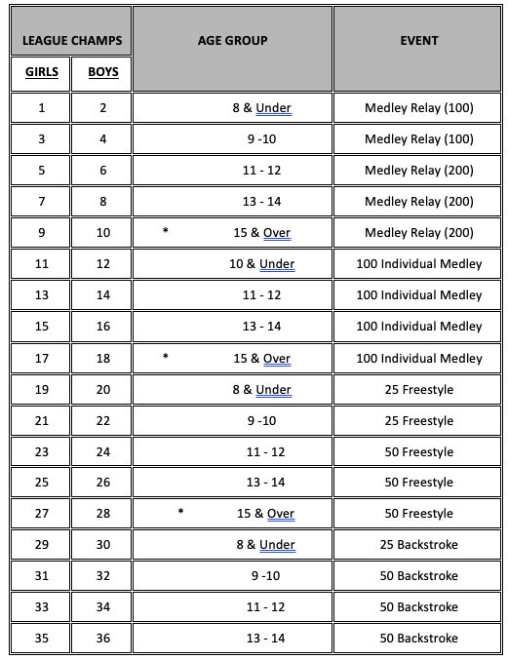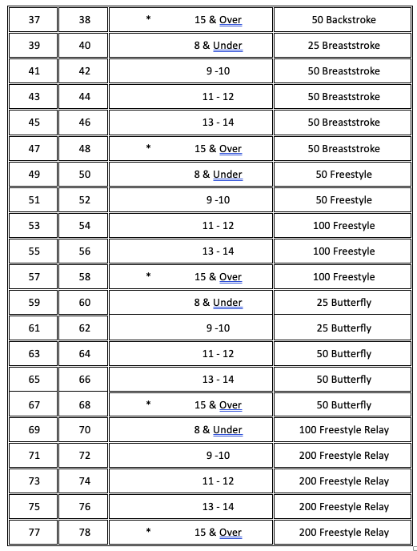

- Open Topics

