Hello Division B,

We are looking forward to hosting you! I just want to give you some information about our meet. We have a 6-lane, 25-meter pool with a lot of deck space for viewing and setting up/seating areas.

The pool address is:
10511 S Serengeti Dr Lone Tree, CO 80124 (sometimes it’s listed as Littleton in navigation instead of Lone Tree).

Set Up: Your team(s) will have the area under the awning (first come, first serve as this area is smaller and fills quickly) which is inside the gate at the non block end of the pool, and the North-East lawn by the parking lot to set up. This area is large and has plenty of room for everyone.

Please note our covered pavilion is reserved for our team’s board members only. Our power is sourced through this area so we don’t want to risk anyone accidentally disconnecting our power so we have reserved this area for our teams board member

Wildcat will be behind the pool inside the gate on the block end of the pool and then outside of the gate at the block end of the pool as well.

Warm-Ups:
Warm ups will be split by the teams.

Wildcat, CP Crocs and Southglenn- 7:00-7:25am

Holly Park, Canterberry Crocs, Piney Creek- 7:25-7:50am

Parking: The parking lot is closed and there are spaces reserved for 1 coach and Parent Rep for each team as well as some of our key volunteers. Most people will need to park on the neighborhood streets.
The main parking lot can be accessed for swimmer and tent/equipment drop off only!
Wildcat Mountain Elementary is the preferred place for parking and is about 2.5 blocks to the north of the pool (turn left on Lionshead Parkway).
Parking on Quebec is prohibited, no parking on Wildcat Ridge (the entrance street into the neighborhood), and absolutely NO parking in front of the homes across and next to the pool on Serengeti Dr (parking here can result in the HOA voting to not allow us to have our team so please reinforce this to your parents).
Please follow traffic laws and park legally to avoid being ticketed or towed.
Parking is allowed on Lionshead Pkwy (the street that loops around the neighborhood), but the elementary lot is preferred. Again, we will have 2 reserved spots for each team in our parking lot. Your families are welcome to drop off swimmers/equipment in the loop then go park.

Parking map below:
Green- Good areas to park (the lot for coaches and parent reps only though)
Yellow-back up area
Red-strictly off limits

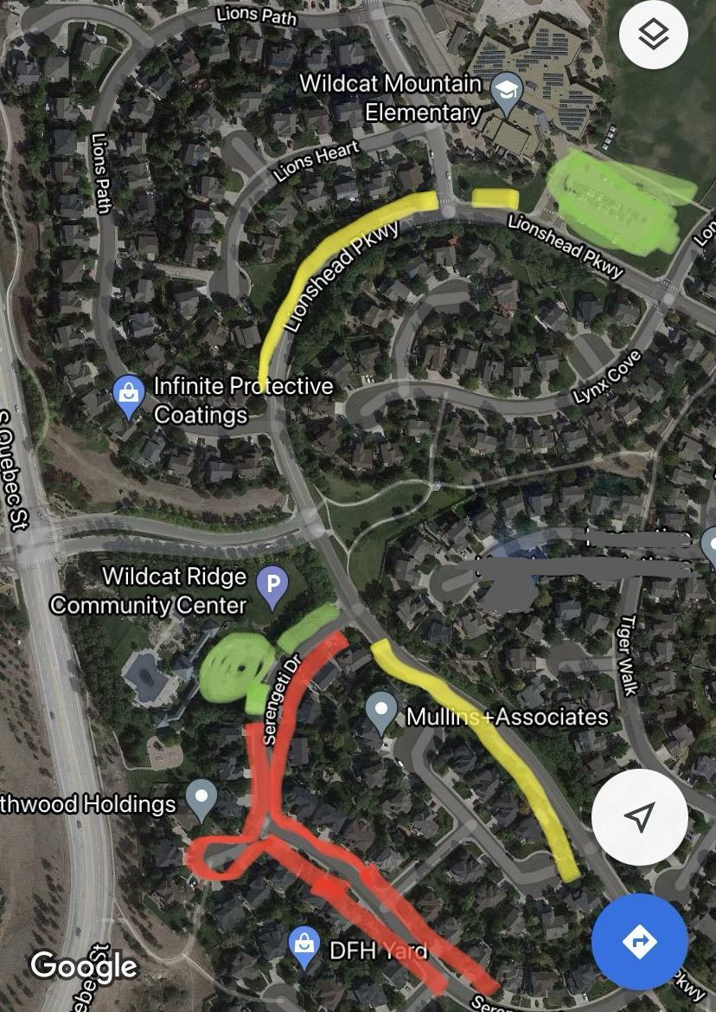

Relays (dual meets only): 3 relays per age group at dual meets.

Volunteers: Our volunteer coordinator is Kristen Seager. We will have a table(s) near the entrance to the pool checking in swimmers and volunteers. You are welcome to use this area or find another area to check in your team. Any specific volunteer questions can be directed to them directly at the email addresses below

wraa.volunteercoordinator@gmail.com

The volunteer meetings should begin at roughly 7:30 am and the announcer will make an announcement.
Please note, per our officials, we switch our volunteer shifts AFTER EVENT 48 for event timing consistency.

Volunteer Help Needed: we will be using the zello app for all stroke and turn judges I will send that info if you can please get that to your stroke and turn judges please.
I also need the names of your stroke and turn judges to give to our scoring judges the morning of the meet. Per new league guidelines the names must be in the system by 7:45am that morning.

Meet Programs: I will have a few programs for the coaches and parent rep. The only other programs we will have printed and available at the meet will be for stroke and turn officials, etc. The program will be available on Friday afternoon/evening and emailed to whoever sends in entries to be shared with your coaches and team.

FOR DUAL MEETS:
Please have all meet entries sent in to our scoring by Wednesday at 5:00pm.
On Thursday please review the preliminary program for any mistakes and send any corrections to our scoring.

Scoring meet managers are
Robin Williams and Amy Larsen .

wrtigersharkscoring@gmail.com

**For prelims-entries are sent to the team hosting championships. Not the prelims host teams.

Concessions: We have a concession stand with breakfast burritos, pizza, grilled lunch items, candy etc. for sale.
Coaches will get a meal voucher for one free meal.

Facility: Our facility has 3 pools. The North/Adult Pool and hot tub are strictly off limits to both swim teams during the meet including any non-swimming siblings. There will not be a lifeguard on duty until 10:00 am when the North Pool will be open to Wildcat Ridge residents who are not participating in the swim meet. This is not a pool open to swim meet patrons.
The baby pool will also not be open to swim meet patrons.

Our HOA requires the meet is completed and cleaned up by 2:00pm so that will need to be strictly enforced and could create the need for combined events to move the meet faster.

Thanks so much for helping us enforce these rules!

I hope I have covered everything.

Please feel free to call or text me at 303-949-0281 (cell).
I will have my cell phone with me at the meet.

We look forward to seeing you on Saturday!

Thanks,
Autumn Murray
Wildcat Ridge Tigersharks
Parent Delegate/Vice President

