Mountain Hi Swim League

Official Guide on How to Use:

Hy-Tek Meet Manager 5.0 for Windows



Version A – Championship and Allstars

September 2012

Tables of Contents

1 INTRODUCTION 4

1.1 Overview 4

1.2 Database Set-Up 5

1.2.1 File Folder 5

2 MHSL PRELIMS / CHAMPIONSHIP PREP & TIMELINE 6

2.1 Championship Prep 6

2.1.1 Host team Responsibilities and Guidelines 6

2.1.2 Division Decisions 7

2.1.3 Championship Contacts 8

2.2 Suggested Championship Meet Timeline 9

2.2.1 Sample Calendar & Checklist 10

2.3 Prelim / Championship MM database setup 11

2.4 Meet Customization 12

2.4.1 Meet Set-Up: 12

2.4.2 Setup – Options: 13

2.4.3 Athlete Relay Preferences 14

2.4.4 Report Preferences: 14

2.4.5 Seeding Preferences: 15

2.4.6 Setup / Entry Scoring Preferences 16

2.4.7 Setup / Scoring Set-up 17

2.4.8 EVENTS: 18

2.4.9 Import Records and Standards 19

2.4.10 Create Sessions 20

2.4.11 Seeding the Preliminary sessions 22

2.4.12 Prelim with Different Pool 23

2.4.13 Print the MM Program (make enough copies for each team): 24

2.4.14 Send MM Back-up Data base to Preliminary Host Teams and each division team: 24

2.5 Scoring the Preliminary Meet: 25

2.5.1 Event Completion: 25

2.5.2 "Swim Throughs" 25

2.5.3 Swim-Offs (during Prelims) 26

2.5.4 Closing Prelim 28

2.6 Seeding the Championship Meet: 29

2.6.1 Input files for Master Championship Database: 29

2.6.2 Championship Relays: 29

2.6.3 Preliminary Results 29

2.6.4 Championship Seeding 31

2.6.5 Adjusting the Relays 33

2.6.6 Championship Programs 33

2.7 Scoring Results 34

2.7.1 Scratching Swimmer in heat #1 (place 9-16) 35

2.7.2 Scratching Swimmer in heat #2 (place 1-8) 36

2.7.3 Award Labels: 36

2.8 Closing Meet 37

2.8.1 Create a Result File for Team Manager 37

2.8.2 Print Score Results 37

3 MHSL ALLSTAR MEET PREP & TIMELINE 38

Note: often the Host team engages another team to setup the meet db. The Host meet manager should ensure there is agreement on the responsibilities for setting up the meet and communicating the timeline to all teams in the league. 38

3.1 Allstar Prep 38

3.1.1 Host MM Responsibilities and Guidelines 38

3.1.2 Host Team Responsibilities and Guidelines 38

3.1.3 Allstar Meet League Decisions 38

3.1.4 Running Allstar Meet Decisions 39

3.2 Communication 40

3.2.1 Allstar Contacts 40

3.2.2 Allstar Suggested Timeline 41

3.2.3 Allstar Suggested Signup and sign-off form 42

3.2.4 Allstar Sample Communication 44

Following is a Sample communication for all teams sent by Meet Manager database setup owner. 44

3.3 Allstar Meet Set-Up Instructions (differences for Allstars only) 45

3.3.1 Entry requirements: 45

3.3.2 Meet Set-up Prep 45

3.3.3 Closing the Meet 47

- INTRODUCTION

Welcome to Meet Manager for Windows for Championships and Allstars. This guide only addresses the differences for setting up and running a championship & prelim or Allstar meet, see the dual meet guide for general MM questions.

  - Overview

Division Championship
A swimmer in the Mountain Hi Swim League swims in a preliminary meet to qualify for Divisional Championships by event. Each Division determines the ages swimming at each preliminary meet. The preliminary meets may run over 2 or 3 days depending on the number of swimmers.

The MHSL Policies and Procedures Manual (P&P) Section 14.15 describes the recommended staffing and responsibilities for the scoring table area. Each Division may modify the recommendations to meet their specific needs.

The host team for the championships meet will be responsible for the operation of the Meet Manager software, thou another team may assist with setup. The basic steps for the Meet Manager are as follows

  - Prelim/Championships Prep
  - Confirm Timeline
  - Setup Prelim/Championship Meet DB

Championship guidelines (see MHSL P&P for latest rules and guidelines)

  - Each swimmer must swim in their respective age group for individual events for Prelims and Finals of the Championship meet.
  - For relays, as long as at least one swimmer is in the correct age group, other swimmers may move up from any age group to swim in the 13-14, 15-18 medley relays. Swimmers may not swim on more than one (1) medley relay or more than one (1) freestyle relay per meet. There will be no exhibition heats.
  - Each swimmer may enter a maximum of three individual events and two relays. He/she must also have met the League requirements - attended at least 10 team practices and competed in at least two League sponsored meets. The swimmer’s name must be on the final team/League rosters and paid the insurance dues.
  - Up to three relays may be submitted per team (without the swimmers’ names) when individual event entries are submitted. Designate each relay team entry as Team Name A, B, and C, respectively, for each event.

Allstars
The All-Star meet is the last swim meet of the Mountain Hi season, this is for the best of the best of all divisions to compete against each other based on:

  - swimmers that are 1st place finishes in their championship meet
  - swimmers that qualify based on All star qualifying times (these times are determined by the results of the prior season) during the season

The venue for the meet changes from year to year based on a pool “stepping” up and volunteering to host the event. A fee is charged for each entrant in the meet, this fee includes the cost of a T-shirt.

  - Allstar Prep
  - Confirm Timeline
  - Setup Allstar Meet DB

  - Database Set-Up

The league championship and allstar template databases are based on a 8 lane meter pool; the databases contains the events and certain generic settings; however the All-Star times and league records will need to be imported into the meet.

There meet templates on the league website:

- Championship 25 meter 8 lane pool (S8) with 6 lane prelims pools
- Allstar 25 meter 8 lane pool (S8)

    - File Folder

It is recommended that each team meet manager follow their existing meet folder setup to setup the championship and allstar meets.

20xx/Championship Jul-xx | 2010-07-17 div# @ home team
20xx/Allstars Jul-xx | 2010-07-24 Allstars

- MHSL PRELIMS / CHAMPIONSHIP PREP & TIMELINE

  - Championship Prep
    - Host team Responsibilities and Guidelines

- Championship Host Team prepares MM Database prior to the July seeding meeting, date set by the MHSL board. (See: guidelines below). Championship Host MM obtains most current by-laws from web or Parent Rep.
- Championship Host team identifies all MM and TM contacts for each team within the Division. Create 3 distribution lists for email communications throughout the Preliminary/Championship time-frame. Define and communicate how the information flow will work between Championship Host, Preliminary Host and each Team's MM & TM volunteers.
- All Division teams prepare one meet in TM for preliminary entries and relay placeholders (A, B, C - as agreed to by Division Reps and Coaches). The swimmers names for the relay teams are usually determined after the last Preliminary. No need to prepare a TM meet for each preliminary - the Hy-tek software recognizes the preliminary and final times for each event.
- All Division teams submit Preliminary entries to Championship Host Team and the League Computer Chairperson (for paper chase), in one TM export by deadline (determined by league/division).
Don't be late with this deadline as it takes some effort to coordinate all the different team's entries
- At the Preliminary Meet, the Championship Host Team will update any changes from the Coaches in the MM database. Each team's Coach signs off on all entries. Once signed off, the Championship Host Team will print the deck labels for all preliminaries. The coaches will place labels on the deck card. The Preliminary Host team then takes cards for their preliminary.
All teams should contribute labels and cards to the host/prelim teams
- Preliminary Host Team inputs the results. All events should be “done” before the meet is completed.
Remember to only select the specific team for a printout of the results – one for each team. This is really important for Coaches in how they select the swimmers for the Championship relays. Often times, the MM person is not at the meet – but has someone picking up the results. Regardless, the Preliminary Host should email to all MM contacts the MM back-up and export MM merge results for that prelim to make sure every team has received the updated information and importantly the Host team has MM database to prepare the MM results export.
- All Division teams send the TM Relay team export via TM file with names by requested deadline. Don’t be late with this deadline as it takes some effort to coordinate all the different team’s entries.
- The Preliminary Host teams prepare the Meet Program from MM. Reminder - Do not select Time Standards. The set-up for the Championship pool dictates the how the MM program will generate. That is, if the championship host pool is meters, but the prelim pool is yards the time will not necessarily convert. So, to avoid any confusion do not select Time Standards in printing the program or results for the Prelims.
To help the swimmers, provide the All Star Times in your MM program
- Preliminary Host Team inputs the results. All events should be "done" before the meet is completed. Preliminary Team provides emails back-ups and TM exports for each team.
Remember to only select the specific team for the TM export - one for each team. This is really important for Coaches in how they select the swimmers for the Championship relays. Regardless, the Preliminary Host should email to all MM contacts the MM back-up for that Prelim.
- Before the agreed upon date, each division team will send the Championship Host team, any revisions to the Prelim results (scratches) and relay entries.
- “A” Relays need to be grouped together in the same heat with the “B” & “C” relay teams grouped together in another heat. The seed times are not always relevant for seeding. This will require manually seeding the event. Some Divisions designate lanes for relays based on team, i.e. Forest Park Swims lane 1, HFII swims lane 2, etc. Others prefer to seed by time, but maintaining all “A” teams swim in the same heat. Each Division will determine the approach prior to the start of the preliminaries.
- The Championship Host Team will email to all Division MM contacts the final Meet Program prior to the championship. Print what you need for swimmers, Coaches, etc.
But please be sensitive that the Championship Host team will print the programs as a money raising effort
- The Championship Host Team will run the Scoring and Ribbons Table. The host team will provide labels for all award ribbons/medals.
- The Championship Host Team will validate that all Award Ribbons are provided based on the by-laws. Prior to the preliminary, the host teams will outline the required scoring support from each team.
- After the Meet is over - the Championship Host team will print results and scores for the awards ceremony. The MM will created and email the MM Database back-up, TM results export and MM results files for each team. Additionally the final score will be sent to the Division VP and the Board's Computer representative.

    - Division Decisions
Prior to setting the prelim/championship timeline, at a minimum the following questions need to be answer, this is usually previously voted on by the Parent Reps and sent out to the division by the Division VP:

  - Establish Prelim Seeding Meeting location, date and time
  - Confirm pools (lanes, yards/meters and location) and ages for prelim date
  - Confirm timeline
  - Confirm contacts for all teams (Parent Rep, Coach & Meet Manager/Team Manager)
  - Confirm # of relay teams, typically 3 “A”, “B” & “C”
  - Confirm reuse of prelim cards for championship
  - Confirm swim throughs; allow or will require swimmer to swim to ensure legal swim
  - Agree on relay seeding, typically “A” in last heat with lanes assigned based on team name. “B” & “C” teams in first heat based on available lanes & seed time

    - Championship Contacts

It is recommended the owner of the meet setup and championship host meet manager (if different) compile these names for the entire group:

Team | Contact names | Contacts email
Team #1 | PR -  MM -  Coach -
Team #2 | PR -  MM -  Coach -
Team #3 | PR -  MM -  Coach -
Team #4 | PR -  MM -  Coach -
Team #4 | PR -  MM -  Coach -
Team #6 | PR -  MM -  Coach -

  - Suggested Championship Meet Timeline

Prelim & Championship suggested Timeline
Week prior to championships
- Tuesday noon, Entries: All Prelim entries (for individual swimmers only) submitted to Championship MM. MM completes seeding and preps for July xx^{th} division seeding meeting. Optionally, relays events can be setup as placeholders for championships. 12 copies are printed for prelim seeding meeting.
- Wednesday afternoon, Prelim Seeding: Prior to the prelim seeding meeting, the six team’s entry files are imported into the prelim meet. 6 copies are printed for each coach to review during the meeting.
- Wednesday evening, Seeding Meeting: Sign-off on seeding of the prelims. During the meeting, the Coaches review, make adjustments and sign-off on the swim teams’ entries. Once all corrections are made labels are printed then each team coach attaches entry labels to deck cards. Note each team should bring labels and decks for the prelims. Once all labels are completed, the prelim Host team takes the deck entry cards (based on specific meet assignments).
It is recommended that each coach sign-off on a single Meet Program, initialing each page and signing the final page. A sign-off form is also an option but you need to have a “master” meet program initialed by each coach.
- Thursday, Final Meet Program: MM Prelim meet file is sent to all MM, individual events only, with the 2 prelim host teams owning the time entry for those events in that session.
Week of prelim & championship
- Monday/Tuesday/Wednesday, Prelim Results: After completion of prelim meet, results are sent back to Championship Host team Meet Manager, using MM export “Results for Meet Manager Merge of Same Event”. Results for each team individually is printed and sent to the team’s MM along with MM results export and backup files. Championship team takes the prelim cards for use at the championships.
- Wednesday afternoon, Relay Entries: Relay entries and scratches from prelim qualifies are sent to championship host MM
- Wednesday evening, Championship Seeding: Prelim results and relay names are merged in Championship meet. Champion program is seeded. Meet Program sent to all 6 division teams for verification
- Thursday, Verification: Champion entries (prelim top 16 plus 2 alternates and relay names) are updated and verified by team Coaches. Corrections are made and meet is re-seeded.
- Friday, Finalize Meet: Final entries are set. Meet Programs and labels are printed (note championship labels are place on the prelim cards,
Note: the prelim swimmer times should be entered on the LEFT side of the card, with the championship swimmer times on the RIGHT side.
- Saturday, Meet: Run Championship Meet
- Saturday, Finalize Meet: Print results: by team, totals by age/gender. Send TM export results file, MM backup file, Score, and Result report (by team and all teams) to each teams, the Division VP and League web-site contact.

    - Sample Calendar & Checklist
Sunday | Monday | Tuesday | Wednesday | Thursday | Friday | Saturday
Week prior to championships |  | Prelim Entries due (noon) | Seed prelims (noon)  Seeding Meeting (evening)  - Update prelim entries  - Re-seed, print final Meet Program & entry labels  - Sign-off Meet Program  - Teams label deck cards | Send Prelim db to Prelim hosts team - no changes from seeding meeting (noon)  Send Meet Program & entries to each team (noon) | Prelim Teams start meet program printing  Prelim meet heat combing
 |  | Entry Checklist  Team #1  Team #2  Team #3  Team #4  Team #5  Team #6 | Prelim Deck Cards  Prelim #1  Prelim #2  Prelim #3
Week of championships | Run Prelim #1 - Deck adds only due by set time of Prelim Host Clerk of source (~7:30am)  Send results (MM backup) to Champ Host MM and results to all teams (after meet) | Run Prelim #2 - Deck adds only due by set time of Prelim Host (~7:30am)  Send results (MM backup) to Champ Host MM and results to all teams (after meet) | Run Prelim #3 - Deck adds only due by set time of Prelim Host (~7:30am)  Send results and backup (after meet)  All teams send individual swimmer updates and Relay names to Champ Host MM (end of day, 5pm) | Seed Championship Meet (morning)  Send Meet Program and entries to all teams (morning)  Send corrections to Championship MM, (end of day)  Update entries (end of day) | Complete final seeding (morning)  Finalize Meet Entries and starting printing (noon)  Send out final Meet Program & entries (noon) | Championship  - Run Meet  - Print Results  - Send out score, results, Results exports by team and MM backup files  (After meet for team awards party)
 | Prelim Cards to Championship Host | Prelim Cards to Championship Host | Prelim Cards  Relay Entry Checklist  Team #1  Team #2  Team #3  Team #4  Team #5  Team #6 | Relay updates & Scratches Checklist  Team #1  Team #2  Team #3  Team #4  Team #5  Team #6

  - Prelim / Championship MM database setup

The Meet Manager software can accommodate a preliminary and championship structure in one database. The key is to set-up a session for each preliminary meet (with events noted as preliminary events), and 1 session for the championship meet (with events noted as Final events).

Please make sure you have a current MHSL By-law printout. As the meet should be set-up based on the parameters set in the by-Iaws.

- Copy MHSL Championship template Database into file called "Championships" and then start to set-up the meet – the template is set up for an 8 lane “meter” Championship pool and the prelims are set up for 6 lane pools
- Save the database as the division championship meet following your existing standards
- Customize the championship database as appropriate. Note this guide will highlight the key differences from a dual meet setup, refer to the “Meet Manager – Dual Meet Guide” for additional information.

IMPORTANT!!! The event sessions lanes and distance (Y or S) will need to be set up based on your prelim and championship pools.

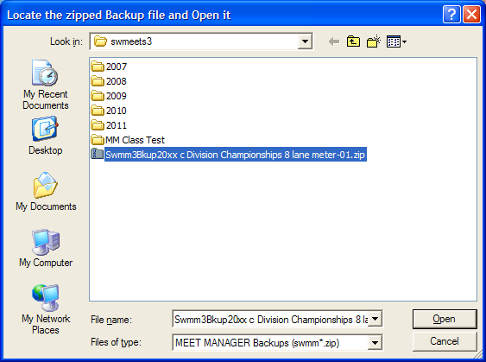
  - Meet Customization

    - Meet Set-Up:

Note: This screen controls how the entry times will be converted or listed in the Meet program. If the championship pool is yards, but the preliminary is at a meter pool- the seed times posted in the preliminary session will be converted to yards. If the preliminary is at a yard pool, but the championship is in a meter pool the seed times posted in the preliminary session will be converted to meters, more on this later.

- Name: "X" Division Championships Location:
- Name of Championship pool
- Start Date: Date of first preliminary
- End Date: Date of championship
- ID: USS
- Base Country: USA
- Class: Age Group
- Meet Type: Standard
- Meet Style: Standard (setup to create 2 rounds: Round-1 Prelim & Round-2 or 3 Finals)
- Course: Yards or Meters based on Championship pool

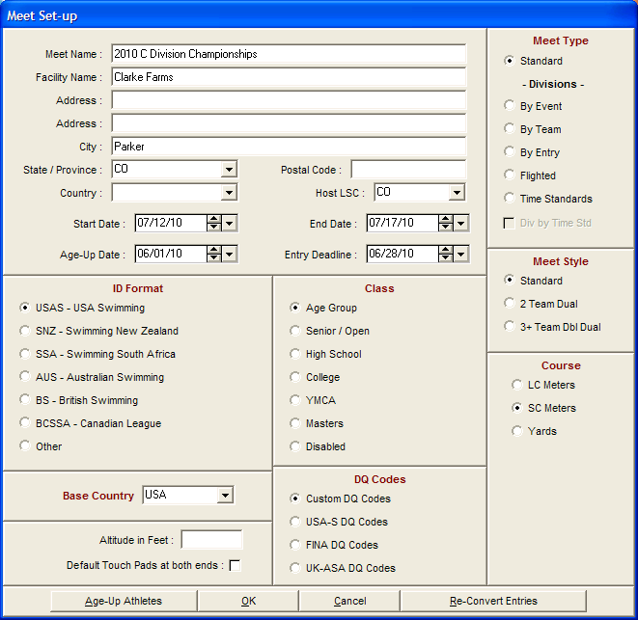

    - Setup – Options:

Number of Lane ': 6 or 8 based on Championship and prelim pools

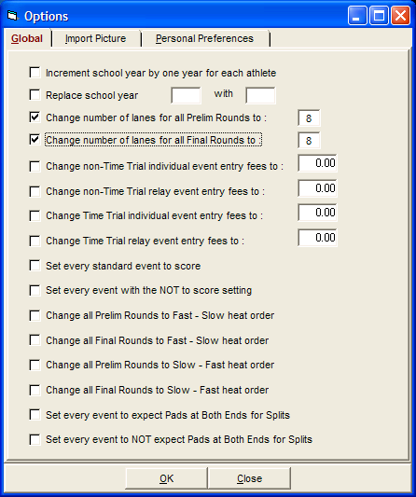

    - Athlete Relay Preferences

- Enter Ages - Checkmark
- Enter Birthdates – Checkmark
- Enter Competitor’s – Checkmark

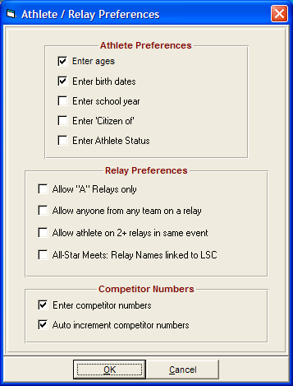

    - Report Preferences:

Can be used to ad more information to header in Meet Program.

    - Seeding Preferences:

At preliminaries the last 3 heats are "circle or barrel' seeded with the each heat having some of the fastest swimmers - the fastest are seeded in the middle with slower swimmers on the outside lanes. The heats are still in slow to fast order.

- Preliminaries – "3' is the number of heats to Circle Seed
- Timed Finals – Standard
- CBA Seed Exhibition athletes Last – Checkmark
- Course Order – YSL for Yards, SYL for Meters

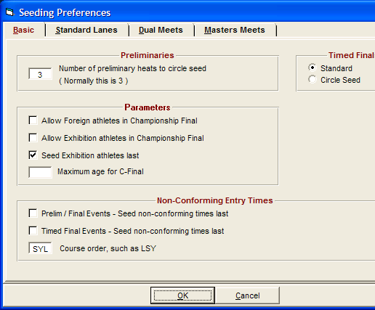

    - Setup / Entry Scoring Preferences

“Scoring/Awards” tab

- Maximum cores per team: leave blank
- Top how any for award labels
Individual: 12 for 6 lane-pool, 16 for 8-lane pool
Relay: 12 for 6 lane-pool, 16 for 8-lane pool

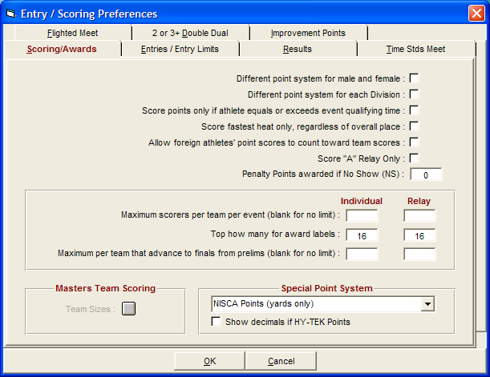

    - Setup / Scoring Set-up

Points are set-up different for a 6 lane versus an 8-lane pool Override the points in the database to match the league's by-laws. Standard scoring (see league web-site for the latest):

 | Place | Individual Event | Relay Event
6 lane Pool | 1 | 16 | 32
 | 2 | 13 | 26
 | 3 | 12 | 24
 | 4 | 11 | 22
 | 5 | 10 | 20
 | 6 | 9 | 18
 | 7 | 7 | 14
 | 8 | 5 | 10
 | 9 | 4 | 8
 | 10 | 3 | 6
 | 11 | 2 | 4
 | 12 | 1 | 2
8 Lane Pool | 1 | 20 | 40
 | 2 | 17 | 34
 | 3 | 16 | 32
 | 4 | 15 | 30
 | 5 | 14 | 28
 | 6 | 13 | 26
 | 7 | 12 | 24
 | 8 | 11 | 22
 | 9 | 9 | 18
 | 10 | 7 | 14
 | 11 | 6 | 12
 | 12 | 5 | 10
 | 13 | 4 | 8
 | 14 | 3 | 6
 | 15 | 2 | 4
 | 16 | 1 | 2

8 lane pool point entry in MM, under scoring setup option

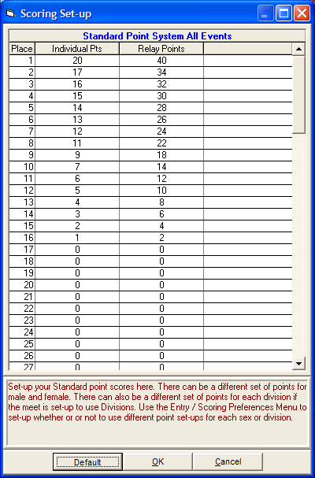
    - EVENTS:

Edit Events: To confirm the meet is setup with preliminary and final events to move into the sessions - you will need to "edit” each event.

Events / select an event then click “Edit”

For individual events:

- Rounds: Prelim / Finals
Marking the Prelims/Finals Rounds will generate a “P" Event and an "F" Event.
- Round 1 - Prelim or Time Finals
  - Number of Lanes: depends prelim pool for that event
  - Assign Lanes: Standard
  - Heat Order: Slow to Fast
  - Score Event: Check-marked (except for the 6&under event)
- Round 2 or 3 - Finals
  - Number of Lanes: # of lanes of Championship pool
  - Number of Final Heats: 2
  - Number of Finals: A-Final, B-Final – Check-marked
  - Order: Slow to Fast

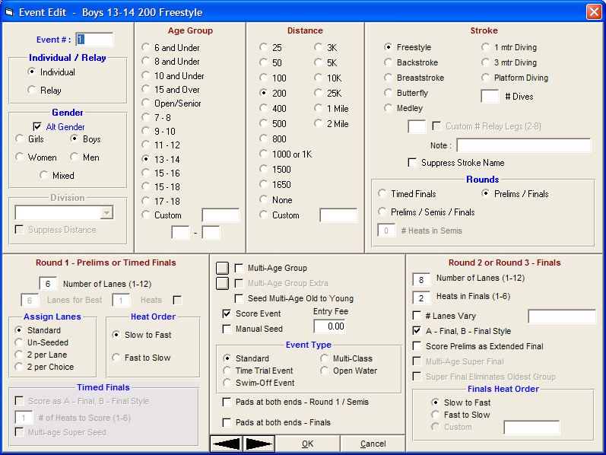

For Relay events:

- Rounds: Timed Finals
- Round 1 - Prelim or Time Finals
- Number of Lanes: depends prelim pool for that event
- Assign Lanes: Standard
- Heat Order: Slow to Fast
- Timed Finals; unchecked
- Score Event: Check-marked
- Manual Seed: optional select box so you can adjust based on time, Relay Name, Team lane assignment, etc per division decision

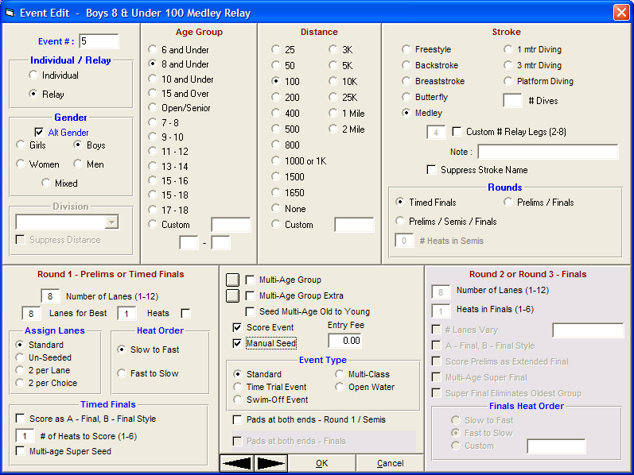

    - Import Records and Standards

In order for interested coaches or swimmers to convert times, place All Star Times and league records in the Meet Program.

    - Create Sessions

Establish a session for each preliminary meet and the Championship Meet. The Preliminary events within the Session are determined by the age groups participating in the Preliminary as scheduled by each Division. If there are 3 preliminaries, you will be creating 4 sessions (Session 1 - Prelim, Session 2 -Prelim, Session 3 - Prelim, Session 4 - Championship). Note: The only way to run a timeline of each meet is to have the events for that meet in a session.

A Session is a schedule of events and rounds that are swum in a specified order. Although setting up a Session is NOT REQUIRED by MEET MANAGER, the advantage in setting up a Session allows you to have the meet timeline in the Meet Program report, create prelim reports and provide prelim results for the championship seeding.

Step 1 - Setup Sessions:

To setup a Session, click on Events from the Main Menu Bar and then click on the Sessions icon. Now click on the Add icon to show the screen below and fill out the information.
Click on Events from the main menu bar. On the toolbox select Sessions. From the options select Add

- Session # - Use Default
- Session Title - enter value
- Start Time: - enter home location start time
- Interval: - recommend 25 seconds, backstroke 45 seconds

Click OK

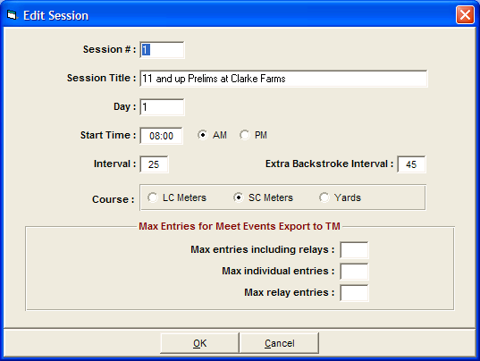

The result will list the following events, note “P” & “F” events:

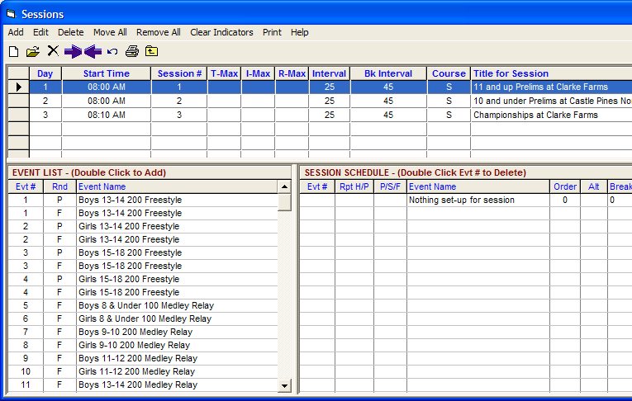

Step 2 – Select Events:

Add Events to session by highlighting those events and double-clicking. All Individual Events should be duplicated with “P” for a Prelim Event, “F“ for Final. Be sure to move the correct events to the sessions, in order. That is, move “P” events to the Preliminary Session, and “F“ events to the Final. Notes relays will only have a “F” event. All “F” events are part of the championship session.

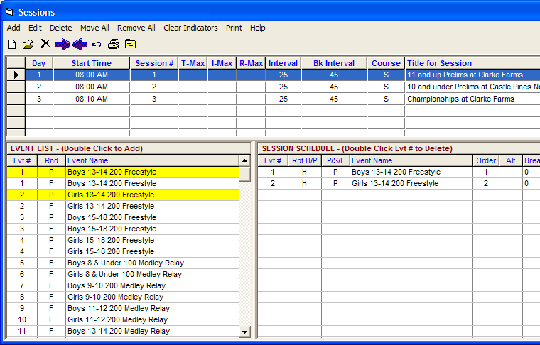

    - Seeding the Preliminary sessions

Receive TM entry files from each team. TM entry files can be built by preliminary, but works better if one file is sent for all age swimmers in one master preliminary file. MM will match events and place swimmers in correct preliminary events. The teams should send entries for relays as placeholders until the names can be sent in another entry file after preliminaries.

Seed the Meet: Click on Seeding from the main menu bar. The seeding options will appear down the left side of the screen and the swim meet events will be displayed on the right. From the options on the left side of the screen, click on Select All. This will highlight all of the events in the swim meet. Then click on Start Seeding. This will seed all of the events.

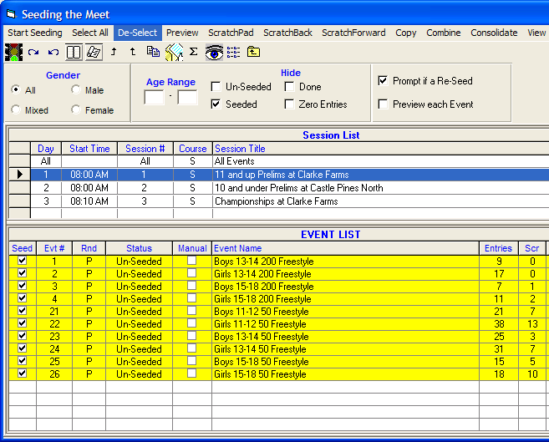

Repeat for the other preliminary sessions.

Do not seed the championship until the preliminary are competed, relay & relay names entry files are imported and championship entry adjustments are received.
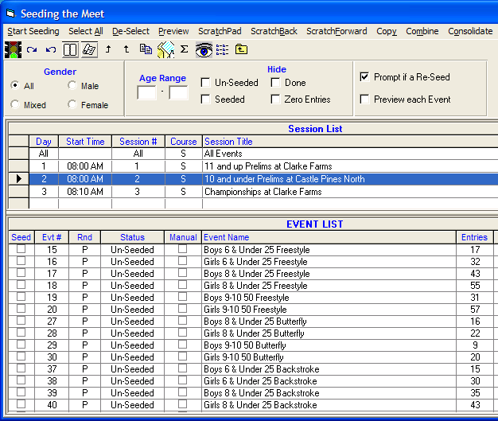

    - Prelim with Different Pool

The Preliminary Host Team will produce a meet program for the preliminary they are running.

Note
The following steps are only necessary if one of your prelims is in a pool with a different course
than the final pool:
- In MM with the final seeded meet…do a File: Save As
- Save the meet with an indicator of the different course (e.g. Y if there are courses in Yard pools)
- In that "Y" database, select Setup: Meet Setup
- In the lower right corner, the course of the championship finals pool should already be selected (e.g. SC Meters)
- Select the course you want to convert this database to: i.e.; Yards
- Click on the "Reconvert Entries" button - this will convert all the entry times in this database to (e.g) Yards

The reason for doing this is so that when the PRELIM programs are printed at each different pool, the entry times, the records, and the All Star times will show for that pool course, appropriately, whether S or Y. Backup both of these databases and attach both to the email to all the MM rep; explaining that they want to use the MM db that has their pools course designation.

    - Print the MM Program (make enough copies for each team):

Be prepared for the Preliminary seeding meeting. Bring computer and printer, and provide a copy per team of the MM program. Each team’s coach will validate the programs and provide any changes to the MM host during the meeting. After making all the corrections, reprint the Meet Program.

It is recommended that you print the labels based on male/female and prelim session. This allows the coaches to keep the deck cards separated for each prelim host team to take from the meeting.

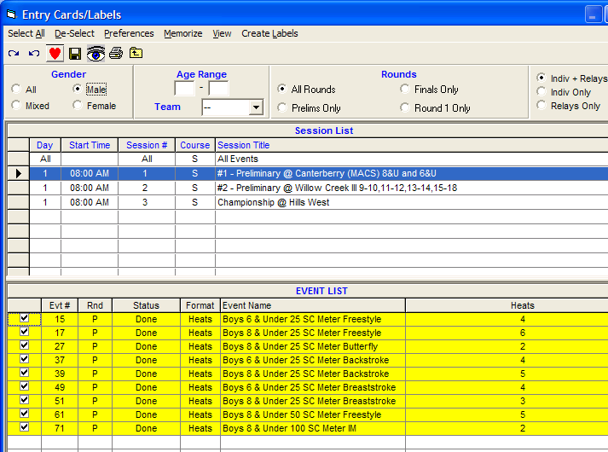

Each coach will signed off on the master meet program; then print deck labels for the Preliminary meets. The coaches will label the deck cards. The Preliminary Host team will take the cards for the Preliminary meet.

    - Send MM Back-up Data base to Preliminary Host Teams and each division team:

The Preliminary Host team will produce a meet program for the preliminary they are running.

Note the MM Meet program will have discrepancies in the Time Standards versus the seed times.

The seed times will be reported in the measurement of the Championship Host pool, while the Time Standards in the measurement of the Preliminary Pool.

  - Scoring the Preliminary Meet:

    - Event Completion:

All swimmers times or status (NS or Scratch) need to be fully entered. Once entered, score the event - the event should turn to "DONE" status (not scored) - as the score will be determined in the Championship meet. Make sure that all events are "DONE" before completing and backing up the meet.

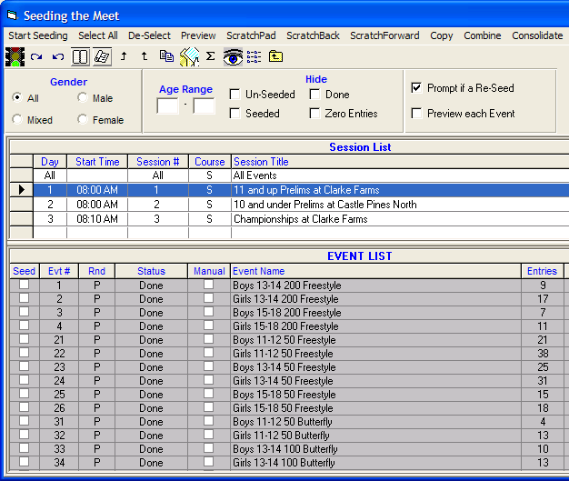

    - "Swim Throughs"

Swimmers must swim prelims to advance to championships.

At times the Division may rule to allow Swim throughs. Swim throughs are the approach that allows swimmers in a preliminary meet to move forward to the Finals if the number of simmers equals the number of the Championship 1st heat lanes. That is, if Finals are in an 8-lane pooI and there are 8 or fewer swimmers in the preliminary - all are eligible for Championships. Enter the seedtime as the results in the preliminary heat. If the swimmer does not have a seedtime, insert a time that is noticeably different. Set the event to "DONE."

    - Swim-Offs (during Prelims)

In Prelims, only the first 8 swimmers (in an 8-lane Championship pool) or the first 6 swimmers (in a 6-lane Championship pool) move on to the Finals. The next 8 swimmers are in the consolation heat. If during Prelims there is a tie for the last spot (8th or 16th), then a Swim-Off is required. The software should indicate that a swim-off is required in the results printout.

The winner of the Swim-Off retains the last spot, the loser is moved (using Judges Decision) to the next position. The times from the swim-off need to be recorded in a separate swim-off event.

To input Swim-Off times into the MM database file:
- From Meet Manager database File, Click “Run", "Events", then Highlight Event that required Swim-off – (for this demo, assume it was Event 20)
- Click "Add".
- In the New Window:
- Name new event "120" (add 100 to original event #)
- "Rounds" - Click Timed Finals
- "Assign Lanes" - Click Unseeded
- Unclick Score Event
- "Event Type" - choose Swim-off
- Close Window;
- From "Run" menu, "adjust athletes" to add swimmers, input times from Swim-Off in the new event (Event 120).
- Use "Judges Decision" to place swimmers in the original event (Event 20).

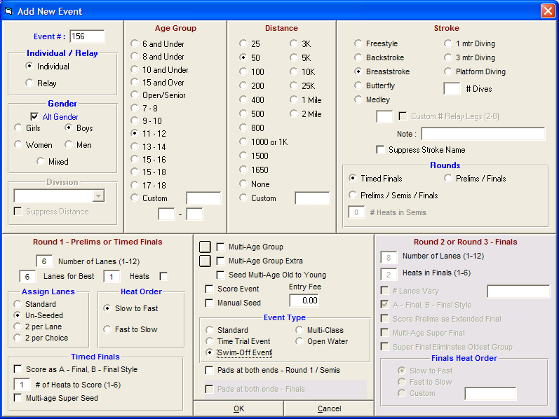

After creating the event
- Select Sessions
- Highlight the session for the prelim where the swim-off is required
- Double click the “new” event, moving it to the Session

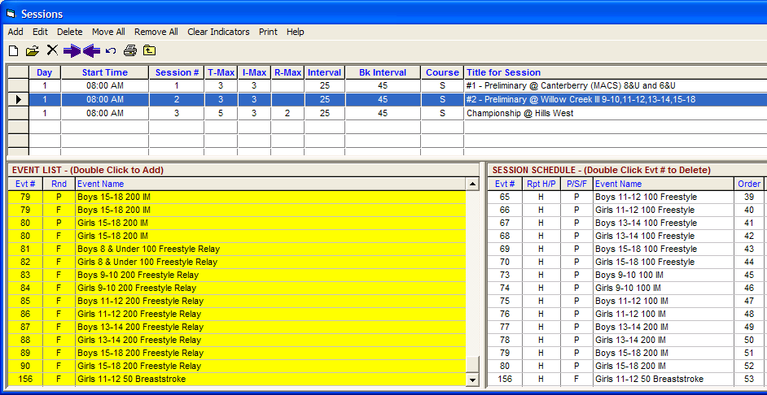

Go to Run Meet
- Select Adjust
- Add Swimmers
- Enter the times

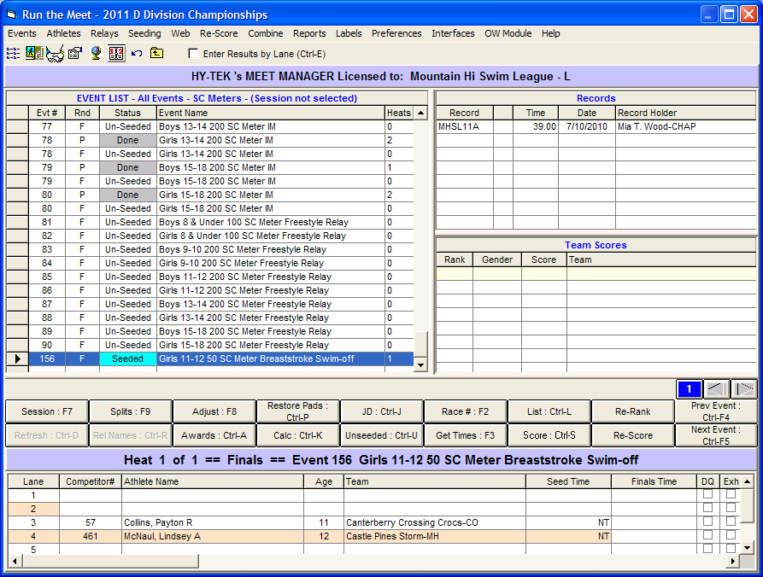

Go to original event
- Select Judges Decision “JD” to override the places

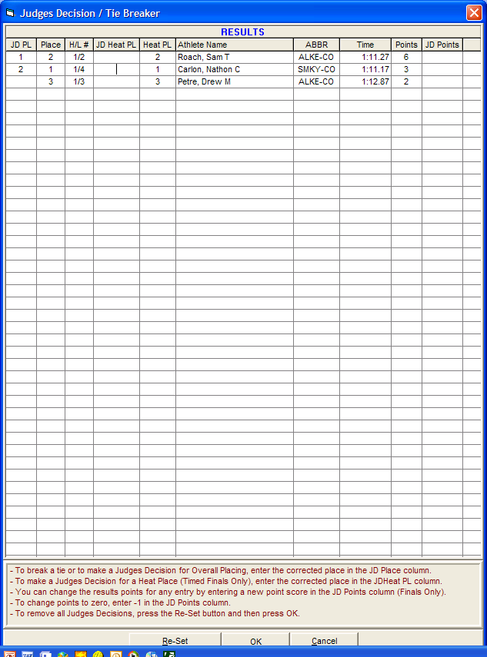

    - Closing Prelim

At the end of each preliminary meet the Preliminary Host needs to
- print results for each team (PDF file)
- send MM Back-up to each team
- send MM export “results for same meet merge” to championship host

The prelim timed deck cads are placed in Team's bag that travels that the championship team gathers for reuse during championships. The 1-12, and 1-16 cards are kept together with the results sheet, and provided to the Championship Host team.

The Championship Host will re-Iabel the cards for Championships or use new deck cards.

  - Seeding the Championship Meet:

    - Input files for Master Championship Database:

The MM host will receive the:
- relay TM files from each team at a time designated after preliminaries
- prelim results files (2 or 3)

    - Championship Relays:

The Teams can declare up to three relay teams (A, B, C) per relay event and can update per agreed to division standards.

Import the relay entries (with names) into your master Championship database - The relay entries will load automatically from TM export files to the Championship session. In order not to overlay the individual entries, make sure to select “Import Relay entries only”.

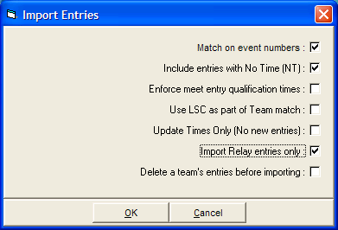

    - Preliminary Results

Make sure you have the MM preliminary databases. Create separate file folders as you do with each meet under "swim meets/year/meet name”

You may want to review that all entries are "done" in the Preliminary databases. If not, all the results will not export. You can also use the export provided by the Preliminary Host or create your own. (see Scoring the Preliminary Meet above)

Compile all the results file and Import the meet results file for each preliminary Click on File / Imports / Merge Results (Win-MM to Win-MM)

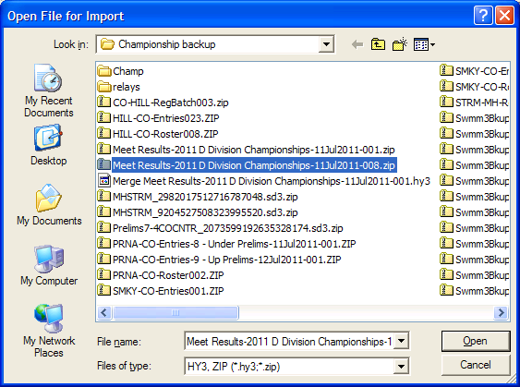

    - Championship Seeding

Go to Seed the Events. Select the Championship session, which should have 90 events all marked as Final. Select ALL and seed.

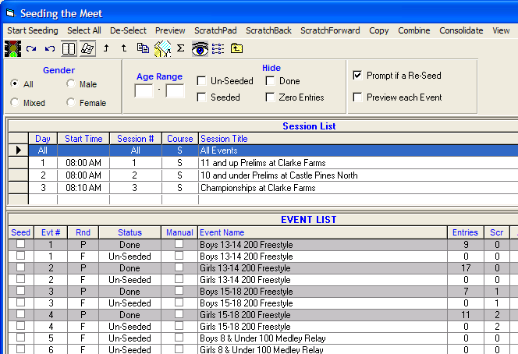

After seeding the “F” event will show seeded:

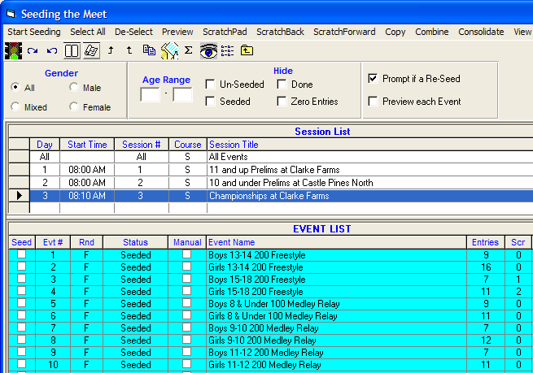

    - Adjusting the Relays

All A relays should swim together. All B& C relays should swim together regardless of seedtime. If there are less than 6 relays or 8 relays in the A heat you may move some team up based on time. This may require manual seeding / adjusting the relay events.

Some Divisions may elect to place Relay teams in a designated Lane. This is determined at the Preliminary meeting. Some Divisions may want determine the seed/lane placement by time.

Once adjusting the relays per the Divisions intentions, then you are ready to create the program.

Under “Run” Meet select the each relay event one at a time, select “adjust”, then move or drag the “A” relays into the appropriate lane under the last heat. Example here is all “A” teams are assigned a lane based on pre-determined lane assignment.

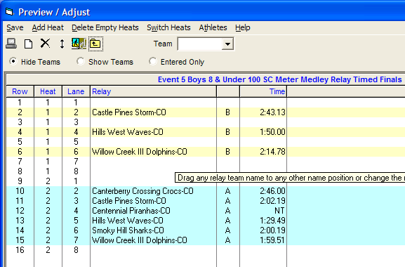

Then move the “B” and “C” relays as appropriate.

Note if you re-seed the meet the relay lane assignments will change and require you to re-adjust.

    - Championship Programs

A good format is to check: Triple Column, Records, Time Standards, Entry Times, Qualifying Alternates, Relay Athlete Names (4) (event comments - if you have them).

Note: The prelim seed times noted in the Meet Program will reflect the type of pool the prelim was run. For example, if the prelim was at a yards pool, but the Championships is at a meter pool, the time noted in the MM program will be in yards. The alternate is also true: If prelim is at a meter pool, Championships is at: a yard pool, the times will show as meters (S). The Time Standards (All Star Times) and the League Records will be shown in the time of the Championship Pool.

You will need to note in the program the conversion factor. Meter times are designated with the letter "S".

Yards to Meters: convert time to seconds, multiply by 1.11 Meters to Yards: convert time to seconds, divide time by 1.11.

  - Scoring Results

During the meet it is recommended you provide scoring and results for posting after 10-15 events.

It is good practice to have the printed results verified against the original cards before posting the results. This check process often finds errors that can slip past the entry team.

Note for individual event positions there is a consolation heat and finals heat:
- Finals heat: 1-8 will score the top 8 places (or 1-6 will score the top 6 places)
- Consolidation Heat: 9-16 will score the next 8 places, 9-16 (or 7-12)

Thus a swimmer in place 9 with a better time than swimmer in place 8 will not score or place higher.

For relays, all teams are score based on actual finish regardless of heat or position.

    - Scratching Swimmer in heat #1 (place 9-16)

If a swimmer in the first heat (which cover places 9-16) scratches, remove them from the event then drag the first alternative (see meet program) into that position. You can see the alternatives by selecting the “Alternates only” button.

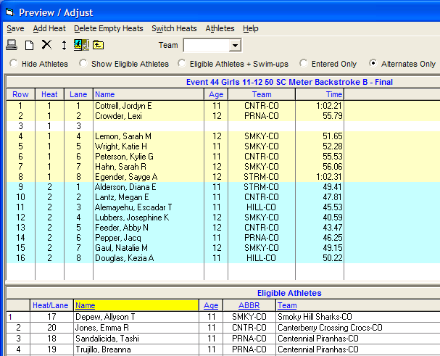

    - Scratching Swimmer in heat #2 (place 1-8)

If a swimmer in the second heat (which cover places 1-8) scratches, remove them from the event then drag the fastest swimmer from heat #1 into the position in heat #2. The move the first alternative (see meet program) into the empty position in heat #1. You can see the alternatives by selecting the “Alternates only” button.

It is recommended you update a Scoring table Meet Program and sync with the clerk-of-course so everyone is on the same page and the swimmer swims in the CORRECT heat.

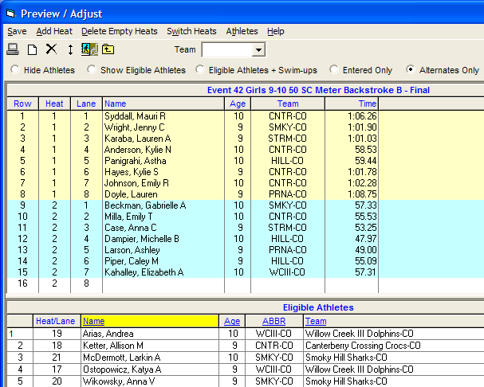

    - Award Labels:

Check with division standards on award ribbons and medals, and the ribbon table for coordination of printing labels and results.

  - Closing Meet

    - Create a Result File for Team Manager

After completion of the meet you will need to send two files to each team “Team Manager - TM”. The results file is used to import the meet into each team’s TM.

    - Print Score Results

Print score by Event Age, Male/Female and Overall score. The scores will be used to award the age group trophies and the overall championship Trophy.

Age Group Score
Event Age report (by age group); Select male, female and combined

Overall Score Reports
No Age criteria; Select male, female and combined

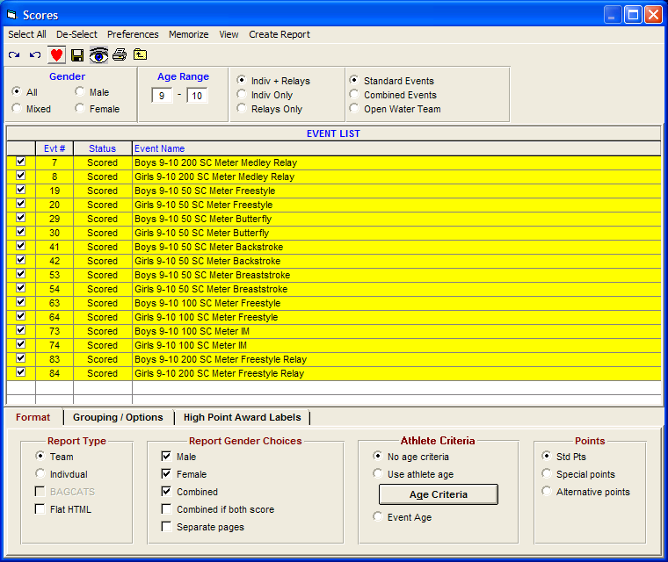

- MHSL ALLSTAR MEET PREP & TIMELINE

Note: often the Host team engages another team to setup the meet db. The Host meet manager should ensure there is agreement on the responsibilities for setting up the meet and communicating the timeline to all teams in the league.

  - Allstar Prep
    - Host MM Responsibilities and Guidelines

- Allstar Host Team prepares MM Database prior to the July seeding meeting, date set by the MHSL board. (See: guidelines below). Allstar Host MM obtains most current by-laws from web or Parent Rep.
- Allstar Host team identifies all MM and TM contacts for each team within the Division. Create 3 distribution lists for email communications throughout the time-frame (Parent reps, Coachs & MM/TM – for entries).
- Allstar Host Team imports each team's entries and verifies the entries are validated (ie correct age, proof of Allstar time via exception report).
- Allstar Host Team emails the MM database to all teams and prepares the Meet Program from MM.
- The Allstar Host Team will validate that all Award Ribbons are provided based on the by-laws.
- After the Meet is over - the Allstar Host team will print results and scores for each team, provide the MM Database back-up and TM export. Next, email the complete and scored database to all Division team's MM contacts and the Board's Computer representative. (Follow the guidelines for the Dual meet in the previous section – Close out the meet)

    - Host Team Responsibilities and Guidelines

- Designate the area for all teams participating at the host site and appropriately marking
- Establish the work schedule for volunteers; requirements for volunteers should be communicated at the All-Star meeting.
- Print Meet Programs for each participating teams (# based on amount agreed during Allstar meeting). Additionally, the host team may put the programs on sale.
- Designate areas for the computer, card marking and awards
- Ensure each team has a container (bag or box) for medals and ribbons

    - Allstar Meet League Decisions
Prior to setting the Allstar timeline, at a minimum the following questions need to be answer, this is usually previously voted on by the Parent Reps and sent out to the league by the host Team:

  - Establish Allstar Meeting location, date and time
  - Confirm location (lanes, yards/meters and location)
  - Confirm timeline
  - Confirm contacts for all teams (Parent Rep, Coach & Meet Manager/Team Manager)

    - Running Allstar Meet Decisions

- Scratch meeting - At least 30 minutes before the start of the meet, computer personnel, coaches and the clerk of course should meet to discuss scratches and changes.

- Officials meeting - At least 30 minutes before the start of the meet the hosting team should run the officials meeting. All instructions, rules and other information defined by the hosting team should be disseminated to the stroke judges, timers and runners.

- Scoring table:
  - Card markers – The official time is the middle time of the three times listed (if there is not three times, the average of the two times should be used) the middle time should be circled and cards placed in order by times. The place should be written in black pen and circled. The cards are placed in the respective team bag along with any medals won by that team.
  - Computer personnel – Responsible for the input of times and producing result sheets and labels for ribbons. Result sheets should be posted as soon as possible following the completion of each event. A back up of the meet results should be emailed to the Meet Manager person for each team as well as the League Computer Chairperson
  - Ribbon Table – Place labels on ribbons/medals and separate (preferably in a box or bag) marked for each team. Post all result sheets in designated area

  - Communication
    - Allstar Contacts

It is recommended the owner of the meet setup and championship host meet manager (if different) compile these names for the entire group:

Team | Contact names | Contacts email
Team #1 | PR -  MM -  Coach -
Team #2 | PR -  MM -  Coach -
Team #3 | PR -  MM -  Coach -
Team #4 | PR -  MM -  Coach -
Team #4 | PR -  MM -  Coach -
Team #xx (thru 24) | PR -  MM -  Coach -

    - Allstar Suggested Timeline
Allstar suggested Timeline
Week of Allstars
- Sunday afternoon, Entries: All Allstar entries submitted to Host MM (or setup MM). MM completes seeding. Any corrections (entries that fail exception report) are due back by Monday noon.
- Monday noon, Entry correction: Coach must submit corrections and Allstar time proof for entries that fail exception report.
- Monday afternoon, Meet Program: Prior to the seeding meeting, the meet manager program is sent to each team parent rep and coach.
- Tuesday evening, Seeding Meeting: Sign-off on seeding of the Allstar entries. During the meeting, the Coaches review, make adjustments and sign-off on the swim teams’ entries. Once all corrections are made labels are printed then each team coach attaches entry labels to deck cards. Note each team should bring labels and decks for the prelims. Once all labels are completed, the Host team takes the deck entry cards and updated MM db. Each coach should plan on completing:
  - Documentation for any swimmer whose time does not show up as ASxx on the meet program
  - Labels
  - Cards
  - Payment—each team should bring a single check made out to “Mountain Hi Swim League” to cover the entries.

Reminder—coaches and qualifying swimmers who will not compete may still purchase the Tee shirt for the same price.

  - Sign-off: It is recommended that each coach sign-off on a single Meet Program, initialing each page and signing the final page.
A sign-off form is also an option but you need to have a “master” meet program initialed by each coach.

- Friday, Final Meet Program: MM file and meet program is sent to each teams’ MM and Parent rep.
- Saturday, Meet: Run Allstar Meet
- Saturday, Finalize Meet: Print results: by team, totals by age/gender. Send TM export results file, MM backup file, Score, and Result report (by team and all teams) to each teams, all Division VP and League web-site contact.

    - Allstar Suggested Signup and sign-off form

Mountain Hi Swim League All Stars Heating Meeting 20xx
Team | Number Swimmers | Amount Paid | Team Signature  I accept the meet entries on the meet program | League Signature  All issues with this team are resolved | Issues (unresolved)  Event—Name—Problem
#1

#2

#3

#4

#5

#6

#7

#8

#9

#10

#11

#12

#13

#14

#15

#16

#17

#18

#19

#20

#21

#22

#23

#24

    - Allstar Sample Communication

Following is a Sample communication for all teams sent by Meet Manager database setup owner.

=============
Hi All!

My name is xxxx xxxxx, and I will be the meet manager for the 2011 All Stars meet at Castle Rock on July xx. The following is information and a timeline for the All Stars meet:

1. Entries are due on Sunday, July xx, 6:00 pm. Please send them to me at email address. Entries include up to 3 qualified events per swimmers, no 6&under and no relays.

2. I will send out a preliminary meet program to each team by Monday, July xx, 6:00 pm.

3. The All Stars heating meeting will be Tuesday, July xx, 7:00 pm, at the xxxxx. At this meeting we will make any necessary changes, reseed the meet, print labels, and put the labels on the cards. Be sure to bring the following:
a. Documentation for any swimmer whose time does not show up as AS11 on the meet program.
b. Labels
c. Cards
d. Payment—each team should bring a single check made out to “Mountain Hi Swim League” to cover the entries. Reminder—coaches and qualifying swimmers who will not compete may still purchase the Tee shirt for the same price.

4. Approval--At the heating meeting coaches need to sign the meet program indicating that they accept the program. A league representative will also sign to indicate that each team’s entries are approved (no issues with ASxx times, etc.)

5. At the All Stars meet we will run the Dolphin system. This means that the times will automatically be sent to the computer without the need for circling times on the cards. Timers will record one time on the card for backup purposes. With the Dolphin system it is extremely important that each swimmer is in the correct lane and heat because the time goes with the heat/lane and not with the swimmer.

If you have any questions, please let me know. Email communication works well for me.
=============

  - Allstar Meet Set-Up Instructions (differences for Allstars only)
    - Entry requirements:
- Each swimmer can enter a maximum of 3 individual events; there are no relays at All-Stars
- Swimmers must meet the League requirements for having attended 10 practices and have swum in at least 2 meets during the current season.
- Their name must be on the final roster and their insurance dues paid.
- Each swimmer must swim in their respective age group. No exhibition swimming is allowed.
- Each team must bring a hardcopy of the team entries to the heating meeting.
- Each coach will be asked to sign off on the Master program, verifying the team’s entries are correct. If there are any outstanding issues, they must be resolved at the heating meeting.
- A swimmer in the Mountain Hi Swim League is eligible to swim in the Allstar meet by beating the Allstar time of placing first in the championship event.

    - Meet Set-up Prep

Remind teams when setting up the meet in team unify or team manager to exclude relays and 6&under events. This will ensure 6&under swimmers signup for the 8&under events (if they qualified)

The Allstar meet is a setup as a single session. Ensure the
  - time standard is selected
  - max events is 3
  - no relays

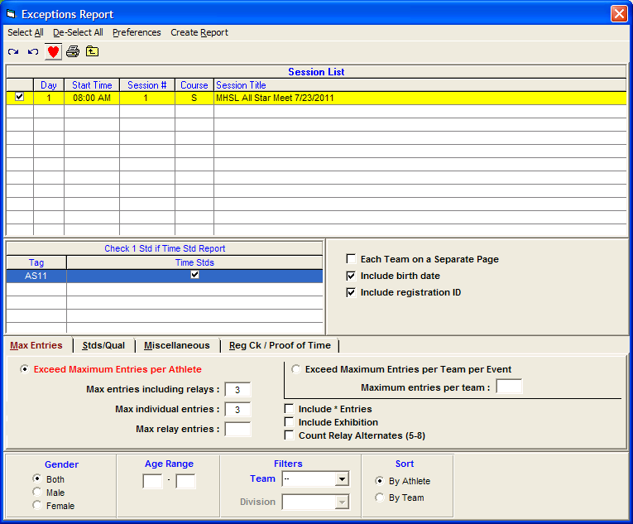

Seeding the event, select all individual events (no relays).

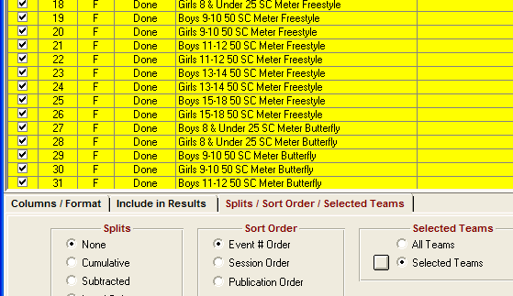

    - Closing the Meet

When running the results report, select your specific team:

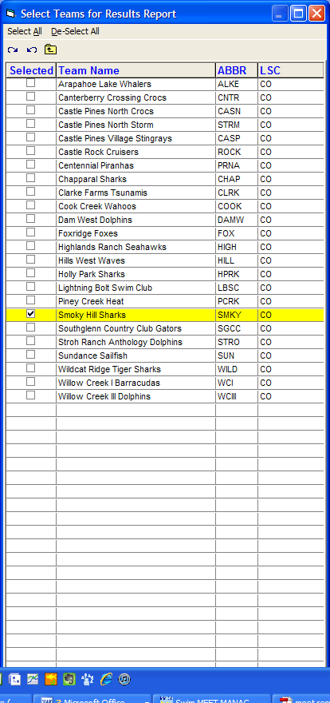

END OF HELP TOPICS

