How to Read a Heat Sheet:
A heat sheet is your guide to know when your child is going to swim. These will be posted at every meet. Here is a brief description of how to use one:
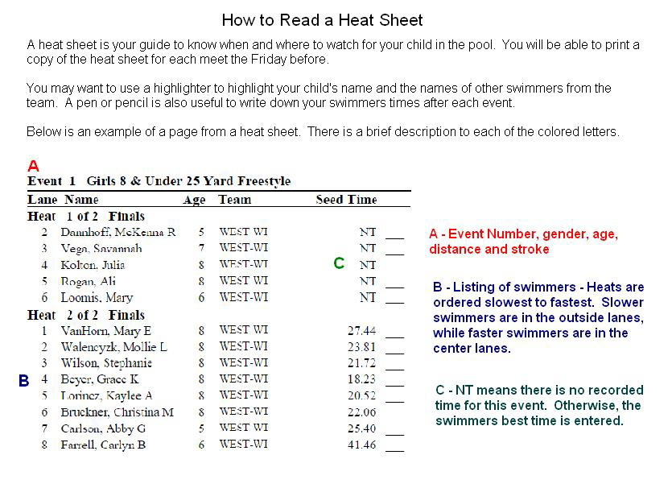
25 yards= 1 Length
50 Yards=2 Lengths
100 Yards=4 Lengths

If it is a 100 Yard Relay- each swimmer swims 1 length

If it is a 200 Relay, each swimmer swims 2 lengths.
If there were an “x” in front of their time that would mean they are in an exhibition race. We can only have 1 scoring heat in each event, which means the other heats are exhibitions. The times still count and your child will still get ribbons

RELAYS! This is an example of what a relay will look like in a heat sheet.
The order for a Medley Relay is Backstroke, Breaststroke, Butterfly, Freestyle.

This would mean the order of this relay would be:
Anna Menti (Backstroke)
Tess Johnson (Breaststroke)
Abigail Cady (Butterfly)
Katie Hawkins (Freestyle)

#1 Girls 8 & Under 100 Yard Medley Relay
1 STC
1. Menti, Anna 6 2. Johnson, Tess 8
3. Cady, Abigail 7 4. Hawkins, Katie 8
What are those swimmers writing on their arms?

In order for everyone to remember, some swimmers choose to write their events on their arms, legs, etc. Here is the way that most swimmers do it:

Event Heat Lane Stroke
# # #

Example:

#19 H1 L3 Free
#29 H2 L2 Back

