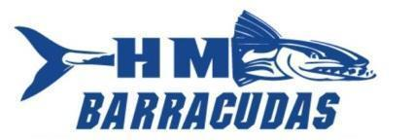
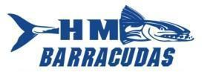
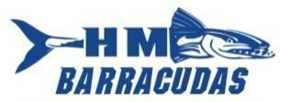
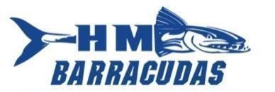
2024 Hollin Meadows Barracudas Swim Team Sponsorship Form
As we plan for the 2024 Hollin Meadows Summer Swim Team season we are looking to our friendly neighborhood businesses, friends, families and community members to help with yearly team expenses and activities. With over 140 swimmers on our team, 300 families as members of Hollin Meadows Swim and Tennis Club and thousands of members of the NVSL, the advertising exposure and recognition you will receive is invaluable!

Your support of the Barracudas is greatly appreciated! www.hmbarracudas.com
Hollin Meadows Swim & Tennis Club is located at 2500 Woodlawn Trail Alex., VA 22306

FRIEND OF THE BARRACUDAS $50 - $249
Your name and/or logo* will appear on our team’s website and you will be mentioned by the announcer at our home meets.
BARRACUDA BELIEVER $250
Your name and/or logo* will appear on our team’s website, you will be mentioned by the announcer at our home meets and 1 yard sign with your logo & contact information placed around the pool at all home swim meets visible to all attendees.
ALL STAR BARRACUDA $500
All sponsorship items of the Barracuda Believer level, plus: Your name and/or logo* will appear on the team t-shirt and team banner that is displayed at all meets
TRUE BLUE BARRACUDA $1000
All sponsorship items of the All Star Barracuda level, plus 10 yard signs with your logo & contact information placed around the neighborhood for the summer season. Verbal reading of commercial advertisement of your choosing at all home meets, if desired

SPONSORSHIP INFORMATION
**Submission Deadline – May 22, 2024**
Organization/Company/Family Name you want to appear on items listed above: _________________________________________________________________
Contact Name:______________________Telephone:_______________________
Address:___________________________________________________________
Email: ________________________Website address: _______________________
Sponsorship level: Friend* Believer* All Star* True Blue*
Sponsor Amount: $_________________
- Make check payable to: Hollin Meadows Swim Team
- Return this form with payment to: Lauren Iannitto, 7616 Range Rd, Alexandria, VA 22306
- *Send your high-resolution logo to Lfalkenhan@gmail.com in two formats (a vector image .eps or .ai and .jpg)

