Hi everyone – a reminder that all jobs are open for signups tomorrow at 8:00 a.m.
As far as family responsibilities – Only one of the below job groupings will apply to each family. If you have multiple swimmers in different groups only the group with the most job requirements applies:
A) Mini Marlin Only (if you only have mini swimmers):
2 job (any meet, social, or invitational)
B) 15-18's Swimmer with no "Marlin" swimmers:
3 jobs (any combo of meet, social, or invitational)
1 OMPA job
C) Marlins (Ages 6 & under thru 14):
6 jobs (any combo of meet, social, or invitational)
1 OMPA job
All job descriptions can be found here: https://www.teamunify.com/team/recompacccm/page/meets--jobs/jobs--descriptions

Online Job Sign up Directions

1. Go to www.cccmarlins.org, log in and click directly onto the events menu name. This will open the list of meets and social events.
2. When you find a date/event you would like to work, click on the “Job Sign Up” button.
3. For each available job you choose to sign up for, click on an empty check box to add your name and then click on the green signup button on the left.
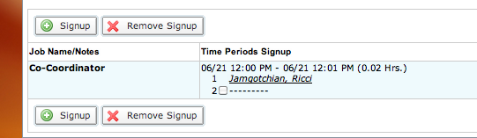
After you click “Signup” a dialog box will appear where you can enter optional contact info, or specify a spouse’s name who is doing the job, or if you will have a substitute that will perform the job.
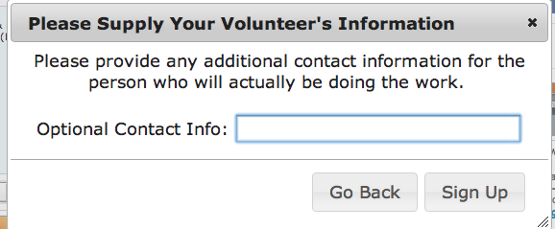

5. After you have completed your sign-ups, you can print a list of your jobs by doing the following:
- Click on Events Tab
- Click on Reports Sub Tab
- Click on Job Signup Report for My Account
- Enter in date range for job report (choose ending date of Aug 31)
- Click on Export

If you have any questions please contact Stuart Schonfeld at jobs@cccmarilns.org

