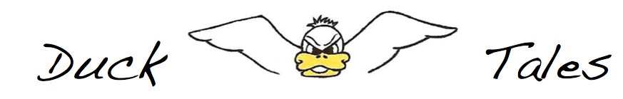April/May 2018
Important Dates
April 7th Winter Clinic Session 2 Begins
April 11th Ice Cream Social @ CPAC 6-8pm
April 28th Suit Fitting @ CPAC 3-6pm
May 1st Last Day to Submit Sponsors for Team Shirt
May 3rd Suit Fitting @ CPAC 4-7pm
May 5th Early Bird Registration for Summer Ends
May 19th Winter Clinic Session 2 Ends
Winter Clinic – Session 2
The second session of Winter Clinic will be April 7th through May 19th from 4:00-5:00pm at CPAC. Registration is live on the team site and forms can be found on the website under documents, or by following this link. The cost of Session 2 is $40.
Suit Fittings
Suit Fittings are scheduled for April 28th from 3-6pm and May 3rd from 4-7pm at Central Park Aquatic Center (CPAC) inside the store located in the main lobby.
Sponsors
Now is the time to start drumming up support for the coming season. Sponsorships are an important source of revenue for the Ducks each year. Money from sponsors helps to offset the cost of t-shirts and other supplies that keep the swim team afloat. Please keep the team in mind in your contacts with local businesses. If sponsors want to be included on the team shirt, they must submit their sponsorship forms by May 1st.
Sponsorship forms for 2018 can be found on the team website under documents, or by following this link.
Early Bird Registration Ends May 7th
The early bird gets the worm or, in our case, cheaper registration cost for summer swim team! Early bird registration ends on May 5th so register now! Early bird registration is $160. On May 6th, the cost will increase to $180. The cost for Ducklings is $175. Registration forms will be available on the website. When you register, be sure to verify your swimmers’ sizes for shirts and suits.
Ice Cream Social
I Scream, you scream, we all scream for ICE CREAM!!! Don’t miss the Ice Cream Social on April 11th from 6-8p at Central Park Aquatic Center.
Towels
This year we are offering team towels. The cost will be $30 per swimmer (without their name on the towel) or $35 per swimmer (personalized with their name on it). Order forms are available on the team website; as well as, at Winter Clinic. Payment must accompany the order - please make checks payable to BLST or include cash. Order forms and payment should be mailed to Claire Loerch, 10829 Monocacy Way, Manassas, VA 20112. The deadline for towel orders are May 1st.

