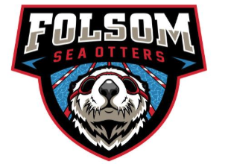Folsom Sea Otters
Sponsorship Deck
ABOUT FSO
The Folsom Sea Otters swim team, established in 1985, is a non-profit organization dedicated to recreational and competitive swimming. Operated by a committed group of parents, our team proudly comprises approximately 350 to 385 young swimmers, ages 4 to 18. Our training sessions are conducted at the esteemed Folsom Aquatic Center. As active participants in the Suburban Swim League, we join seven other teams, collectively representing around 1,800 swimmers. Each season, from April to July, unfolds with a series of competitive events, beginning with a Time Trials meet and seven dual meets. The season culminates in a thrilling three-day championship meet, where all eight teams showcase their talents. The Folsom Sea Otters Swim Team is guided by a philosophy emphasizing a positive, team-oriented learning environment. Every swimmer is encouraged to reach their full potential by honing essential skills while enjoying the journey. Our dedicated coaching staff, Board of Directors, and parents work harmoniously to deliver a high-quality program that balances recreational and competitive elements, all while upholding the principles of good sportsmanship.
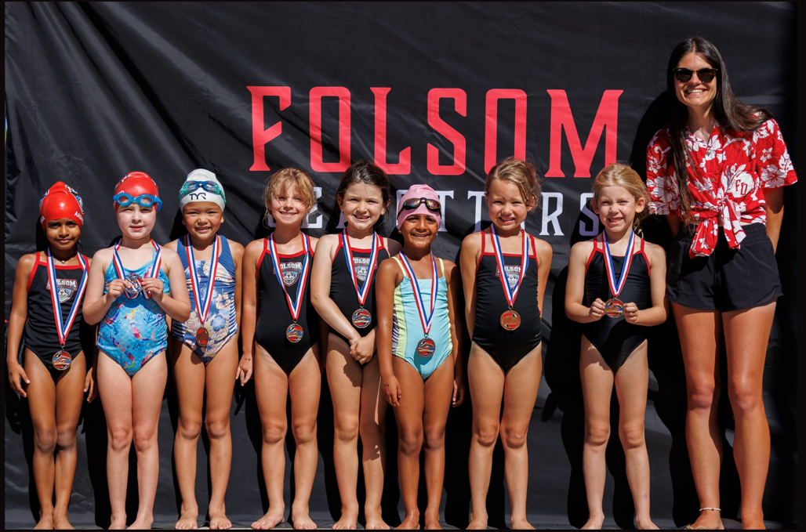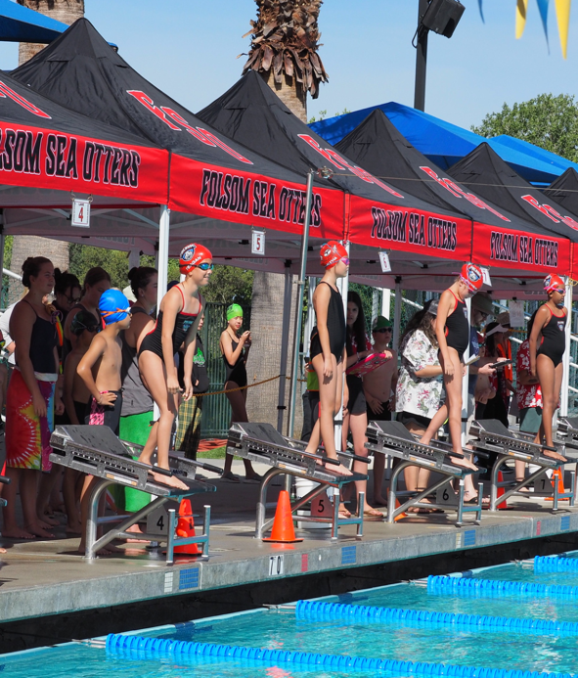
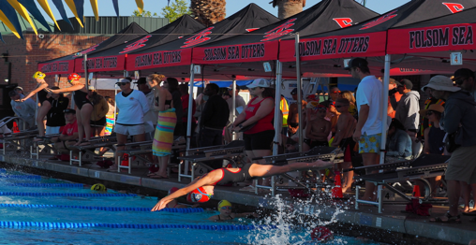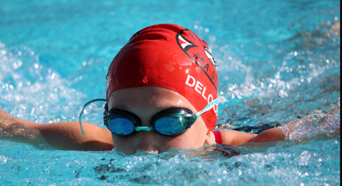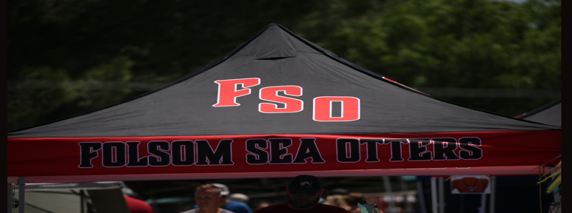

WHY SPONSER?
Partnering with the Folsom Sea Otters is not merely an investment in your local community—it is a strategic business opportunity. With over 1,500 swimmers frequenting the Folsom Aquatic Center, your logo will be prominently displayed, capturing the attention of thousands of parents and supporters. This partnership allows you to engage with a dedicated audience and significantly enhance your company's visibility. Your support will directly contribute to swimmer scholarships, advanced training for coaches, and essential equipment upgrades, among other vital needs. Most importantly, your involvement will empower local youth, equipping them with the skills, confidence, and ability to embrace a healthy and active lifestyle.
Sponsor Levels & Benefits
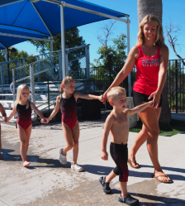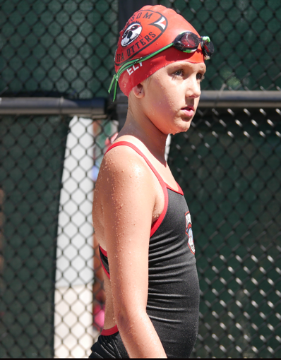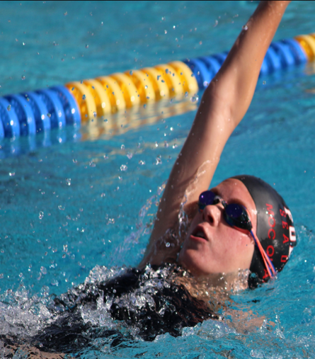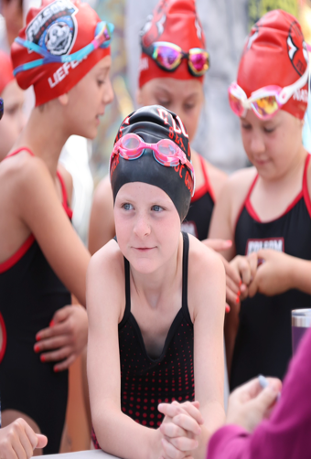

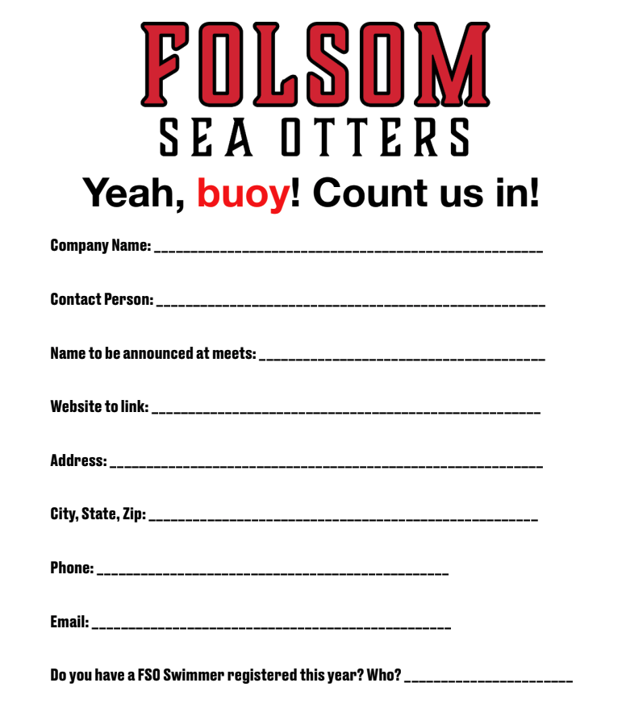Please submit this form with a check payable to Folsom Sea Otters
Mailing Address: PO BOX 879, Folsom, CA 95763
Logos can be emailed to: Info@FolsomSeaOtters.com

