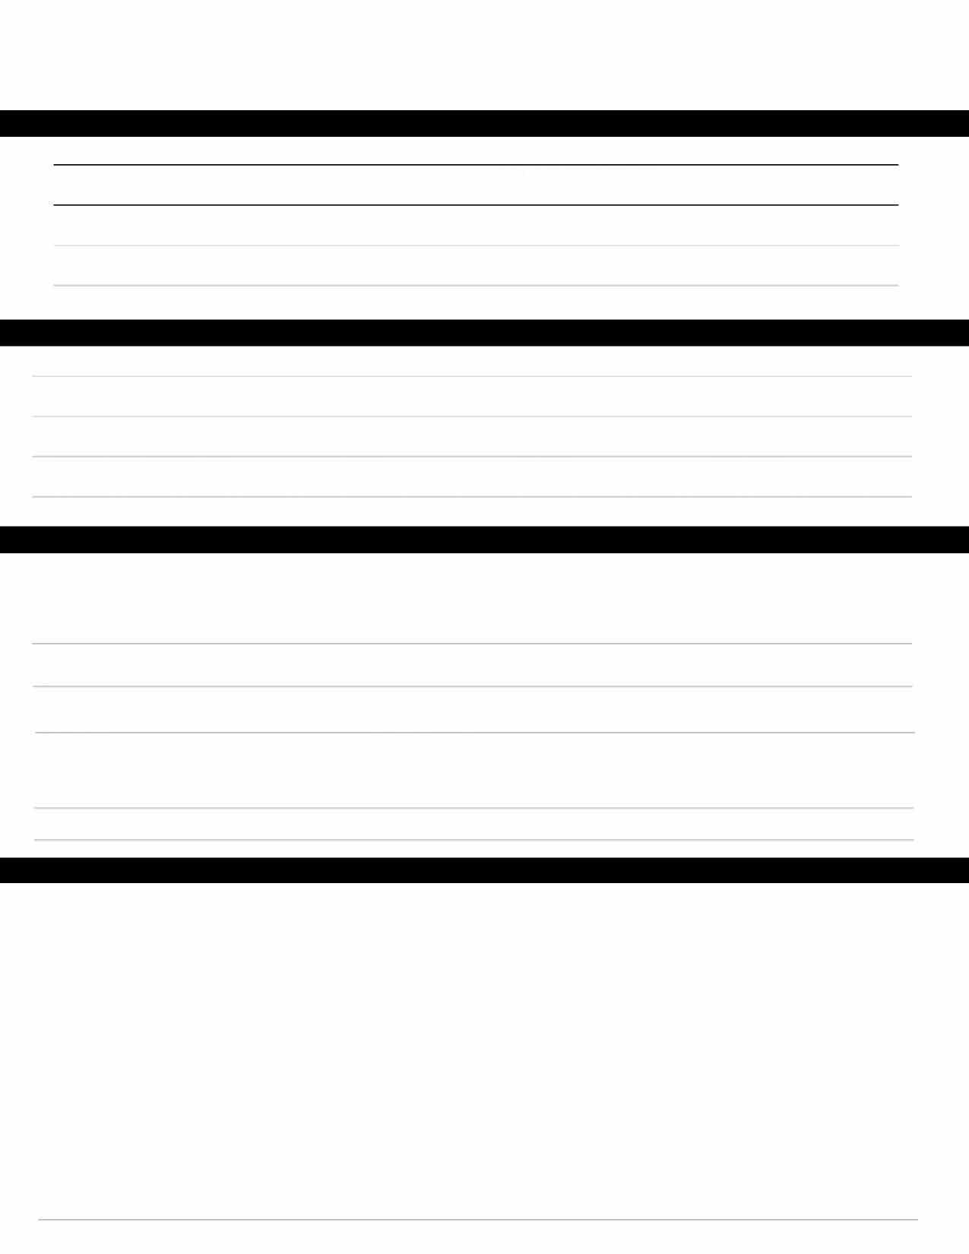
PLEASANTON VALLEY SWIM CLUB FALL SWIM CAMP
5014 GOLDEN ROAD PLEASANTON, CA 94566

SWIMMER INFORMATION:
1.
Last name | First Name | Date of Birth(1/11/1111) | Age
Last name | First Name | Date of Birth(1/11/1111) | Age
Last name | First Name | Date of Birth(1/11/1111) | Age
Last name | First Name | Date of Birth(1/11/1111) | Age

2.

3.

4.

CONTACT INFORMATION:

Address | City | Zip
Home Phone | Email
Father's Name (First & Last) | Home Phone | Cell Phone | Work Phone
Mother's Name (First & Last) | Home Phone | Cell Phone | Work Phone

EMERGENCY CONTACT INFORMATION:

Name Relationship Phone Cell Phone
Insurance & Medical Information

Insurance Company | Member ID | Insurance Phone Number
Physician's Name | Physicians Phone #
Dentist Name | Dentist Phone #

Please list any and all conditions, illnesses or information, which the coach should be aware of (If none, please write "None")

PARENT AUTHORIZATION FOR PARTICIPATION AND RELEASE
I agree to the Dolphin Camps Safety Rules, healthy safety checks for my child(ren) and understand the importance of COVID- 19 Warning Signs. (Initial Here):
I, the undersigned parent or guardian of the above-referenced child(ren) hereby give my authorization and approval for his/her/their participation in any and all activities of the PVC Fall Swim Camp. I hereby absolve and release Pleasanton Valley Club
(PVC), and all persons associated with the Club, of any responsibility or liability for any accident or injury of my child(ren), as a result of his/ her/their participation in said activities

I acknowledge the contagious nature of COVID-19 and voluntarily assume the risk that my family, including child(ren), and I may be exposed to or infected by COVID-19 at the pool and that such exposure or infection may result in serious illness. I voluntarily agree to assume all of the foregoing risks and accept sole responsibility for any injury to my entire family, my child(ren), and myself (including, but not limited to, personal injury, disability, and death), illness, damage, loss, claim, liability, or expense, of any kind, that I, my family, and my child(ren) may experience or incur in connection with my child(ren)'s attendance at PVC or participation for PVC Dolphins. On my behalf, and on behalf of my children, I hereby release, covenant not to sue, discharge, and hold harmless Pleasanton Valley Club.

Name Signature Date

