2025 Willoughby Stingers Handbook

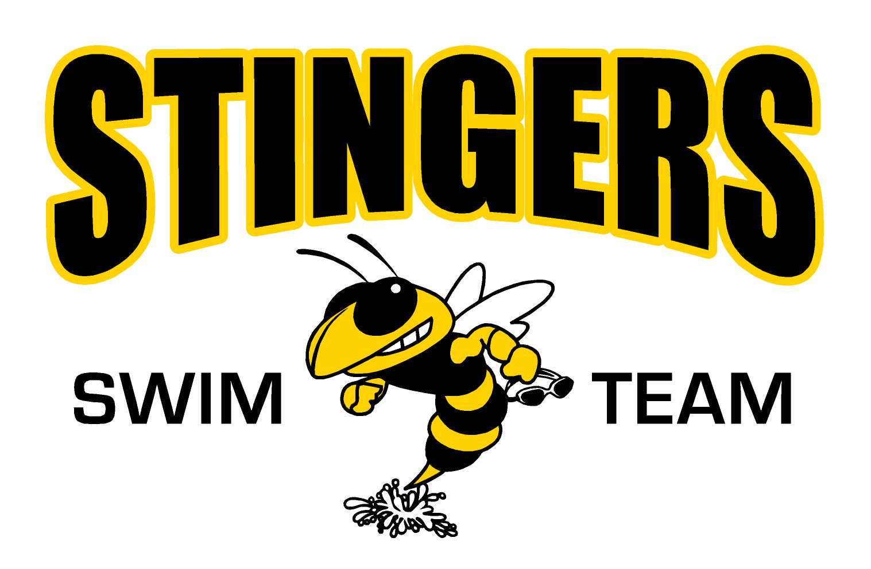

2025 Willoughby Stingers Handbook

All material contained in this handbook is subject to change pursuant to CDC, city, county or state directives.

Team Overview
The Willoughby Stingers Swim Team is a competitive summer swim team that competes in the Suburban Swim League (SSL). While it is a competitive team, at its core, it is a recreational team designed to promote the sport of swimming, sportsmanship and fun for swimmers of all levels. Children between the ages of 6 and 18 (as of June 1) are eligible to join. Children 6-8 years of age must be able to swim at least one length of the pool in one of the four competitive strokes (front crawl, backstroke, breaststroke or butterfly) unassisted and children 9-18 years of age must be able to swim a minimum of two lengths of the pool in the aforementioned competitive strokes unassisted. (Unassisted = no flotation devices)

The SSL is comprised of 10 teams from neighboring communities including Chardon, Cleveland Heights, Euclid, Highland Heights, Mentor, Pinegate, South Euclid/Lyndhurst, Wickliffe and Willowick. The league season will run June 2nd through July 27th. We will be hosting an intra-squad Black & Gold time trial meet June 7. Swim meets will commence the weekend of June 14th and run every weekend through the July 26/27 weekend. Swim meets are usually held on Saturday mornings (8:00 am-1:00 pm) but due to scheduling conflicts may be flexed to either Friday night or Sunday.

Practice Schedule and Details
Practices will begin Monday, June 2nd and conclude Friday, July 25th

Osborne Park Pool
Monday-Friday- 9:00 – 10:30 am: 10 & Under
Monday-Friday- 10:30 am – 12:00 pm: 11 & Over
Tuesday, Wednesday and Thursday 5:30 pm – 6:45 pm All Age Groups

If you have children in multiple age groups or cannot attend your assigned time, please talk to Coach Oliver. We will be flexible as we understand families have schedule constraints. We are trying to avoid a scenario where too many kids show up and the practice is unmanageable. In most cases we will ask you to swim the earlier practice, unless your younger swimmer can handle an 11&U practice.

City shuttle: The City of Willoughby will once again run a courtesy shuttle between the Euclid Avenue Pool and the Osborne Pool. Please remind your swimmers to be courteous and to follow the driver's directions. The coaches will help usher the swimmers from the Osborne Pool to the shuttle after each practice; however, it is your swimmer's responsibility to get on the shuttle. The shuttle driver will have a roster and will ask for your swimmer's name for the sole purpose of tracking who boarded the shuttle at each location.

Shuttle Schedule:
8:35 am - Pickup/Depart Euclid Ave and drive to Osborne pool - arrive by 8:50 am
10:10 am - Pickup/Depart Euclid Ave and drive to Osborne pool - arrive by 10:20 am
10:35 am - Depart Osborne and return the first group to Euclid Ave - arrive by 10:50 am
12:05 pm - Pickup/Depart Osborne and return second group to Euclid Ave – arrive by 12:20 pm

Parent Board and Coaching Staff
Erik Buckland, President ecbuckland@hotmail.com 440-382-4161
Karin Hostelley, Vice President Karin6473@gmail.com 216-548-2793
Anne Curwen, Treasurer ahcurwen@gmail.com 440-339-9878
Katie McGinty, Secretary kmurfey@gmail.com 216-402-0299
Leigh Perrino, Member At Large leighperrino@gmail.com 440-289-7867
Erik Buckland, Head Official ecbuckland@hotmail.com 440-382-4161
Oliver Curwen, Head Coach ocurwen@lakecountyymca.org 440-231-1174
Ella Anderson, Assistant Coach
Claire Dumstorff, Assistant Coach
Séamus Garry, Assistant Coach
Gianna Minotas, Assistant Coach
Maria O’Keefe, Assistant Coach

Coaching Staff Biographies
Oliver Curwen - Head Coach
This is Oliver’s third year with the Willoughby Stingers. Oliver has been coaching in Northeast Ohio since 2006, both in the SSL and has been the Head Coach of the West End Y Wildcats for 12 seasons. He has also coached high school and college swimming. Oliver's children, all swimmers, will also be swimming on the Willoughby Stingers.
Ella Anderson - Assistant Coach
This is Ella’s fourth year as Assistant Coach of the Willoughby Stingers. She just completed her first year at the University of Cincinnati. She is a 2024 graduate of Willoughby South High School and was a member of the Rebels Swim Team. She started swimming when she was 9 with the Willoughby Stingers and continued on with the Eastlake Vikings and West End Wildcats until she was 15. Her favorite strokes are freestyle and backstroke. Her favorite events are the 50 freestyle and the 100 backstroke. When not coaching she spends her free time hanging out with her friends and family.
Claire Dumstorff
This is Claire’s second year as Assistant Coach of the Willoughby Stingers. She just completed her first year at Miami University. She is a 2024 graduate of Kirtland High School and was a member of the Hornets Swim Team. She was a District Qualifier each year in the 100 breaststroke. While at Kirtland, she also was a member of the Cross Country and Track Teams. Claire started swimming at 11 years old for the West End Wildcats and has also swam for the Lake Erie Silver Dolphins. Her favorite events are breaststroke, the IM and relays. Some of her hobbies other than swimming are spending time with friends and family, painting, working out, traveling, and listening to music.
Séamus Garry – Assistant Coach
This is Séamus’ fourth year as Assistant Coach of the Willoughby Stingers. He currently attends the Ohio State University and is a 2023 graduate of Willoughby South High School and was a member of both the Rebels Swimming and Diving Team. As a senior in 2023, he participated in the Ohio High School Division 1 State Championship Meet for Diving. He also participated on the Soccer and Tennis Teams. He swam for the Willoughby Stingers starting at the age of 5 and has also swum for the West End Wildcats and Great Lakes Sailfish. His favorite events are butterfly and backstroke, and especially relays. When not coaching his hobbies include going outside, swimming, and spending time with friends and family.
Gianna Minotas
This is Gianna's second year as Assistant Coach of the Willoughby Stingers. She is a 2025 graduate of Gilmour Academy and will be attending the University of Dayton this fall. She qualified for the Ohio High School State Championship Meet each of her four years and medaled in multiple events each year, most specifically the 100 back and the three relays. While at Gilmour she has also participated in softball and has danced for several years. Gianna started swimming as a 7 year old for the Stingers as well as the West End Wildcats and Great Lakes Sailfish Swim Club. Her favorite events are the backstroke and freestyle. Some of her hobbies besides swimming are working for school doing social media postings for athletics, working out, spending time with family and friends, and making tiktok's with her dad.
Maria O’Keefe – Assistant Coach
After stepping away for a year, Maria is excited to return for her sixth year as Assistant Coach of the Willoughby Stingers. She is a 2025 graduate of the Ohio State University and a 2021 graduate of Lake Catholic High School. She was a member of the Lake Catholic Swim Team as well as the Cougar Tennis and Track teams. She grew up in Willoughby and swam for the West End YMCA Wildcats. Her favorite strokes were freestyle and backstroke. Her favorite events were the 50 and 100 freestyle. When not coaching her hobbies include spending time with family and friends and being outside.
2025 Meet Schedule
Home warm-ups begin at 7:00 am. Competition begins at 8:00 am.
Away warm-ups vary by pool and will be posted accordingly. Competition begins at 8:00.
2025 Suburban Swim League Schedule
Week One  June 14th | Home | Away
Week One  June 14th | Willowick | Willoughby
Week Two  June 21st | Home | Away
Week Two  June 21st | Cleveland Heights | Willoughby
Week Three  June 28th | Home | Away
Week Three  June 28th | Willoughby | Pinegate
Week Four  July 5th | Home | Away
Week Four  July 5th | Willoughby | Mentor
Week Five  July 12th | Home | Away
Week Five  July 12th | Wickliffe | Willoughby
Week Six  July 19th | Home | Away
Week Six  July 19th | Willoughby | Highland Heights
July 26th & 27th | Championship Weekend
July 26th & 27th | Hosted by Chardon & South Euclid/Lyndhurst at South Euclid/Lyndhurst

Parent Engagement
To successfully run a swim meet, a large number of parent volunteers are needed for every meet---both home and away. It is an expectation and requirement that every family volunteer in some capacity at each home meet. Volunteers can register to help via the events tab on the team website: https://www.teamunify.com/Home.jsp?_tabid_=0&team=recwsst.
***If you are interested in becoming a certified league official*, please let Erik Buckland know ASAP.***

*Officials that are currently certified through USA Swimming or YMCA Swimming do not need to attend a league training. All other officials, including returning SSL Officials, are required to complete SSL training annually.

The following list details the number of volunteers needed from the Willoughby Stingers for each half of home swim meets.
Stroke Officials – 2, Administrative Officials – 2, Timers – 12, Back-up Timer – 1, Finish Judge – 1, Announcer – 1, Runner – 1, 8 & Under Helper – 2, 50/50 Raffle – 1
The following list details the number of volunteers needed from the Willoughby Stingers for each half of away swim meets.
Stroke Officials – 2, Timers – 8, Finish Judge – 1, 8 & Under Helper – 2
Additional Information
Champs – The league championship is a two-day spectacle. Champs is the culmination of the season where approximately 4,000 swimmers, fans and spectators converge on one pool for a meet split over two days. Willoughby last hosted the event in 2019 and earned rave reviews from our peers across the league. We are set to host again in 2026. To be eligible to participate in Champs, swimmers must participate in at least three swim league dual meets ---this is a league rule. Each team is responsible for providing volunteers. Assignments will be posted at a future date.

Willoughby Stingers Team Website is available through Team Unify. For most current information throughout the season please visit the team’s website: http://www.teamunify.com/recwsst

OnDeck App has been retired and replaced by SportsEngine Motion.

News from SportsEngine Motion:
TeamUnify is changing its name to SportsEngine Motion, and they've got a new app to go with it!
Here's what's happening:
- New Name, Same Platform: You'll notice our new SportsEngine Motion logo when you log in on your computer, but everything else stays the same.
- OnDeck App Upgrade: The OnDeck mobile app is being replaced by the SportsEngine Motion app. To keep enjoying all your favorite features—and discover some new ones—you'll need to make the switch.
What You Need to Do:
- Download SportsEngine Motion from the App Store or Google Play.
- Log in using your current OnDeck username and password.
- Explore the same great features, plus some exciting updates!
Facebook – The Stingers are on Facebook: https://www.facebook.com/willoughbystingersswim/

Team Swim Suits – Customized (team logo) suits are available through Swimville USA. You are not required to purchase a team suit; however, if you purchase a non-team suit it should be solid a solid color or a combination of black and yellow to align with the team colors. There is a link to Swimville on the team website or you may go to https://www.swimvilleusa.com/register.asp?cg=212.

Spirit Wear – We are excited to announce that we have partnered with Artemis Awards and Apparel again for our 2025 team store. The store will be open until June 1st. There is a link to the spirit store on the team website or you may go to
https://awardsandapparel.com/collections/willoughby-stingers-merchandise-store
Team Pictures – Team picture day TBD.
Team Sponsorship – We appreciate the gracious support provided by our team sponsors. Due to the timeline to order team shirts and reward sponsors with walking billboards, our 2025 sponsorship window has closed. We will begin soliciting 2026 sponsors next spring.

