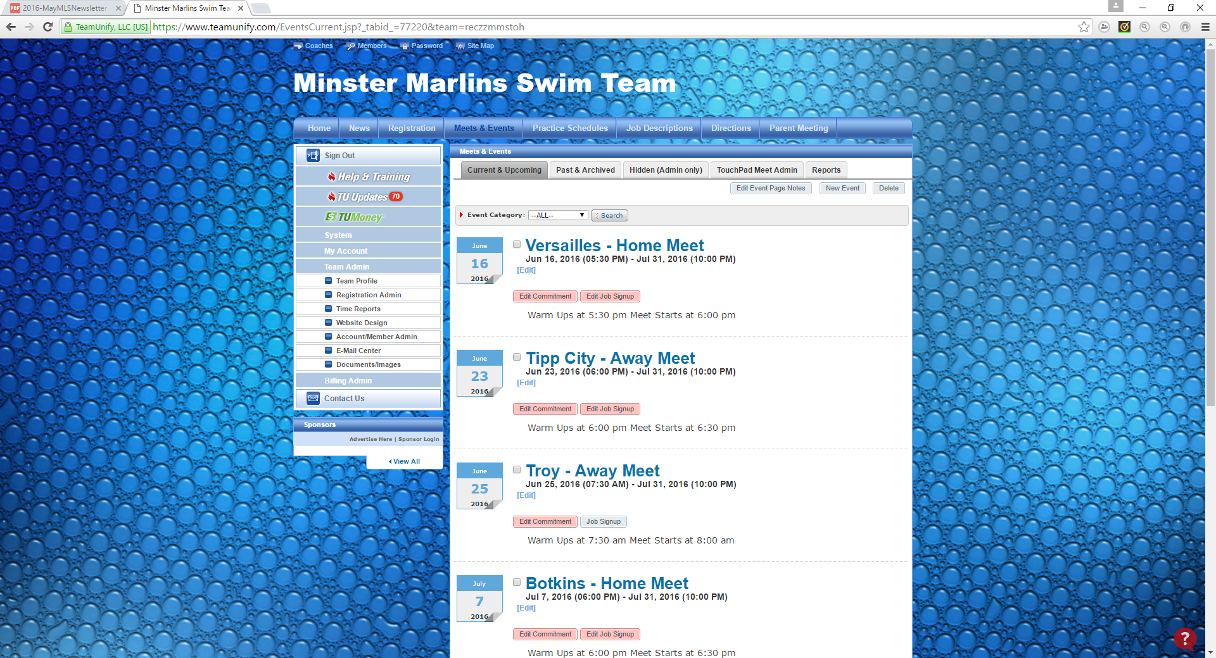

Click on the Edit Commitment button.

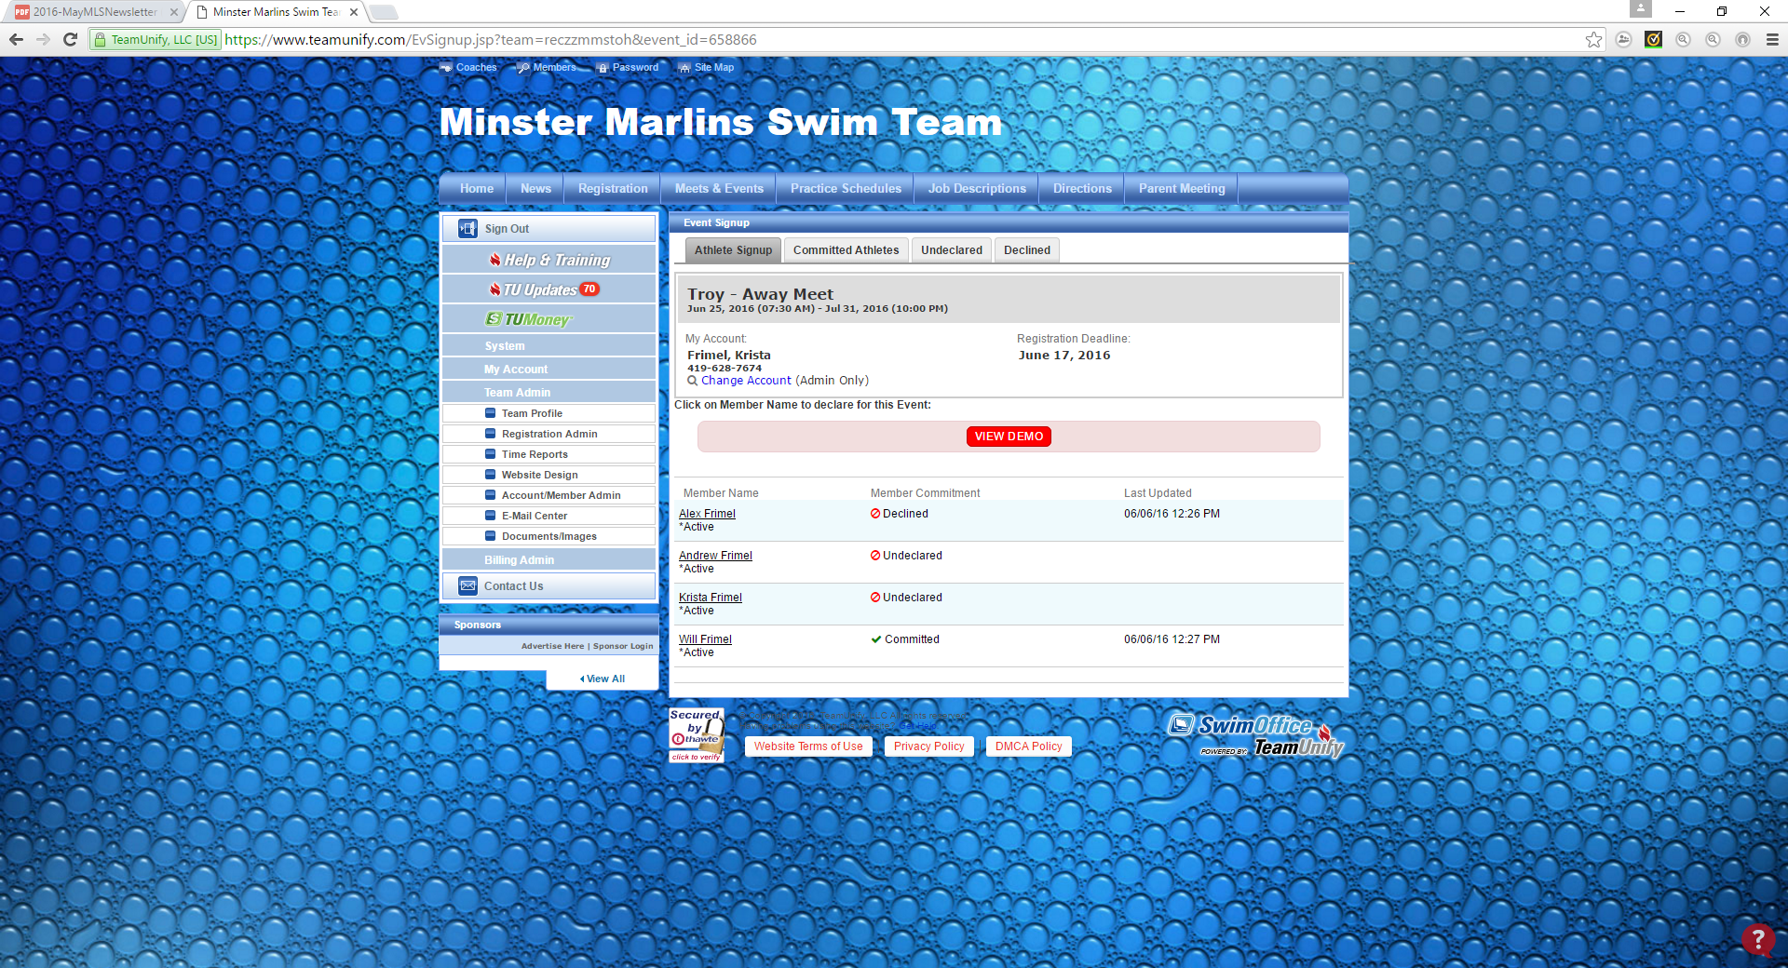

Click on each individual swimmer.

Declare each of your swimmers for each meet. You will need to go into each meet separately to do this. Remember to click on the Save Changes button. This is what allows Jessie to know if see should sign up each of your kids for events at that particular meet.
For the Thursday meets, you will be able to declare your swimmers through 11:59pm the Sunday before.
For the Saturday meets, you will be able to declare your swimmers through 11:59pm the Monday before.

