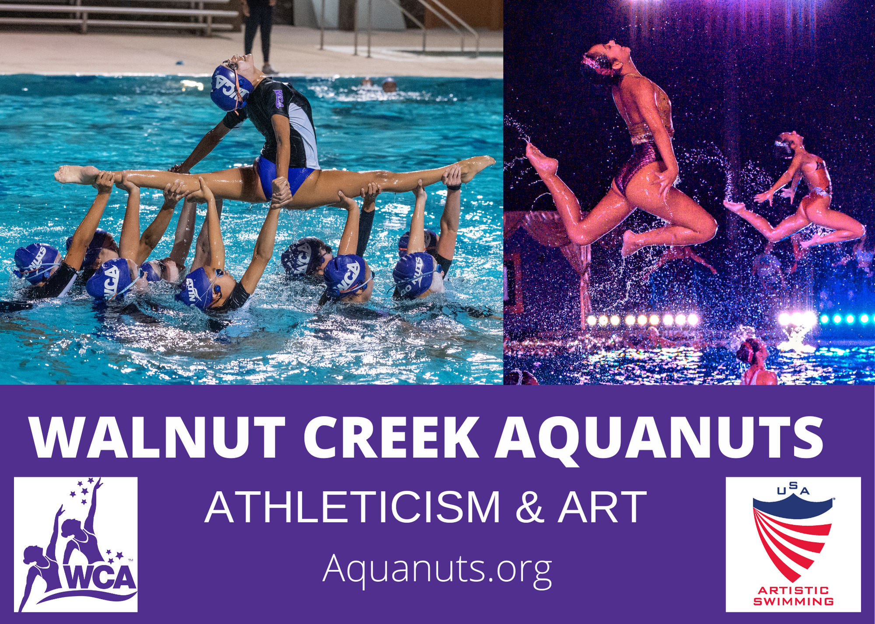
Sponsor the Aquanuts Today!
The Walnut Creek Aquanuts is the Bay Area’s premier artistic swimming team with more than 100 athletes. In its 57-year history, the club has won more than 200 national and world titles, and has produced over 4,000 elite level athletes, 17 Olympians, and eight Olympic Gold Medalists.
As a registered 501c3 nonprofit, WCA develops athletes from novice to elite. Beyond developing swimming skills, the club is committed to fostering teamwork, sportsmanship, self-confidence, healthy lifestyles and empowering girls and young women to be leaders.
We are happy to earmark the funds from your sponsorship to support scholarship opportunities that increase access to artistic swimming for those with limited means, and toward college scholarships to support educational goals of graduating Aquanuts. In 2024, WCA awarded over $13,000 in scholarships to our athletes who have made the USA National Team and our graduating Seniors thanks to the generosity of our sponsors!
Fundraising Events:
Celebration of Champions - May 31, 2025 - Clarke Memorial Swim Center
COC is a formal poolside event with live & silent auctions. Swimmers perform their competition routines. (Program and Table Sponsor opportunities)
Fall Swim Show - Aug 28-Aug 31, 2024 - Clarke Memorial Swim Center
A professional-level theatrical swim show complete with lights, props, and a 3-D stage that attracts thousands of guests, including East Bay business leaders and VIPs. The iconic evening show dazzles more than 4,000 attendees over Labor Day weekend. (Video Wall, Program and Signage opportunities)
There has never been a better time to partner with the Walnut Creek Aquanuts!

2025 WCA Sponsorship Opportunities

Sponsorship Opportunities | Amount
$5,000 Marquee Sponsor - Includes Full Page Color Ad in Program & Video Wall Ad (Fall Show Only). 10 VIP event tickets, Signage at events and your choice of one additional option from the benefits below. | $
$3,000 Sponsor - Includes ½ Page Color Ad or Full Page Black and White Ad in Program & Video Wall Ads (Fall Show Only). 8 VIP event tickets, Signage at events. | $
$2000 Table Sponsor - Includes 10 VIP Table Seats & ½ Page Color Ad | $
$1,000 Ticket Sponsor - Includes your business name, logo, contact information, on the back of event tickets. Creative use of the space could be a coupon or discount to maximize customer engagement. | $
$1000 – Display Booth at event | $
$800 – Full Page program ad, color  $800 – Video Wall Ad - (Fall Show Only)  $500 – ½ Page program ad, color  $500 – Full Page program ad, B&W  $400 – ½ Page program ad, B&W  $200 – ¼ Page program ad, B&W | $
$125 ea – VIP Table seat (COC Only) | $
Monetary Donation – If you are not interested in the benefits above, but would like to make a flat tax-deductible donation of any amount, please include that here. | $
In-Kind Donation – If you would like to donate a gift card, product, tickets or experience for our auction or event raffles, include the item description on the following page and insert the value of the item here. | $
Insert Total Contribution Here | $

For More Information: www.aquanuts.org or sarahp@aquanuts.org

Yes, I would like to support the Walnut Creek Aquanuts!

Contact information:

Company: _____________________________________________Contact: _________________________________
Address: ______________________________________________________________________________________
City: _________________________________________________ State: ___________ ZIP: ___________________
Phone: _____________________________________Email: _____________________________________________
Contribution total: _______________________________________________________________________________
If you are donating an in-kind contribution for our silent auction or raffles, please describe your contribution below:
______________________________________________________________________________________________________________________________________________________________________________________________________________________________________________________________________________________________________
Please mail sponsorship form and check or credit card payment to:

Walnut Creek Aquanuts, PO Box 3068, Walnut Creek, CA 94598

Name on card: ______________________________________ Card number: _________________________________
Security code: ___________ Expiration: _______________ Card type: AmEx Discover Mastercard Visa
Billing Address: __________________________________________________________________________________
Signature: ______________________________________________________________________________________
Walnut Creek Aquanuts is a non-profit 501c3 (Tax ID: 23-7103045)

Thank you for your generous support of the
Walnut Creek Aquanuts!
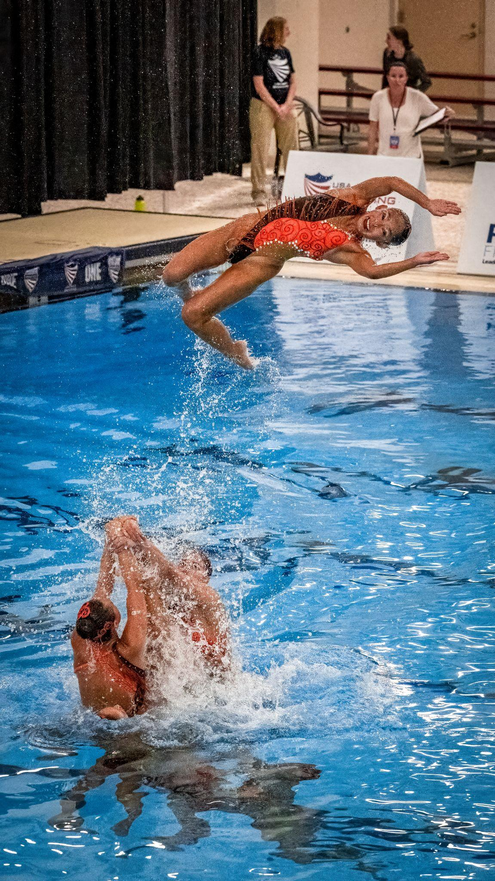
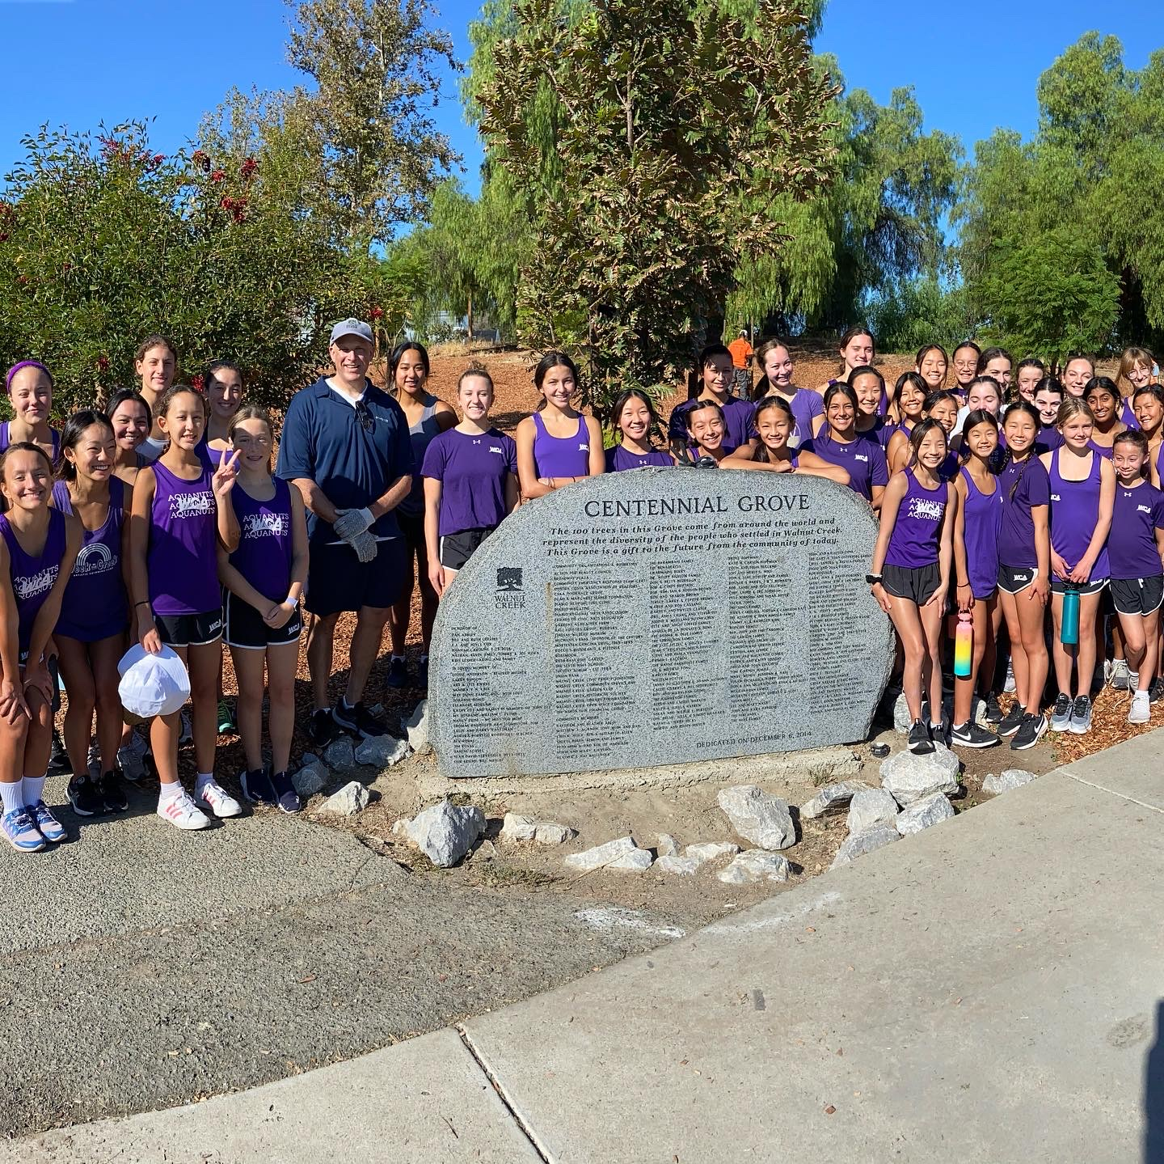
COC Committee
Chair: Raffaella Cerruti
Co-Chair: Sarah Pikal
Sandy Coloma
Heather Olson
Alvin Shen
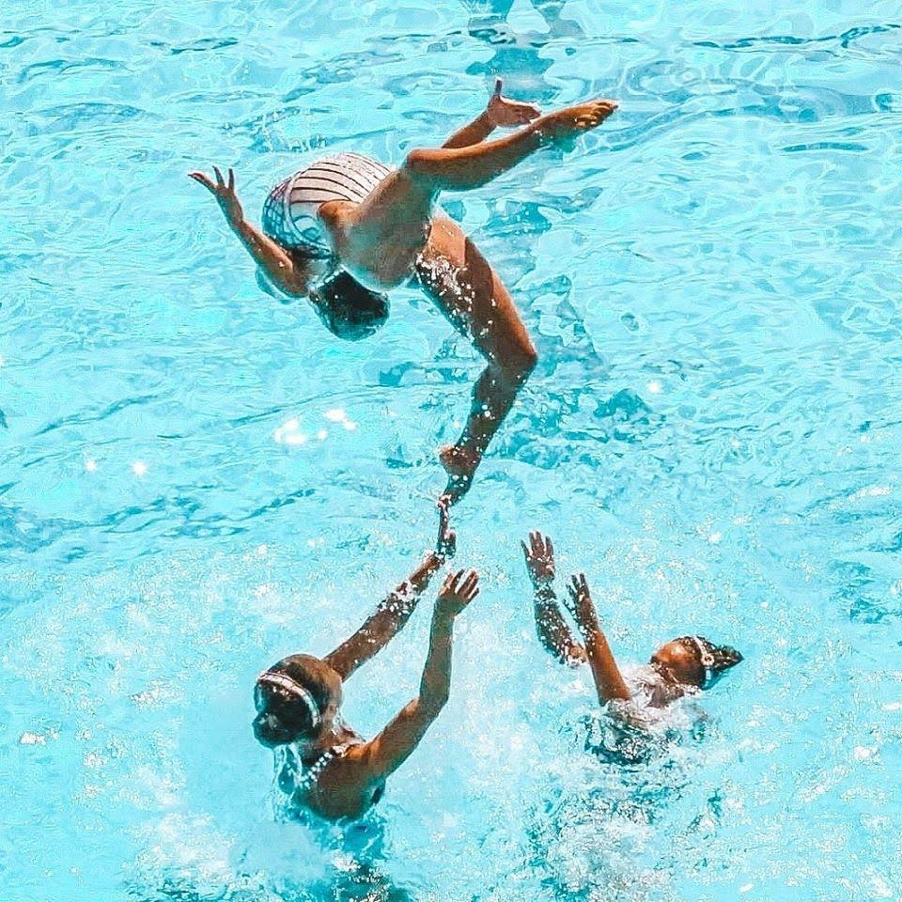
Kristen Smidstra
12A Families

Board of Directors
Head Coach: Kim Probst
Club Manager: Kristen Smidstra
President: Mike Yuan
CFO: Veronica Cerruti
Treasurer: Carol Lim
Secretary: Dariia Polyulya
VP of Fundraising: Raffaella Cerruti
Bingo Parent Rep: Elena Kaprovskaya
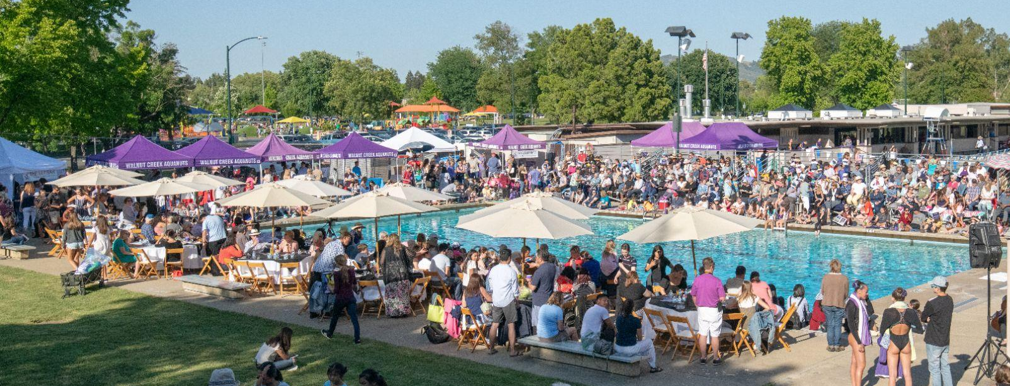
Celebration of Champions Show Publicity: Heather Olson
Recruitment: Sharon Portillo
Parent Participation: Lisa Hom
Bingo Manager: Sarah Pikal
Athlete Representative:
Sam Cerruti

