Minutes for Special HOD Election Meeting Mar. 17, 2024
1) Accept nominations from the floor for nominating committee.
2) Close nominations.
3) Conduct vote.
Call to Order: 7:03pm
New members of the Nominating Committee nominated and voted in are:
Kevin Chester, Kevin Eslinger, Sammie Hail, Sean Redmond, Krissy Payton, Ohj Nobles, Scott Lawson, and Isabella Dang (athlete).
Alex Pletcher (athlete) had been previously voted in November 2023.
Adjourned: 7:15pm

Minutes for SI BOD Meeting Mar. 17, 2024
1) Review approve previous minutes
2) Consider items in consent agenda
3) Old business
4) New Business
5) Adjournment

General Chair Report: Dave Kilmer
Admin Chair Report: Sammie Hail
Finance Chair Report: Maddie Mohr
Treasurer Report: John McGlynn
Senior Report: (vote required) Paul Folts
Age Group Report: Sean Redmond
Registration Report: Mary Redmond
Timing Task Force: (possible vote required) Sean Redmond
Program Committee: Paul Mazarelle (not present)
Coaches Rep Report: Kevin Eslinger
DDEI: Maria Davila

Nothing to report from: Officials, Operational risk, safe sport, Athletes Rep, Championship

Call to Order: 7:17pm

Attendees: Dave Kilmer, Mary Redmond, Joy Cabrera, Sammie Hail, Maria Davila, Kiran Jayasinghe, Bob Horne, Kevin Eslinger, Jeslyn Tran, Sean Redmond, Melissa Eisenhamer, Bradford Hancock, Maddie Mohr, Vinh Dang, Kevin Chester, Isabella Dang, Eric Hughes, Catherine Rowe, Scott Lawson, Anhton Tran, Reid Krebs, Alex Pletcher, Krissy Payton, Hugo Camarillo, John McGlynn, Paul Folts, JJ Brown, Rick Tran

M/S/A/P (Motion, Seconded, Approved, Passed) December 2023 BOD Meeting Minutes and January 2024 BOD Meeting Minutes. For reference, all meeting minutes are posted on the SI website under SI Governance to view.
General Chair report: Dave Kilmer
In late February I proposed two appointees for the positions of Admin Vice Chair and Finance Vice Chair to the voting board members for the advice and consent process. I received almost unanimous consent for the Admin vice chair position, and unanimous consent for the Finance Vice Chair position. With only one dissent, I went forward with the appointments.
Welcome to the board for Sammie Hail as Admin Vice Chair and Maddie Mohr as Finance Vice chair. These appointments will carry a term until the November election, at which time there will be a regular 2-year term with an open election that these two can choose to or not to run for.
Remaining 2024 board meeting dates: (meeting times will be 7:00 PM)
May 19th
July 21st – could be changed to 28th if Si LC champs ends up on 21st weekend
Sept 15th or 22nd – depending on dates of USA swimming HOD meeting
Nov 17th
SI Website
You will notice a more active news section on the SI website. If you have newsworthy swimming items to post on the SI site please send them to me (davekilmersigc@gmail.com) or to the office (office@Si-swimming.com); and we will review them and consider posting. Recommendations for postings are swimmer accomplishments (like new SI records, collegiate accomplishments like x swimmer made it to NCAA’s, a list of swimmers who will continue their swimming at colleges they were accepted to, etc.)
Admin Vice Chair report: Sammie Hail
Thank you all for the vote of confidence to fill in the Admin Vice Chair position. I’ve made initial contact with all those under the Admin Vice Chair umbrella and have talked to Keith Clemens who held the position before to get a handle on the position.
One of the first items I have been tasked to do is to take a complete inventory of all equipment the LSC owns (timing equipment, office equipment, etc.)
Currently, the Equipment Committee Chair is vacant which a search will be underway to fill. Additionally, there is an inactive Education Committee that we will look to restart. The plan is to contact USA Swimming to find more information and to get materials together to distribute to teams.
I look forward to working with all you of upcoming months.

Financial Vice Chair report: Maddie Mohr
Thank you for entrusting me as the new Financial Vice -Chair for SI - Swimming. I am the North American Assistant Controller for Cubic Transportation Systems. Some of my primary duties include being responsible for financial reporting, overseeing day to day accounting and finance operations, ensuring compliance with statutory requirements, and the main liaison/ point of contact for internal and external audits. I have accounting experience in industry as well as time serving as an auditor at a nationally recognized public accounting firm.

I recently met with John Mcglynn (Treasurer) to obtain an overview of SI financial operations and will be speaking with Alison Turner & Associates this week. I am excited to get up to speed and look forward to becoming active in the new role and working with you all.
Treasurer Report: John McGlynn
Jan Mar (as of 3-15)
Checking - $169,246.50 $191,094.80
Savings - $75,043.80 $75,046.32
Investment - $530,675.63 $552,541.72

Still working on the best format for a P&L report that isn’t too detailed to lose everyone. Not there yet. But one is linked here attach P&L dated 3-16-24 for period Oct 2023-Feb 2024

Senior Report: Paul Folts (vote required)
Paul will present figures for spring and summer travel, which will need approval.

Copy of Paul’s analysis/estimation of Spring/Summer 2024 travel is below.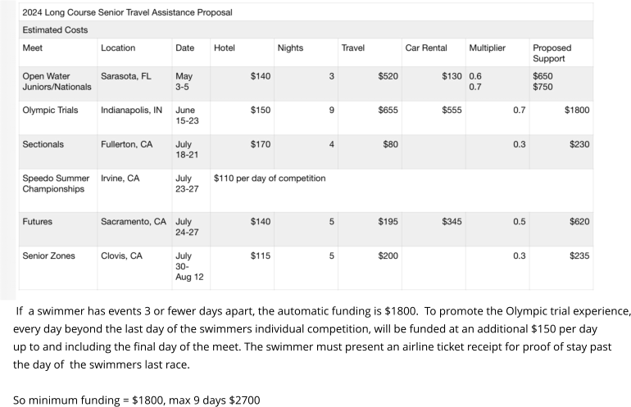

M/S/A/P to accept Senior Travel Proposal for all meets except for Olympic Trials. Held a separate discussion regarding Trials

Olympic Trials - Discussion points regarding the above analysis and SI’s commitment to assisting with funding for travel:

- Any SI athletes who are current college students attending Olympic Trials need to represent their SI team to receive financial assistance.
- SI has budgeted $60K-$70K for Trials.
- Question asked if partial funding is available for an athlete if representing both college team & SI team. Partial funding has never been done per Dave. It is ok to represent two teams but if the athlete is not compensated by college, then SI can fund.
- How do you verify swimmer is not getting college funding?? Need to avoid more $$ to an athlete than they paid. All agreed receipts needed including copy of airline ticket showing return flight date. Reimbursement only for days present at Trials.
- Flights to Indianapolis are now closer to $800-$900.
- Paul Folts agreed to draft & circulate an Information Sheet on how Trials will be funded.

M/S/A/P to fund Olympic Trials at a minimum of $1,800 plus an additional $150/day for a maximum of $2,700 with airline ticket receipt as proof of number of days at Trials.

Age Group Report: Sean Redmond
At the 2024 Age Group Championships we had 6 new championship records set.
10&U Boys 50 Breast 33.85 Daniel R Corkery South Bay
10&U Boys 100 Breast 1:13.88 Daniel R Corkery South Bay
11-12 Boys 200 Free 1:52.95 Tristan G Rousseau Pacific Swim
11-12 Boys 500 Free 4:59.61 Tristan G Rousseau Pacific Swim
11-12 Boys 100 Back 58.23 Tristan G Rousseau Pacific Swim
13-14 Boys 200 Breast 2:11.16 Eric E Yu Pacific Swim

We are in the process of selecting a head coach and staff for the 2024 Age Group Zone in Boise this August. If anyone is interested, please contact Sean Redmond or Kevin Eslinger.

Registration Report: Mary Redmond

Registration Type | 2021 Registrations  060120 thru 083121 | 2022 Registrations 090121 thru 083122 | 2023  Registrations  090122 thru  083123 | 2024  Registrations  090123 thru  083124
 |  |  |  |  | Member Type
Athlete Premium (YR) | 2693 | 3271 | 2966 | 2577 | Athlete
Athlete Seasonal 1 | 21 | 117 | 109 | NA | Athlete
Athlete Flex | 1453 | 1133 | 672 | 487 | Athlete
Athlete Outreach | 61 | 60 | 46 | 44 | Athlete
TOTAL ATHLETE REG | 4228 | 4581 | 3793 | 3108 | Athlete
Individual | 307 | 353 | 438 | 343 | Non-Athlete
Life | 5 | 5 | 5 | 5 | Non-Athlete
Club | 27 | 29 | 29 | 27 | Clubs
Club Seasonal | 0 | 0 | NA | NA | Seasonal Club

Total Athlete Registrations 2018: 3929
Total Athlete Registrations 2019: 4440
Total Athlete Registrations 2020: 3860
Total Athlete Registrations 2021: 4228
Total Athlete Registrations 2022: 4581
Total Athlete Registrations 2023: 3793

The registrations numbers are through March 12, 2024

There are 5 apprentice officials registered but there is no fee until they pay their registration fee after they complete their shadowing. They are not counted in the registration numbers.

Outstanding Fines owed through 2/19/24
BAY $75 CSTE: $225 NCA $75 SDSA $150

Update from USA Swimming: Coaches will now see all certs listed on their card. If is a course is not currently required it will state as such.
If a course states that a course is not completed, the coach is required to take the course to be in good standing.
Coaches that were registered before 9/1/22 will no longer be required to take the following courses as they are grandfathered in: QFC: Quality Coaching Framework, Welcome to USA Swimming, Rules and Regulations and CORE Certification.
All coaches registered for the first time after 9/1/22 will be required to take the courses.

Clubs: There is a new report print button on the Club Staff Requirements.
Transfers: There will be an email notification to the head coach of previous club when someone initiates a transfer
2024 Registration Fee Information

SI fee and outreach information is posted on the SI website Here
https://www.gomotionapp.com/sandiegoimperial/UserFiles/Image/QuickUpload/2024-si-registration-fees-and-information_071218.pdf

Registration links: DO NOT POST REGISTRATION LINKS FOR YOUR CLUB ON YOUR WEBSITE- These are specific to your club.

Timing Task Force: Sean Redmond (May require vote)
The task force met and decided to recommend that the LSC should purchase timing equipment that can be rented to teams in the LSC that are hosting meets and do not have access to timing equipment for their meet. We have sent a survey out to teams to see if they would be interested in using/renting equipment from the LSC. This will help to determine if we need purchase one set or two sets of equipment. We do not recommend purchasing tarps/canopies to be rented to teams; we recommend purchasing some tarps for the LSC to use over the CTS at LSC hosted meets.
We are looking at the cost of everything and waiting to hear back from some vendors on pricing. Currently Colorado has about a 10-11 month backup on their pad orders. We are looking at another option. The other option is Omega.

At this time, I would recommend a minimum purchase for the summer – this would allow us to help with the current long course season that is about to start.
- Long course; 50 meters; harness extension so that both ends of the pool can communicate to the CTS. Quote from Lincoln Aquatics is $1,400.
- 50 meters microphone cable. Still researching price because we can only find this in 100 ft. length only. 100 ft. costs $230. Estimate $500 for a cable long enough.
- Have a CTS Tech come and look at our scoreboard and see what it will take to fix it. My understanding is that their fee is $200 per hour/min of 2 hours plus the cost of parts. $400 minimum labor charge plus parts estimated at $600 for total of $1,000.
- Total amount requested $3,000

M/S/A/P $3,000 to allow Sean and the Timing Task Force to make these purchases for our LC summer season. Dave & Sammie to work on getting funds to Sean and Timing Task Force.

Members of the Timing Task Force: Sean Redmond, Carlos Davila, Brian Davis, Kevin Chester, Scott Lawson, and Isabella Dang.

Program Committee: Mary Redmond
The approved Summer Schedule with hosts is now posted on the SI site

Two pending items:
- Awaiting surcharge fees from a few teams for upcoming LC meets to finalize meet announcements
- Following up on the prior request made at the last BOD meeting in Jan 2024 to increase the surcharge fee for Splash & Dash, LC Champs, and WAGS from $15 to $20 to cover the increased cost of pool rentals.

M/S/A/P to increase surcharges for these meets to $20.

Coaches Rep Report: Kevin Eslinger
No report due to General Chair asking him to further evaluate things. Kevin Eslinger sent out a request for feedback on championship meet relay issues and got so many responses, that I (general chair) ask that he convene a zoom meeting in the next two weeks to hash out issues surrounding championship relays as well as time stds for Summer Championships. He will pull a meeting together and we will have to send out the resulting proposal to the board for an e-mail vote. The great thing is that his discussion thread quickly included responses from more than 10 coaches / teams.

Plan is to hold this Zoom meeting sometime in the next few weeks. BOD will vote via email on the proposed time standards and who can swim. Information will need to be up on SI website before April.

DDEI Report: Diversity, Disability, Equity, & Inclusion Committee Report
March 12, 2024
Submitted by Maria Davila, Chair

- 2024 WZ DEI Camp
  - Remaining fees due to the WZ ($200/participant; $800 total) must be received by Lisa Vetterlain no later than 3/20 or SI will lose our spots for the camp Maria to provide John with information to cut this check and where to send payment ASAP.
    - Funding was approved as part of the DEI budget so should get pulled from that account.
    - If our alternate gets a spot, their full participant fee ($425) will be due after we are notified by the WZ
  - Flights need to be booked ASAP
    - Southwest not possible due to conflicting arrival times with camp schedule (either way too early or too late) 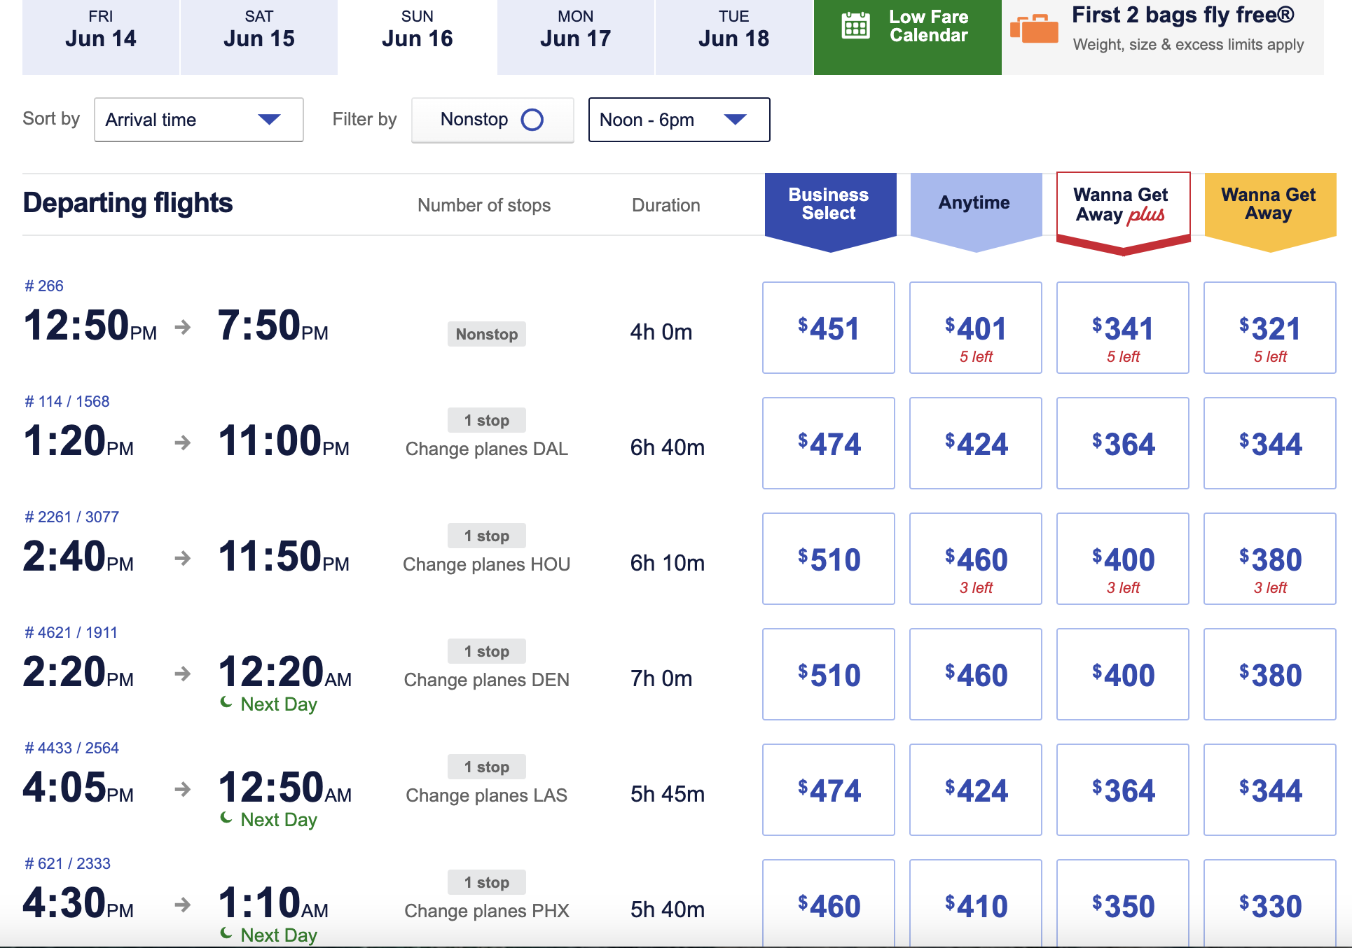

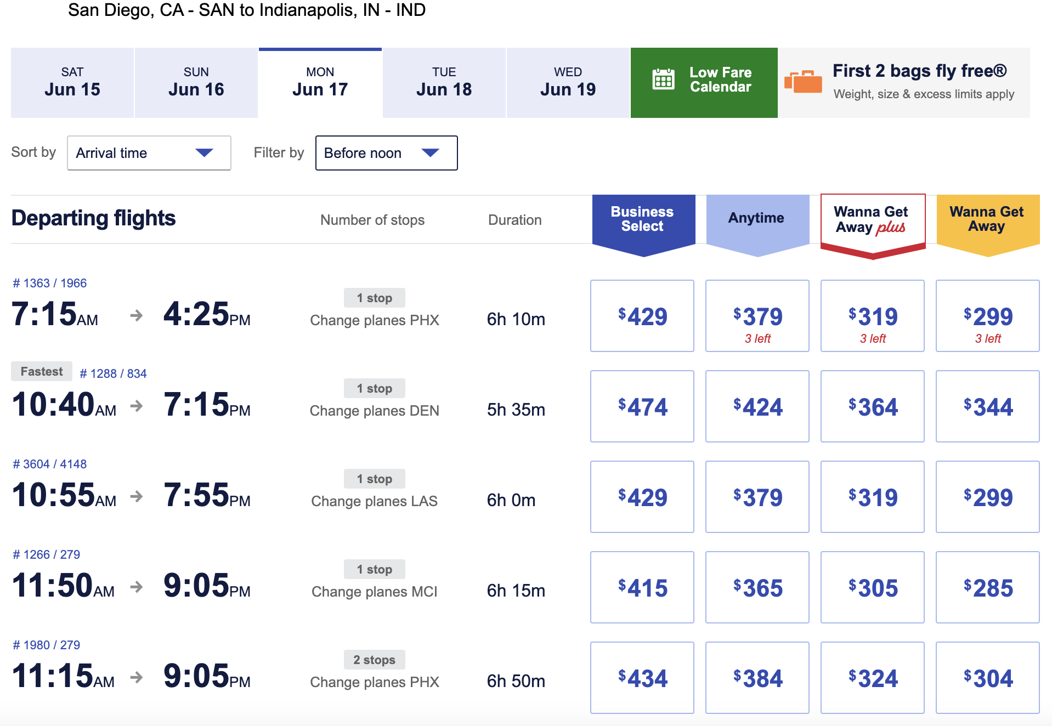
    - Options will need to be a red-eye departing June 16 PM to arrive June 17 AM
      - DELTA - TOTAL COST 1 ADULT + 2 ATHLETES RT - $2,526
        - Outbound June 16 @ 9:59PM SAN; arrives June 17 @ 8:50AM IND
          - DL712; 2hr layover ATL; DL3125
            - Boeing 737 for both
        - Outbound June 20 @ 11:41AM IND; arrives 5:54PM @ SAN
          - DL2952; 3hr layover ATL; DL947
            - Boeing 737 for both
      - AMERICAN - TOTAL COST 1 ADULT + 2 ATHLETES RT - $1,917.60
        - Outbound June 16 @ 10:15PM SAN; arrives June 17 @ 11:15AM IND
          - AA2056; 3 hr 19 min layover CLT; AA683
            - Airbus A321, Boeing 737
        - Outbound June 20 @ 3:45PM IND; arrives 10:42PM SAN
          - AA2215; 3hr21min layover CLT; AA2647
            - Airbus A321 for both
      - 2-3 other potential flights, 2 American, 1 Delta. Pricing between $2,300 - 2,800 RT
Goal is to get everyone on the same flight. It’s possible Maria might not be flying out of San Diego & will have to meet everyone there, but at minimum athletes will be accompanied by the other non-athlete so that we don't have to go through the unaccompanied minors process/paperwork.
  - Attendees
    - Athletes: 4 athletes have filled out the app - we have 2 athlete slots + 1 alternate
      - Closing apps 3/17 @ 11:59PM PST

      - SI DEI Committee will meet on March 18 to deliberate. Selections will be sent to the Board that same night & notifications will go out to athletes (& other non-athlete) the morning of the 19th.
    - Non-athletes: DEI Chair + 1 additional slot
      - Krissy Payton has indicated interest in going. If no one else emails me by 3/17 @ 11:59PM PST she will get the 2nd non-athlete spot.
  - Schedule
    - We were asked to try to get flights arriving to Indy in the morning as opposed to the afternoon so we don't miss the check-in window + to make airport pick-up more efficient.
    - We can leave anytime on the 20th, but were asked to keep in mind that lunch would not be provided on that final day & to plan accordingly.
    - Practice on the first day of the camp (June 17th) is expected to be at 3pm
    - There will be a 2-hr window for check-in at the university on the 17th, time TBD but most likely to be around 12pm
    - The WZ will be providing transportation from & to the airport on the first & last day of the camp.
    - Re: Olympic Trials Incentive: We have official confirmation that we will be attending the finals session on Wednesday, June 19th. Events that session are:
      - W - 100 free final
      - M - 200 fly final
      - W - 200 fly semi
      - W - 1500 final
      - M - 200 back semi
      - W - 200 brst semi
      - M - 200 brst final
      - M - 100 free final

NOTE: Subsequent to BOD Meeting, DDEI committee met and formally announced the attendees for the WZ DEI Camp:
- Mateo Camarillo Moran, SBA (athlete)
- Maia Hideg, RSD (athlete)
- Krissy Payton, TAQ (non-athlete & BOD At-Large rep)
The Committee also designated the following individuals as our alternates:
- Iker Davila, RSD (1st athlete alternate)
- Catherine Rowe, PS (2nd athlete alternate & BOD Athlete Rep)
- Hugo Camarillo (non-athlete alternate)

- 2024 Don Watkinds Scholarship
  - Because it’s an Olympic year, my thought is to push our normal timeline back a few months to line up awards with the post-Olympic surge of new athletes.
    - SI DEI Committee will meet in the coming weeks to discuss timeline & selection criteria
    - Application itself will be the same format as last year (Google Form info + Personal Statement submission)
M/S/A/P will announce Don Watkinds scholarship at LC Championships.

Old Business: None
New Business: None

Meeting Adjourned 8:23pm

Next meeting
May 19th 7:00 PM

