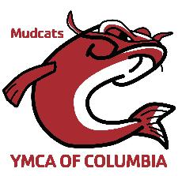

YCSC ATHETE CODE OF CONDUCT

The purpose of a code of conduct for athletes is to establish a consistent expectation for athletes’ behavior. By signing this code of conduct, I agree to the following statements:
❏ I will respect and show courtesy to my teammates and coaches at all times.
❏ I will demonstrate good sportsmanship at all practices and meets.
❏ I will set a good example of behavior and work ethic for my younger teammates.
❏ I will be respectful of my teammates’ feelings and personal space. Swimmers who exhibit sexist, racist, homophobic, or otherwise inappropriate behavior will be faced with consequences.
❏ I will attend all team meetings and training sessions, unless I am excused by my coach.
❏ I will show respect for all facilities and other property (including locker rooms) used during practices, competitions, and team activities.
❏ I will refrain from foul language, violence, behavior deemed dishonest, offensive, or illegal.
❏ If I disagree with an official’s call, I will talk with my coach and not approach the official directly.
❏ I will obey all of USA Swimming’s rules and codes of conduct.

I understand that if I violate this code of conduct, I will be subject to disciplinary action determined by my coaches and the swim club’s board of directors.
_________________________________ _____________________
Swimmer’s signature Date
_________________________________ _____________________
Parent’s signature Date

