6 STEPS TO BEING WELL-HYDRATED
compliments of Fitter & Faster

An athlete’s hydration status can have resonating effects on performance in practices and during competition. The human body is made up of over 60% water, and fluid carries essential nutrients throughout the body. Here are some steps to becoming fitter and faster with proper hydration!

1. BEGIN EXERCISE WELL HYDRATED.
Drink 16 oz about 2 hours before practice and another 8 to 16 oz about 15-20 minutes before practice.

2. WEIGH YOURSELF BEFORE YOU GET IN THE POOL.

3. DURING EXERCISE:
If less than 60 minutes, drink 6 to 12 oz of water every 20 minutes
If more than 60 minutes drink 6 to 12 oz of a 6 to 8% carbohydrate solution drink (ie Gatorade) every 20 minutes

4. WEIGH YOURSELF AFTER TO CALCULATE SWEAT RATE.
For every pound you lose, drink 16-24 oz of fluid.

5. DRINK WATER WITH EVERY MEAL
Ensure pale yellow colored urine to indicate you are hydrated (check out the hydration chart).

6. AFTER EXERCISE, DRINK WATER WITH CARBOHYDRATES TO SPEED UP THE RECOVERY PROCESS.
Thirst lags behind the body’s need. Prevent yourself from becoming thirsty because if you’re thirsty, then you are already dehydrated.
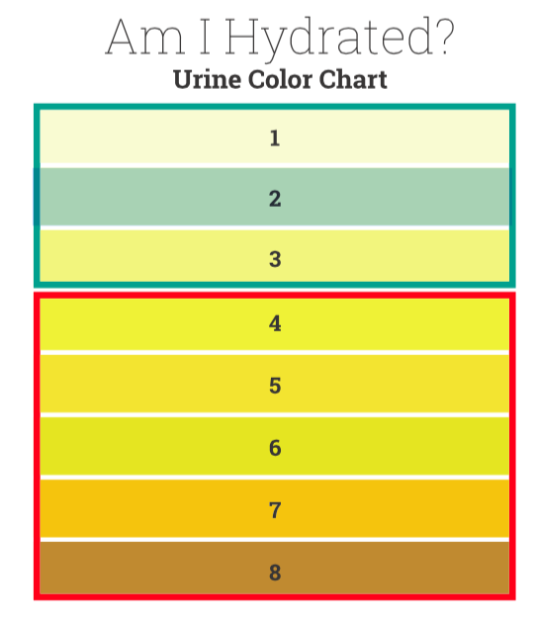

THIS URINE COLOR CHART IS A SIMPLE TOOL YOU CAN USE TO ASSESS IF YOU ARE DRINKING ENOUGH FLUIDS THROUGHOUT THE DAY TO STAY HYDRATED.
- If your urine matches the colors numbered 1, 2, or 3 you are hydrated.
- If your urine matches the colors numbered 4 through 8 you are dehydrated and need to drink more fluid.
Be aware! If you are taking single vitamin supplements or a multivitamin supplement, some of the vitamins in the supplements can change the color of your urine for a few hours, making it bright yellow or discolored.

