

Team Handbook

www.cityofbartlett.org/xtreme
Click on “JOIN OUR TEAM” to register.

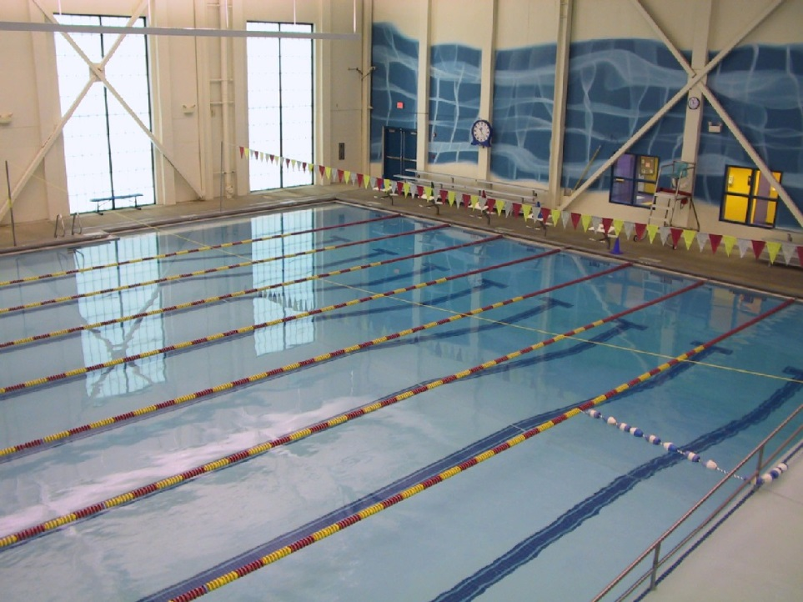

Introduction
Welcome to Bartlett Xtreme Swim Team! Our staff is very well respected in the coaching community and has produced a number of highly accomplished swimmers over their many years of experience. We accommodate a variety of ability levels and work toward the overall improvement for each individual swimmer and the team.

BXST Mission/Philosophy

The Bartlett Xtreme Swim Team is committed to providing an enjoyable swimming experience to swimmers of all ages and abilities, while providing a challenging and positive training atmosphere where swimmers can develop a positive self-esteem through individual and team achievements.

Vision Statement
Leading the Southeastern LSC in Achievement, Development, Diversity, and Citizenship

Coaching Staff
Head Coach | Scott O'Reilly
Asst. Coach | Ellen Doxtater | coachellen1@hotmail.com
Asst. Coach | Ainslee McKinney | Amckin23@vols.utk.edu
Asst. Coach | Morgan Cowan
Asst. Coach | Colin Lee
Asst. Coach | Amber Diviney

Contact Information
Soreilly@cityofbartlett.org
(901) 385-6470


Training Groups
The Bartlett Xtreme Swim Team has established five groups or levels that are based on the swimmer’s current ability. The groups provide the swimmers the opportunity to progress through each season and group. Our goal is to develop team cohesion and an appreciation for swimming through 3-D swimming (Dedication, Determination, and Desire).

The following guidelines will be used by coaches to assess a swimmer’s placement in a group. They are only guidelines. Coaches have the final decisions of how a swimmer is placed in a group.

BXST 101 | A transition from the BRC lesson program to our full-time swim team. It is intended to be a temporary stop for swimmers to acclimate themselves to swimming multiple full laps while honing technique, especially Free and Back. We would prefer to keep this group largely at 10 & Unders. 11 & Overs at this ability level should take lessons, either private or group, to prepare for White Group.
White Group | The entry-level group of the competitive team. Emphasis falls on technique development of all strokes while improving conditioning through longer practices and additional yardage than what the swimmer has done in the past. Additional skills taught include practice and competitive skills: clock awareness, circle swimming, adjusting speeds/effort, streamlining, starts and turns and competitive events. We would prefer this group to be 12 & Under.
Black Group | More advanced than White Group, but still on the “developmental track” with majority emphasis on technique rather than performance/competition. Additional endurance is gained from a more extensive weekly practice schedule (4 practices each week at 1 and a half hours per practice). More advanced skill development is taught, with greater focus on all 4 competitive strokes. This group is primarily for 9-14 year olds.
Red Group | Red Group is the performance group for swimmers, age 10-14, who are willing and able to make a commitment to practice and competition (USAS over MSS meets). Greater emphasis is on training and meet performance rather than technique development. Swimmers in this group must exhibit an internal drive to maximize their abilities while also setting long-term and seasonal goals (with particular focus on qualifying for Southeastern Championships). Commitment must be shown during long course and short course seasons as well as dryland training.
Senior Group | Senior Group is for high school age swimmers in addition to 13/14 year old swimmers working toward Senior Sectionals level competitions (or higher). This training group accommodates swimmers who are incorporating their high school competition schedules.
In-School Practice Schedule
(runs approx. 2nd week of August to Memorial Day)

Senior Group
Monday – Friday 3:30 PM – 5:30 PM Swim
Saturday 6:00 AM – 8:00 AM Swim
Mon., Wed., Fri. 5:00 AM – 6:00 AM Weights
Monday, Tues., Thurs. 5:40 - 6:10 PM Dryland

Red Group
Monday - Thursday 4:15 PM – 6:00 PM Swim
Friday 4:00 PM – 5:30 PM Swim
Saturday 6:00 AM – 8:00 AM Swim
Monday, Tues., Thurs. 6:10 PM – 6:40 PM Dryland

Black Group
Monday – Thursday 6:20 PM – 6:30 PM Stretch
6:30 PM – 8:00 PM Swim

White Group
Monday – Thursday 5:30 PM – 6:30 PM Swim

BXST 101
Monday & Wednesday 6:00 PM – 6:45 PM Swim

Summer Practice Schedule is posted each spring on the team website and on bulletin boards outside of the coaches’ office.

BRC MEMBER MONTHLY DUES
BXST 101 $40.00
White Group $55.00
Black Group $65.00
Red Group $75.00
Senior Group $85.00
SUBTRACT $10.00 FOR MULTIPLE SWIMMERS PER FAMILY

BRC NON-MEMBER MONTHLY DUES

BXST 101 $55.00
White Group $70.00
Black Group $80.00
Red Group $90.00
Senior Group $100.00
SUBTRACT $10.00 FOR MULTIPLE SWIMMERS PER FAMILY

OTHER FEES

USA Swimming Registration Fee (for 13 & Over swimmers) $80.00
USA Swimming Flex Registration Fee (for 101 and White) $30.00
USA Swimming transfer fee in and out of the LSC $15.00
Team Registration Fee $110.00
*Includes 2 team shirts and cap
Late Fee $10.00

Payment Information

USA Swimming Registration Fees
This is an annual fee and registers each BXST swimmer with USA Swimming for one year (September through the following December). The fee allows swimmers to compete in swim meets and also covers the necessary insurance for the swim team. The fee is due after a one-week trial membership for all new swimmers. Renewal for USAS registration must be completed on-line by each family. Flex membership is for beginner swimmers (12 & younger only). It provides the same insurance coverage but limits the swimmer to two USA Swimming meets in a calendar year (does NOT include MSS meets).

Team Registration Fee
This annual fee registers the swimmer with BXST for one year (September through the following September). The fee is due after a one-week trial membership for all new swimmers. Each swimmer will receive a team cap and 2 team shirts after payment of the team fees. Renewal for team registration is collected starting in September and is not pro-rated.

USA Swimming Transfer Fee
This fee applies to currently registered USA swimmers who transfer from another USA team. This fee is due after a one-week trial membership for new swimmers.

Monthly Swim Team Dues
This is the monthly team fee for each group. Our monthly team dues are determined by dividing the cost of running the team for one year over a 12-month period. These fees are not pro-rated. Swimmers in each group must pay the fee by the 15th of each month to avoid a late fee of $10. For new swimmers, this fee must be paid after a one-week trial membership upon completing registration via the team website. Fees are to be paid by automatic draft through the team’s website via credit card or ACH.

Swim Meet Entry Fees
Entry fees for all USA meets will be billed to each account after the conclusion of each meet. All fees are non-refundable. Fees are determined by the host team and usually include a surcharge and fee per individual event. There is a $50 fee for the entire MSS regular season and the MSS Championship meet. If a swimmer swims in at least 1 regular season MSS meet, the fee will be applied after the last regular season meet.

Required Positions for Hosted Events
Throughout the year, BXST hosts multiple USAS, MSS, high school and college meets. Competitions and team events cannot be successful without the teamwork of all Bartlett Xtreme Swim Team families.
Position commitments can be fulfilled by any member of a family. However, some positions may have a minimum age, training, or qualification requirements. If you are interested in becoming more involved with the team and our sport (i.e. an official or computer operator), please see the Head Coach for more information.
Typical positions at USA Swimming meets:
- Meet Director. The official in charge of the administration and planning of the swim meet. This person directs the “dry side” of the meet. He/She will prepare order of events, sanction the meet, organize warm-up lanes and times, organize volunteers, accept late entries, collect fees, order awards, and deals with last minute details. This individual must be a registered USA Swimming non-athlete member. Membership fees are paid by Bartlett Xtreme Swimming.
- Meet Official. Officiating brings you the closest to the swimming action. Bartlett Xtreme is always looking for individuals to become meet officials. If interested, please talk to the Head Coach. This position requires training and certification. This individual must be a registered USA Swimming non-athlete member. Membership fees are paid by Bartlett Xtreme Swim Team.
- Announcer. Uses PA system to announce when swimmers should report for events.
- Awards Preparation. Prints computer-generated labels and applies them to awards/ribbons.
- Clerk of Course. 2 – 3 people will check in the 8 and Under swimmers and stage them for each race and line them up by their respective heat and lane. Primarily used (and especially important) for MSS Meets.
- Computer Operator. Records and scores the meet. This person enters the deck entries, creates timer sheets, creates heat sheets for officials and coaches, makes adjustments to swimmer lane positions as required, and works with the Meet Referee/Meet Director regarding any issues that may come up during the meet.
- Concessions. Staff the concession stand during meets. Arranges donations prior to the meet.
- Console Operator. Operates the Colorado Timing System.
- Timers. Operates stopwatches for each race of a meet session.
- Hospitality. Staffs the hospitality room for coaches, officials, and volunteers. Arranges donations prior to the meet.
- Runner. Takes the timer sheets to the computer operator.
- Set Up/Take Down. Sets up and/or takes down all meet equipment.
Team Policies

- Parents and other BXST spectators are asked to view practice from the bleachers or balcony area. Any/all questions/concerns should be addressed before or after practice time via e-mail, phone call, or scheduled meeting.

- All swimmers must be USA Swimming registered athletes. For new swimmers, paperwork and fees are due after a one-week trial membership. Team registration is completed through the team’s website. www.cityofbartlett.org/xtreme. USA Swimming registration should be completed through the USA Swimming website.

- Parents, siblings, and other family members of BXST swimmers must be members of the BRC to use the facility. All BXST swimmers will have access to the pool and locker rooms before, during and after practices. All BXST swimmers will have access to other parts of the facility only during special events.

- Full payments of account balances are due on the 1st of the month through automatic draft. There will be a $10 late fee for any payment received after the 15th of the month. Families are responsible for making sure that a current credit card is uploaded for payments.

- Members with balances over 30 days past due will not be permitted to practice or participate in meets until the account is paid in full. Members with accounts over 60 days past due will be considered in violation of the membership agreement.

- USA meet entry fees will be billed to each account 1-2 days after conclusion of the meet. A swimmer will still be billed for their entry fees if they scratch due to illness or other reason.

- Swimmers leaving the team will need to submit a 30 day notice in writing to the Head Coach. If the swimmer returns to the team at a later date, all registration fees will need to be paid upon their return.

- If a swimmer leaves the team without notifying the Head Coach, they forfeit all registration fees and monthly dues paid.

- The Bartlett Xtreme Swim Team and the Bartlett Recreation Center are not responsible for lost or stolen items. It is strongly recommended that swimmers keep possessions on the pool deck/in the bleachers/in the balcony during practice rather than in the locker room.

- Swimmers should arrive to practice, ready to swim, 15 minutes prior to practice start. Swimmers are responsible for maintaining a full equipment bag with equipment listed on the Xtreme Swim Shop home page for each group. Equipment bags may be left in the bins on the pool deck between practices. Water bottles are strongly recommended for each swimmer at each practice regardless of age.
- BXST enforces the USA Swimming’s MAAPP program linked to the front of the team website (found under “New Member” tab).

