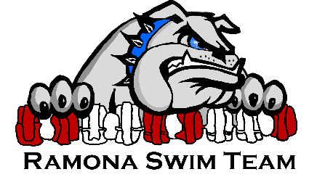 Swimmer Commitment Agreement
As a member of Ramona Swim Team all swimmers represent our club as the face of the team at practices, meets and team events. To maintain good standing with Ramona Swim Team, all swimmers must agree to the following expectations.
As a swimmer of Ramona Swim Team, I will:
- Be on time, ready to learn, to all practices, meetings, and meet warm-ups. Arrive ready to warm-up with proper gear before practice begins. Arrival time for Morning Practice is 15 Minutes prior to swim time to allow time to prepare the pool.
- Show respect for all facilities and other property (including locker rooms) used during practices, competitions, and team activities. Put away any equipment used during practice. Follow all pool and facility rules and leave all areas as clean or cleaner than when I arrived.
- Put forth my best effort during every practice that I attend, recognizing that I set an example for my younger teammates.
- Display proper respect and sportsmanship toward coaches, teammates, officials, parents, and the public, and I will refrain from any behavior that may discredit or embarrass the team or myself, including foul language, violence, behavior deemed dishonest, offensive or illegal.
- Refrain from use of illegal substances, alcohol, and tobacco.
- Obey all of USA Swimming’s rules and codes of conduct.
- In meetings I will pay attention to the speaker and contribute only when it is appropriate to do so.
- Listen intently to every coach and follow their instructions at practices, meets and team activities. This includes keeping my head above water at the walls to hear instructions.
- Never interfere with the progress of another swimmer.
- Support and encourage my teammates at practice and meets. Not physically or verbally harass others, including pushing or pulling other swimmers under the water. Be respectful of my teammates’ feelings and personal space. Swimmers who exhibit sexist, racist, homophobic, or otherwise inappropriate behavior will be faced with consequences.
- Be respectful of other people’s possessions and property. I will refrain from activities that cause damage to either. I understand that team members are financially responsible for any damage they cause and theft.
- Keep my coaches informed of any illnesses or injuries.
- Show team pride by wearing team gear at meets. If I wear a cap, it will only be a Ramona Swim Team cap.
- Display a positive attitude and give an honest effort in training and competition. I will:
- Accept assigned practices/events without complaining or arguing.
- Refrain from being disruptive in my practice group or disrupting other swimmers in my practice group.
- Be a good sport no matter how I finish my race.

Consequences: One or more of these steps may be bypassed to address instances deemed by the coaches to be severe or threatening to others or for swimmers who repeatedly violate team expectations and guidelines. Failure to follow the rules in this agreement will result in the following disciplinary actions:
Step 1: Verbal warning
Step 2: 5-10 minute on-deck time-out: Parents/guardians will be contacted after practice.
Step 3: Asked to leave practice or meet: If asked to leave practice, the swimmer will be provided a phone to call and notify their parent/guardian while the coach continues to supervise practice. Swimmers must wait on-deck with the coach until their parent/guardian arrives. Under no circumstances is the swimmer to wait upstairs, in the lobby, or outside if they are asked to leave practice. Parents/guardians are asked to speak with the coach after practice so the coach’s attention remains on the swimmers in the water.
Step 4: Suspension from the team: The length of suspension is determined by the severity of the swimmer's actions. All decisions regarding suspension are determined by a majority vote of the Board of Directors. Families are not issued any refund for suspension from the team.
Step 5: Dismissal from the team: All decisions regarding dismissal from the team will be determined by a majority vote of the Board of Directors. Families are not issued any refund for dismissal from the team.
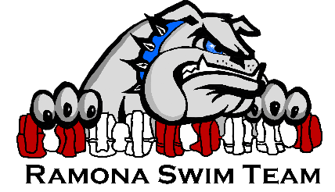 Swimmer Commitment Agreement
Please sign and return this signature page to your coach and keep page 1 One per family—All swimmers and parents/guardians must sign this agreement

Family Name_________________________________

As a member of Ramona Swim Team I understand that all swimmers represent our club as the face of the team at practices, meets and team events. I understand that in order to remain in good standing with Ramona Swim Team I must follow all of the expectations in the Swimmer Commitment Agreement.
I have read and understand my responsibilities as a member of Ramona Swim Team. I understand and agree to the consequences if I do not follow the team behavior expectations.

Swimmer #1 Signature: _________________________ Date: ______________

Swimmer #2 Signature: _________________________ Date: ______________

Swimmer #3 Signature: _________________________ Date: ______________

Swimmer #4 Signature: _________________________ Date: ______________

As the parent(s)/guardian(s) of the above swimmer(s) I have read and understand the team behavior expectations. I understand and agree to the consequences set forth by the team for violating the team behavior expectations. I agree to wait until the end of practice to discuss any discipline or other issues with the coach.

Parent/Guardian#1 Signature: ___________________ Date: ______________

Parent/Guardian#2 Signature: ___________________ Date: ______________

