Links to Meet Info

All of the info host teams send to us is posted on our website that you can access through TeamUnify or OnDeck. When the meet info is initially sent out the meet invite is included; closer to the meet additional info is added like psych sheets, timelines, and heat sheet if available.

Accessing out of Desktop TeamUnify website at www.caldwellswimclub.org

Step 1: Login and then go to Events & Competition, click on the MEET NAME – it doesn’t look like a hyperlink, but it is.

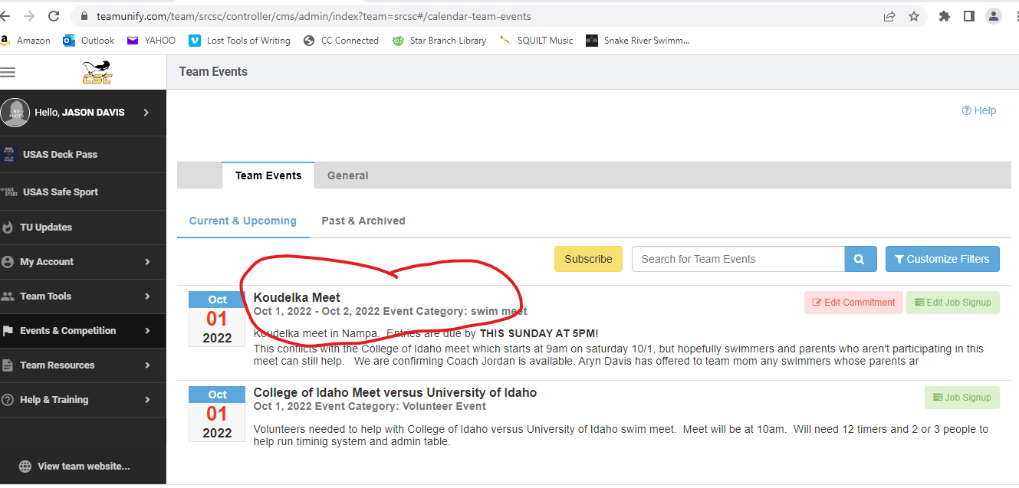

Step 2: Once arriving to the Team Event Details page, scroll down to the bottom FORMS/DOCUMENTS.

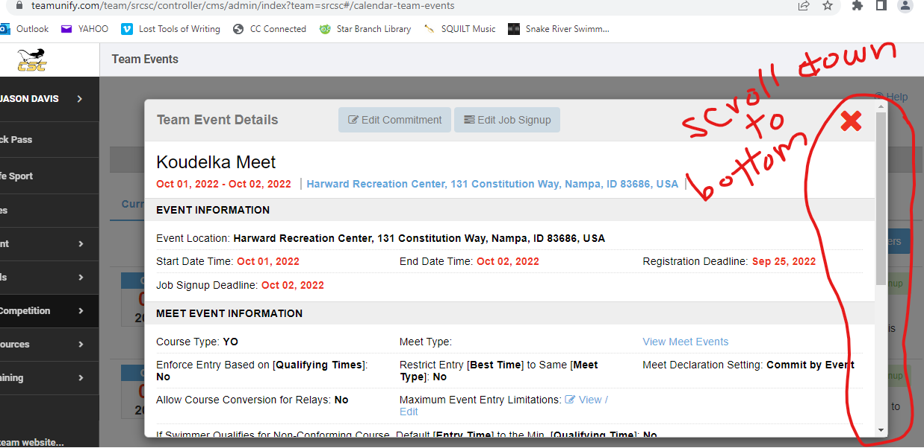

Step 3: In FORMS/DOCUMENTS section, Click on Koudelka 2022 Invite.doc. Usually important times for warmups and start of meet are included in page 1 or 2. The other documents are added closer to the actual meet.

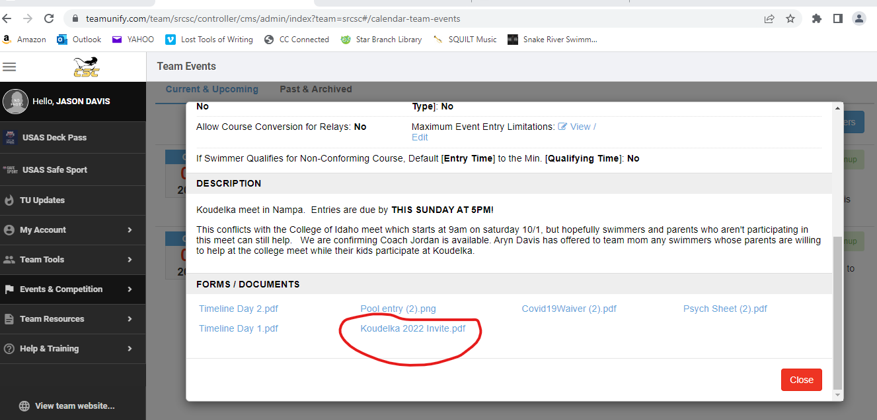

This info is also very easy to access through OnDeck.

Go to the OnDeck app and login. From there, go to the tab on the left (click the 3 lines in top left corner if needed) and select events:
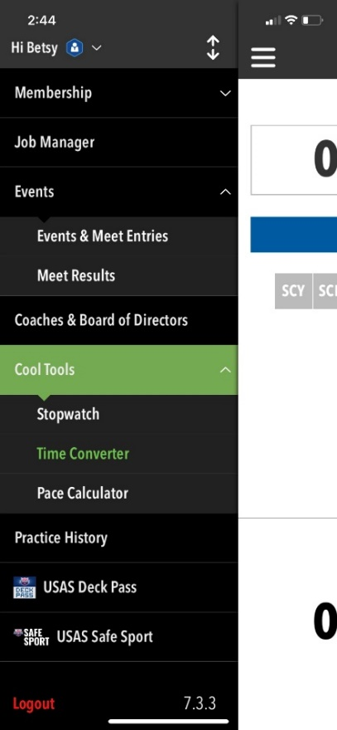

On this screen, press “events & meet entries” and it will take you to a list of meets

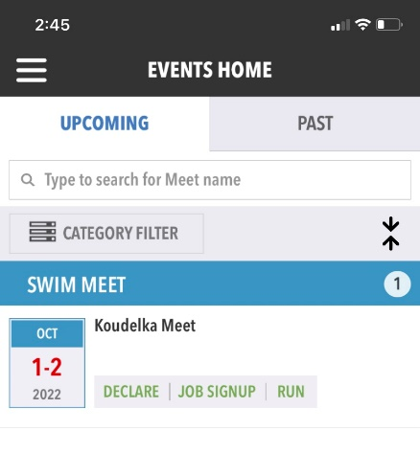
click on koudelka meet or in the white space in that block.

That brings you to this screen:

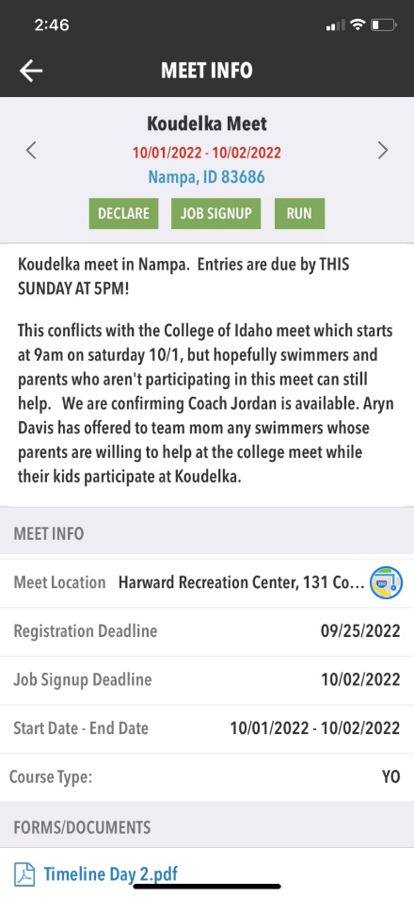

Scroll down and it will take you to the forms & documents:

