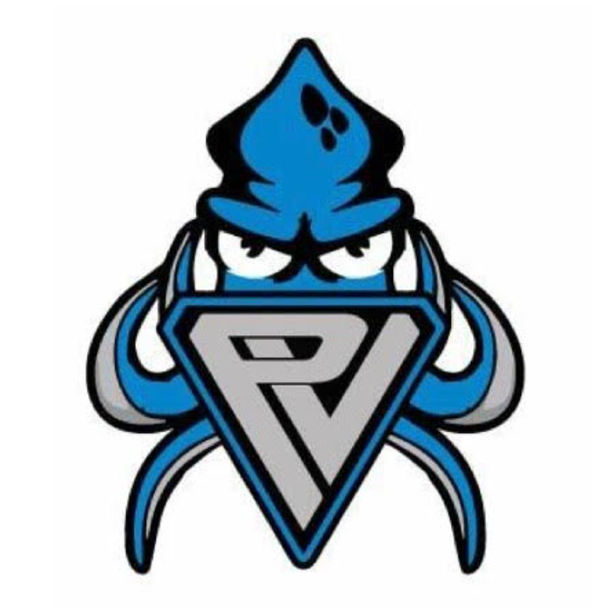

Swim Challenge 2024

Considering the interest from families and swimmers for more team-oriented events, we've decided to reintroduce the Swim Challenge on Friday April 5th, during regular swim hours.. This event is aimed at strengthening our sense of community and providing an enjoyable and engaging activity for everyone involved.
The primary purpose of the swim challenge is to raise funds for the club, which will be used to organize a special field day at Lagoon. This promises to be a memorable experience for all participants, with the trip planned for Monday, June 17. For each family that raises $200, their registered swimmer(s) can look forward to not only entry into Lagoon but also bus transportation with the team to and from, a meal, and the use of a reserved terrace where the team can relax and dine together. If your swimmer cannot attend on this date, rest assured the ticket will be valid for any other day during the 2024 season, offering flexibility to enjoy Lagoon at a more convenient time. Additional funds raised will contribute to the development of scholarship funds that families can apply towards coaching and swim meet fees.
Regardless of funds raised, we encourage ALL swimmers to participate in the swim challenge. Swimmers earn ducks after completing a certain number of laps*, and then they can use those ducks to see if they have won additional prizes. It is a great team building activity, and fun for all who participate.
Attached you will find a letter that you can send to family and friends for fundraising. It includes our team Venmo QR code which will be the easiest way to donate. If they need to send cash or a check, there is a slip that can be included with their payment. PVST has a locked black mailbox by the entrance to the Rec Center where you can leave payment. All payments need to be in by Friday Apr 19, 2024. Make sure that you identify your swimmer(s) by their first and last name with either payment method so that they will get credit for the donation.

*Swim Challenge Hours and Length Requirements
- 3:15-4:00 pm: Kraken Kids, Blues and Grays-20 lengths (1 duck for every 5 lengths.)
- 4:00-5:00 pm: Juniors–50 lengths (1 duck for every 10 lengths.)
- 4:00-5:30 pm: Seniors and Nationals–125 lengths (1 duck for every 25 lengths.)
(ENTER SWIMMER’S NAME)
(ENTER RETURN ADDRESS)

Dear ________________________,

This is ______________________________and I swim competitively for Portneuf Valley Swim Team. We are one of the best year-round swim teams in Idaho thanks to our amazing swimmers and coaches.

This year our club is doing a Swim Challenge to raise money for a team building trip to Lagoon, PVST events, meets, athlete travel, equipment, and more. The Challenge will be held on Friday April 5th. Your donations help keep our program strong and it would be hard to do it without you.

Here is how our Swim Challenge works: On Friday, April 5th, I will swim _________ lengths of the pool. You can do a pledge per length or a flat pledge to support me in my Swim Challenge efforts.

There are two ways to donate. The preferred method is Venmo using the QR code provided. Please be sure to include my first and last name so that I can get credit for the donation. If you don’t have Venmo you may include the strip below with your cash or check. If I can raise $200, I will earn a full day at Lagoon with transportation and a meal.

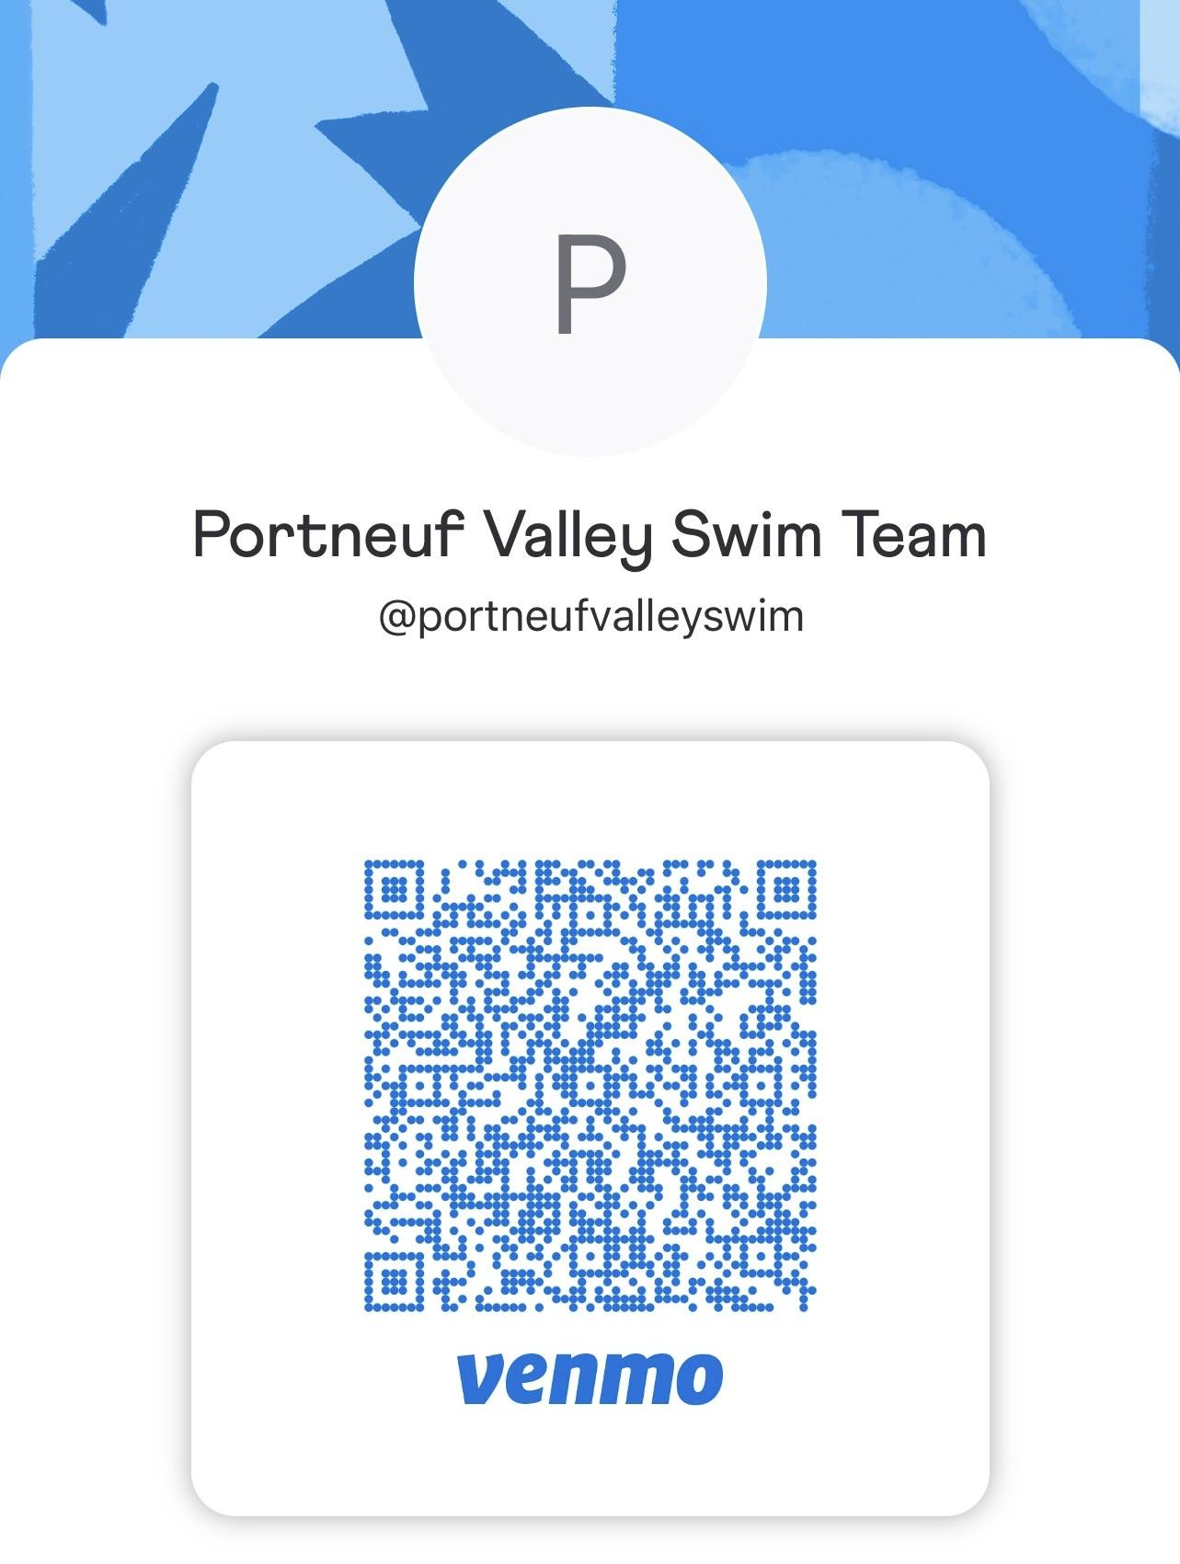
Please have your donation in by Friday April 19th.

Thank you for supporting me!
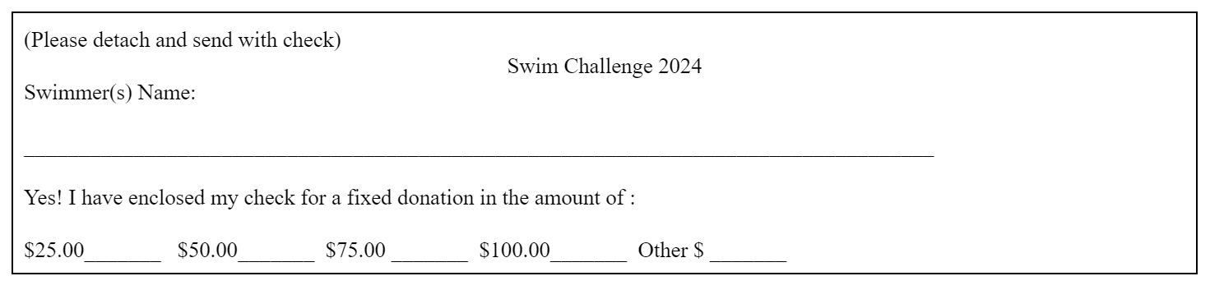

PVST Swim Challenge 2024 Pledge Sheet

Swimmer’s Name__________________________________________
Total lengths swam on April 5th:

Donor’s Name (and contact info if necessary) | Amount per length | OR Flat Donation | Total Money Raised
Total money raised:

