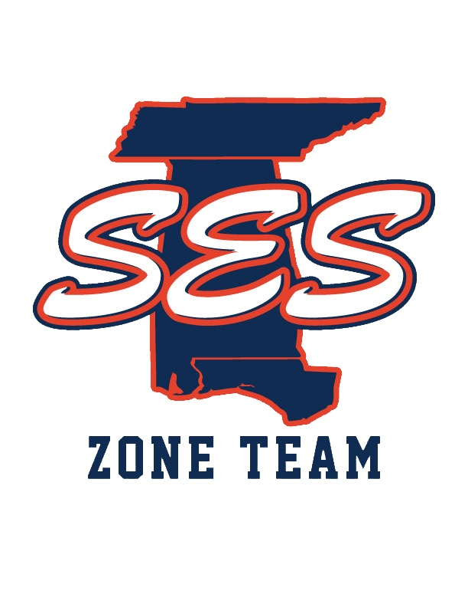
Southeastern Swimming
Age Group Report
2020-2021
Caroline Bentley
Age Group Chair

2021 Short Course Regional Championships

Host Region

Xcel 1 Baylor 2 Wake/SBY/CTA 3
GPAC 4

2021 Southeastern Swimming Short Course Championships

Hosts:

HSA -Senior
HSA - Age group (Alabam/Florida)
Ensworth - Age group (Tennessee)

2021 Southeastern Swimming Long Course Championships

Hosts

NAC/Excel

2021 Southern Zone Open Water Championships

The 2021 Open Water zones was held June 5-6 in Chattanooga, TN. SES had 17 swimmers representing the LSC. We had 3 top 8 finishes individually.

2021 Southern Zone Age Group Championships

Host: Shockwave Aquatics (Tupelo, MS)
Dates: July 27, 2021 - July 31, 2021

Team Placement:

1st: North Carolina
2nd: Florida Swimming
3rd: Team Georgia

SES: 6th place (with no senior swimmers)

We finished the meet with 35 top 8 finishes including 7 individual wins! 13 out of our 18 relays finished in the top 3! One swimmer, Peyton Williams, won high point award for 11-12 girls. The 6th place finish was one place higher than 2 years ago, the first year we only took 11-14 year olds.

2021 SES Records Broken

Short Course

13-14 Girls

Levenia Sims (100 back)

15-16 Boys

Sam Powe (100 back, 200 back)

Long Course

13-14 Girls

Levenia Sim (100 fly)

17-18 Girls

Gretchen Walsh (50 free, 100 fly)

Letitia Sim (100 breast)

8 & Under Boys

Samuel Stern (50 free, 50 back)

