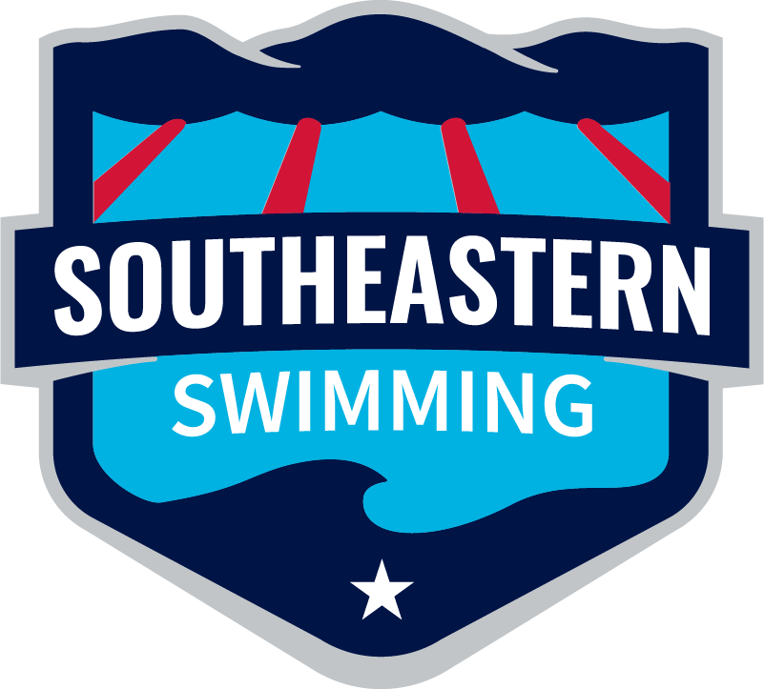
Southeastern Swimming

2023-24 Age Group Report

Michael Bottchen

Age Group Chair

2024 Short Course Regional Championships
- Region 1 Host – XCEL (results)
- Region 2 Host – Baylor (results)
- Region 3 Host- BSL (results)
- Region 4 Host- GPAC (results)

2024 Southeastern Winter Championships
Host – Huntsville Swim Association
- (results)
- (team scores)
- (Individual high point)
- (Age Group Team Scores)

2024 Southeastern Summer Championships
Host – Huntsville Swim Association
- (results)

2024 Southern Zone Open Water Championships
Host – Kentucky Swimming (Lucas, KY)
- (results)
We had 20 swimmers selected this year for the OW Zones Championships.
- 11-12 Girls – One
- 11-12 Boys- Two
- 13-14 Girls – One
- 13-14 Boys – Two
- Senior Girls- Eight (Congratulations to Zara Kocak of Xcel, National Team Qualifier)
- Senior Boys- Six
Southeastern Swimming finished 6th overall, however, all 5 teams that placed ahead of us had 40+ athletes on their roster. It is clear that we need to have more age group swimmers apply and attend this meet in the future. I will work on pushing for that here in the upcoming season.

2024 Southern Zone Age Group Championships
Host- West Texas (Midland, TX)
- (results)
We had 45 swimmers attend the meet this year for AG Zones. (2 athletes backed out after SEs)
- 11-12 Girls – 11
- 11-12 Boys -10
- 13-14 Girls -12
- 13-14 Boys -12
Southeastern Swimming finished 5th overall after a LONG and EXHAUSTING travel out to Midland, TX. The swimmers stepped up after competing at SE the weekend before and continued to swim fast and show true determination to race. We had 2 event winners (Erfosini Kerny won the 13-14 Girls 100 Breaststroke and our 13-14 Boys A Relay won the 200 Freestyle relay). I expect us to have a full roster of 48 next year in Orlando, FL.

