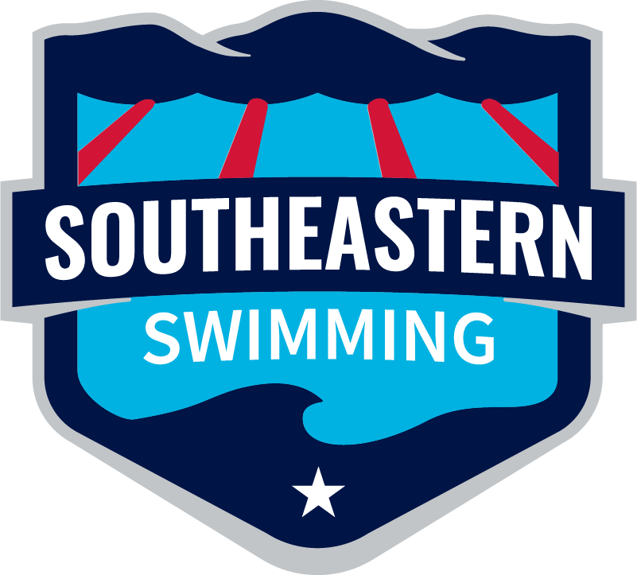
Southeastern Swimming

2024-25 Age Group Report

Michael Bottchen

Age Group Chair

2025 Short Course Regional Championships
- Region 1 Host – XCEL (results)
- Region 2 Host – Baylor (results)
- Region 3 Host- BSL (results)
- Region 4 Host- GPAC (results)

2025 Southeastern Winter Championships
Host – Huntsville Swim Association
- (results)
- (team scores)
- (Individual high point)
- (Age Group Team Scores)

2025 Southeastern Summer Championships
Host – Huntsville Swim Association
- (results)
- (team scores)
- (Individual high point)
- (Age Group Team Scores)

2025 Southern Zone Open Water Championships
Host – Florida Swimming (Fort Myers, FL)
- (results)
- (Team Pursuit)
We had 11 swimmers selected this year for the OW Zones Championships.
- 11-12 Girls – Two
- 11-12 Boys- Two
- 13-14 Girls –
- 13-14 Boys – Two
- Senior Girls- Three
- Senior Boys- Two
Southeastern Swimming finished 6th overall, however, all 5 teams that placed ahead of us had more athletes on their roster. It is clear that we need to have more age group swimmers apply and attend this meet in the future.

2025 Southern Zone Age Group Championships
Host- Florida Swimming (Orlando,FL)
- (results)
- (team scores)
We had a full roster of 48 swimmers attend the meet this year for AG Zones. We had 91 apply.
Southeastern Swimming finished 4th overall after an incredible effort down in Orlando, FL. Thankfully we had a week between Southeastern’s and Zones this year. We were able to fly down and back without in issues. It was a slow start for our athletes at the beginning of the meet but they continued to push through and found their speed. We had multiple 1st place relay finishes and a few individual event winners as well. I look forward to another great year down in Orlando, FL next year for zones.

