Southeastern Swimming

Operational Risk Report

August 2021

CPR/Safety Training Extension

The extension for obtaining CPR/Water practicum safety training ends of 9-1-21 as availability does not appear to be an issue any longer. As of 8-19-21, however, approximately 20% of coaches nationwide were still deficient with one or both.

Report of Occurrence (ROO)
The number of reports filed is up a little, as expected, from last year. Combined data for all LSCs through the end of June showed that the majority of incidents were reported during practice and occurred in the water. Head strikes continued to be the most reported issue.

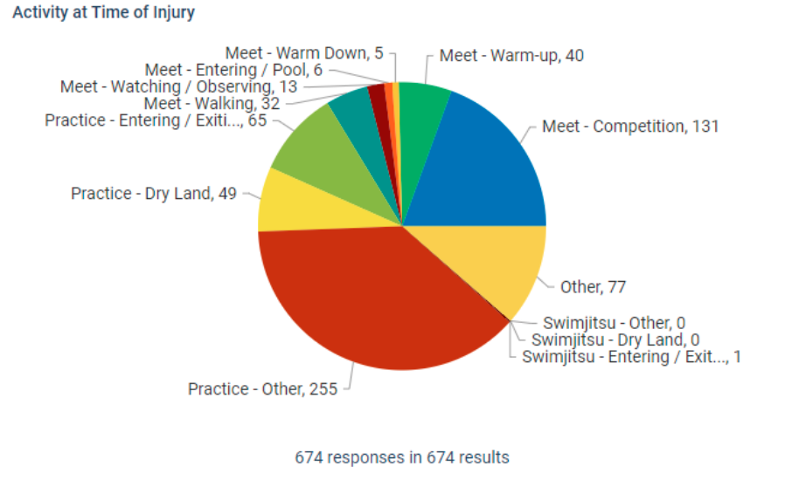

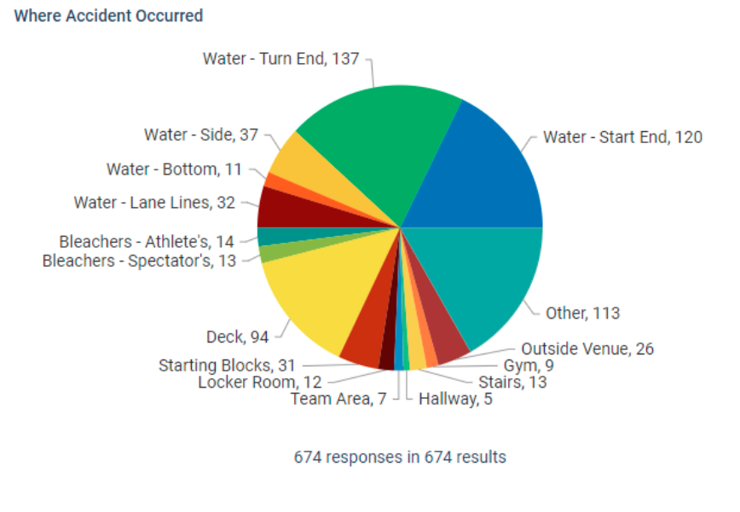

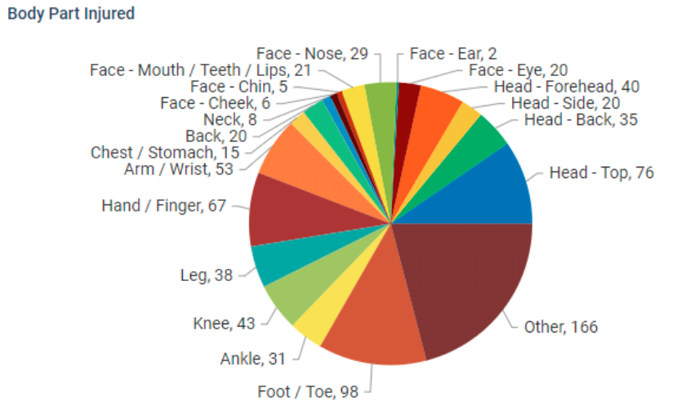
There was only one Report of Occurrence received from SES during this time, which suggests that we may be under-reporting. Everyone should be encouraged to report in a timely manner any accident/incident regardless of severity. This is the only mechanism to connect the individual (or their parent/legal guardian) with the proper person for USAS insurance purposes.

Air Quality
I had the privilege of chairing a task force on air quality. We assembled a team of experts and presented “Inhale/Exhale – How Air Quality Impacts Swimmer Respiratory Health & What You Can Do about It”. This two-part webinar series focused on the respiratory health of swimmers and the importance of minimizing exposure to airborne contaminants in both indoor and outdoor pool environments. Speakers included:
- Tod Olin, MD, MSCS – respiratory consultant for US Olympic and Paralympic Committee as well as USAS. He taught us to recognize the difference between asthma and EILO.
- Melissa Millerick-May, Ph.D. – Assistant Professor of Medicine at Michigan State University, just published research on air quality and lung function for age-group swimmers
- Keenan Robinson, MS-ATC, NASM-PES – Director of Sports Medicine and Science for USAS
- Anthony Oliveri, Ph.D., MPH, CIH, CSP – Assistant Professor at Michigan State University, studying air quality in pools and the respiratory health of collegiate swimmers.
- Chip Blatchley, Ph.D., PE, BCEE, FASCHE – Professor in Environmental Engineering at Purdue University, has spent 20 years studying the links between swimming pool chemistry and indoor air quality in indoor aquatic facilities.
Both webinar sessions were recorded and are available under Recently Recorded Webinars here https://www.usaswimming.org/coaches/clinics-workshops#webinars---presentations. They will eventually reside on the Operational Risk webpage.

Operational Risk Annual Open Meeting
Since there will be no Convention this year, the Operational Risk Committee will hold our annual open meeting on Thursday September 16 at noon Central time via Zoom. Anyone is welcome to join this meeting. You have to register through USAS and be sent a link to attend.

If you have any questions, please let me know.

Submitted by: Donna S. Williamson, Chair Operational Risk
Submitted on: August 26, 2021

