USA SWIMMING
COACH MEMBERSHIP REQUIREMENTS

Steps to become a coach member (additional details are below):
- Initiate your criminal background check (www.usaswimming.org/backgroundcheck).
- Complete a CPR/AED course from the list below (courses not on the list will not be accepted).
- Complete Safety Training for Swim Coaches (details below).
- Determine your Local Swimming Committee (www.usaswimming.org/LSCmap) and then go to the LSC website to print the non-athlete application form.
- Send the completed form, payment, CPR/AED and STSC certifications to the LSC (amount due and address will be printed on the form)
- Receive email confirmation that your application has been received and entered into the database; then complete Steps 7 & 8.
- Complete Foundations of Coaching 101 (new coaches only) (www.usaswimming.org/FOC).
- Complete the online Athlete Protection Training course (www.usaswimming.org/protect).

* * * * * * * *

From the USA Swimming rulebook: “Anyone who coaches athletes at a USA Swimming practice or competition must be a coach member of USA Swimming and must have satisfactorily completed safety training, criminal background checks and other coaches’ education as required by USA Swimming.”

Requirements must be kept current at all times. There is no grace period; coach membership is not valid if any of the requirements lapse or expire. A coach does not have USA Swimming insurance coverage if his/her membership is not valid. To help coaches manage their membership requirements, the date that each requirement expires is printed on their USA Swimming coach membership card, as well as being available on the Deck Pass phone app and through the online Club Portal. Additional information and links for each requirement can be found at www.usaswimming.org/coachmember.

APPLICATION FORM, SUBMITTAL INSTRUCTIONS, MEMBERSHIP CARD
Memberships are processed by each LSC (Local Swimming Committee). Non-athlete application forms can be found on most LSC websites. A map of LSCs and a list of their websites can be found at www.usaswimming.org/lscmap. If you cannot find the form online, please contact the LSC directly. Coaches should complete and mail their application to the address printed on the application form. The membership fee is also printed on the application form. The LSC will mail the coach membership card after all membership requirements have been met. Coaches can check their membership status at any time on any mobile device through their Deck Pass account (www.usaswimming.org/deckpass)

CRIMINAL BACKGROUND CHECK
All non-athlete members must pass a criminal background check every 24 months. Go to www.usaswimming.org/backgroundcheck for additional information and to initiate the background check. When the background check has been passed, the membership database is updated and the LSC is notified automatically. The cost of the initial background check is $39. The cost of the renewal is $19. If you do not renew it within 30 days of its expiration date, you will need to complete the $39 initial background check again.

ATHLETE PROTECTION TRAINING
All non-athlete members must complete the online Athlete Protection Training course every 2-3 years (varies depending on the month the course is completed). The course takes approximately 60 minutes to complete and is offered at no charge. Go to www.usaswimming.org/protect for additional information and to access the course. When the course has been completed, the membership database is updated and the LSC is notified automatically.

Current and previous members can access the course at any time. New non-athlete members must register through their LSC first. New members cannot initiate the course until their membership application has been processed by their LSC. When the membership application has been processed, the new member will receive email notification and the course can then be completed. (An error message will appear during the log-in if the new member’s application hasn’t been processed yet. New members will receive an email as soon as their membership has been processed by the LSC.)

THREE EDUCATIONAL REQUIREMENTS
- Foundations of Coaching 101: Foundations 101 must be completed prior to becoming a coach member of USA Swimming. ($15)
- Foundations of Coaching 201: Foundations 201 must be completed prior to 2nd year of registration. ($25)
- Rules and Regulations for Coaches Test: Rules and Regulations for Coaches must be completed prior to 2nd year of registration. (no fee)

TWO SAFETY TRAINING REQUIREMENTS
1. Adult and Pediatric/Child CPR & AED
Coach members must maintain two safety certifications: (1) Adult & Pediatric/Child CPR/AED and (2) Safety Training for Swim Coaches (STSC). A list of acceptable courses is below. Certifications must be on this list. Online-only courses are not acceptable. Coaches should enclose a copy of their safety certifications with their application and payment to their LSC.

Coaches who do not have access to an acceptable CPR/AED course or have taken a course that is not on this list can call their local American Red Cross chapter to challenge one of their Adult and Pediatric CPR/AED courses. The challenge involves passing the skills assessment with an ARC instructor without having to take the entire course. The ARC will charge a fee for each challenge.

2. Safety Training for Swim Coaches (STSC)
The STSC requirement consists of two components: (A) an online course and test, and (B) a skills session in a pool.

- All coaches must complete the online course and test.
- There are three options for the skills session:
- Take the full skills session with an American Red Cross instructor;
- Print the new STSC in-Water Skills Checklist and review the skills with an instructor certified by one of the organizations on the checklist;
- Maintain a valid lifeguard certification.

To take the online component of Safety Training for Swim Coaches:
Mac users: You will need to use Mozilla Firefox as your browser in order to complete the online course and test. Other browsers, when using a Mac, may cause you to lose any record of having completed any part of the course.

Coaches who are taking the full in-water component from an American Red Cross instructor will receive a special link from the instructor and should NOT follow the steps below. Coaches who plan to complete the in-water component using the In-Water Skills Checklist or have a valid lifeguard certification can go directly to
www.redcross.org/take-a-class and complete the steps below (screen shot of this ARC web page follows below):
- Select your location – no need to change the default since your coaches are doing an online course, not an in-person course.
- Select a class category – click on the down arrow and scroll down to Coaches Training; hit Enter.
- Search for classes – click on Find Classes.
- “Safety Training for Swim coaches – Online Content Only” will appear.
- When the course is completed, save/print the Online Content Only certificate (to forward to your LSC registrar).

The cost of the online course if $19 and should take 2-3 hours to complete. Coaches can exit the course at any time and log back in to resume where they left off UNTIL they begin the final exam. Once they start the exam, they need to complete it in one session.

COACHES WHO HAVE A VALID LIFEGUARD CERTIFICATION:
- Obtain or renew an eligible lifeguarding certificate (see the list below for eligible certifications).
- Complete the STSC Online Content Only course option. Enroll in this course at www.redcross.org/take-a-class. (See instructions above.) Print/save the Online Content Only certificate (not the certificate of the test score).
- Send a valid, eligible lifeguarding certificate and the STSC Online Content Only certificate to the LSC Membership Chair. The earlier of the two expiration dates will determine the STSC credential.
- Repeat this procedure every two years.

COACHES WHO DO NOT HAVE A VALID LIFEGUARD CERTIFICATION AND PREFER TO USE THE NEW IN-WATER SKILLS CHECKLIST:
- Contact a lifeguard instructor certified by any of the organizations on the in-water skills checklist (sample checklist is below; a copy should also be posted on your LSC website). Set a time to review the skills in a pool with the instructor.
- Complete the STSC Online Content Only course option. Enroll in this course at www.redcross.org/take-a-class. (See instructions above.) Print and save the Online Content Only certificate (not the certificate of the test score).
- Take a copy of the Online Content Only certificate and the in-water skills checklist to the pool for the skills review with the lifeguard instructor (see Step 1). Review the skills with the instructor, sign the checklist and have the instructor sign it, then send both the checklist and certificate to your LSC registrar.
- Repeat this procedure every two years.

COACHES WHO DO NOT HAVE A LIFEGUARD CERTIFICATION AND HAVE ACCESS TO AN AMERICAN RED CROSS INSTRUCTOR:
The full Safety Training for Swim Coaches course is only offered by the American Red Cross. Detailed information about this course can be found at www.usaswimming.org/STSC > Frequently Asked Questions. Steps to follow for the full course with an ARC instructor:

- Find an ARC WSI (water safety instructor) or LGI (lifeguard instructor) to arrange a date and place to complete the skills session in a pool. The easiest way to find an ARC LGI is to contact pools in your area and find out which ones hire ARC lifeguards, or go to www.redcross.org/aquaticrepresentatives for a list of ARC aquatic representatives by region. If the WSI/LGI is not familiar with the STSC course, they can go to Instructors’ Corner (a password protected website for all ARC instructors – click on Water Safety Education, then the Swim Coach tab). The ARC instructor needs at least two weeks to get the course set up.
- Once the course has been set up and confirmed by the ARC, the instructor will email a Course Registration Link to you.
- Register for and take the online course and test by using the link provided by the instructor (the course can be started, stopped and restarted at any time; progress will be bookmarked automatically. Coaches CANNOT, however, stop the final exam once it is begun; that must be completed in one session.) If you take the online course without waiting for the registration link from the instructor, you will be required to take it again and pay another registration fee to do so. The instructor MUST be able to link your online course to his record of the pool session; he cannot do that if you take the course without going through the registration link set up by the instructor.
- After completing the online course and test, print the certificate as proof and then attend the pool session scheduled by the instructor. This session will be an abbreviated review session for those with a current STSC certification or a full session for those without a current STSC certification.
- Upon successful completion of the STSC pool session, the instructor will email the completion certificate. Save and print the certificate and submit it to your LSC Membership Chair; the credential will be valid for two years.
- Repeat the process every two years.

STILL HAVE QUESTIONS? Contact your Local Swimming Committee registrar.

www.redcross.org/take-a-class screen shot for STSC Online Content Only course:

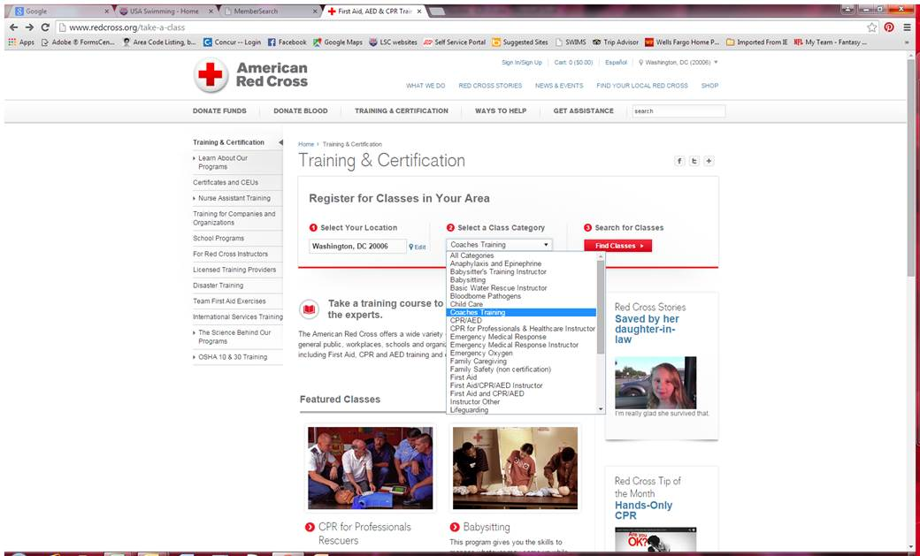
APPROVED SAFETY CERTIFICATIONS

Requirements must be kept current at all times. There is no grace period; coach membership is not valid if any of the requirements lapse or expire. Coaches do not have USA Swimming insurance coverage if their membership is not valid; club insurance is also jeopardized by allowing coaches with lapsed certifications to be on deck. To help coaches manage their membership requirements, the date that each requirement expires is printed on the USA Swimming coach membership card, as well as being available on the Deck Pass phone app and through the online Club Portal. Below is a list of courses that have been approved by the Operational Risk Committee. Certifications from courses not on this list will not be accepted.

ORGANIZATION | COURSE NAME | CPR | STSC | NOTES RE THIS COURSE
American Red Cross  1-800-red-cross or support@redcrosstraining.org  NOT ACCEPTABLE:  - Instructor certifications  - First Aid, Health & Safety for Coaches  - Foreign Red Cross certs | Adult and Child CPR/AED | Yes
 | Adult and Pediatric CPR/AED | Yes
 | CPR/AED for Professional Rescuers and Healthcare Providers | Yes
 | Adult and Child First Aid/CPR/AED | Yes
 | Adult and Pediatric First Aid/CPR/AED | Yes
 | Responding to Emergencies | Yes
 | Lifeguarding/CPR/AED | Yes | Yes | For STSC, must also complete online STSC course
 | Emergency Medical Response | Yes
 | Lifeguarding, Lifeguarding Review |  | Yes | Must also complete online STSC course
 | STSC In-Water Skills Checklist |  | Yes | Must also complete online STSC course
 | Responding to Emergencies with CPR/AED – Adult and Pediatric | Yes
 | Safety Training for Swim Coaches |  | Yes
 | Safety Training for Swim Coaches with Adult and Pediatric CPR and AED | Yes | Yes
American Heart Assoc. | ACLS Provider | Yes
American Heart Assoc. | Adult & Pediatric Basic Life Support | Yes |  | Two separate cards issued – one for Adult and one for Pediatric – both are required
American Heart Assoc. | Heartsaver CPR & AED | Yes
American Heart Assoc. | Heartsaver First Aid with CPR & AED | Yes
American Heart Assoc. | Healthcare Provider | Yes |  | Also known as BLS for Healthcare Providers
American Heart Assoc. | AHA Basic Life Support Instructor | Yes
American Heart Assoc. | AHA Instructor or Instructor Trainer | Yes |  | Applies to any of the AHA courses above
American Lifeguard Assoc. | Lifeguard, or Lifeguard Recert, with CPR/AED | Yes | Yes | Card must have “Instructor Led” printed on it  For STSC, must also complete online STSC course
American Lifeguard Assoc. | STSC In-Water Skills Checklist |  | Yes | Must also complete online STSC course
ASHI (American Safety & Health Institute) | CPR and AED | Yes
ASHI (American Safety & Health Institute) | CPR Pro | Yes
ASHI (American Safety & Health Institute) | Pediatric CPR and AED | Yes |  | (The pediatric course does include adult CPR/AED)
ASHI (American Safety & Health Institute) | Basic First Aid, CPR and AED | Yes
California Parks & Rec | California State Lifeguard | Yes

ORGANIZATION | COURSE NAME | CPR | STSC | NOTES RE THIS COURSE
Ellis & Associates | International Lifeguard Training | Yes | Yes | One year certification  For STSC, must also complete online STSC course
Ellis & Associates | Water Safety+ | Yes
Ellis & Associates | STSC In-Water Skills Checklist |  | Yes | Must also complete online STSC course
Ellis & Associates | Int’l Lifeguard Training Instructor | Yes | Yes | For STSC, must also complete online STSC course

EMS Safety Services | CPR/AED for Community Rescuers | Yes
EMS Safety Services | CPR/AED for Professional Rescuers | Yes
EMS Safety Services | CPR/AED & First Aid for Community Rescuers | Yes
EMT | Emergency Medical Technician Basic or Intermediate | Yes |  | The training agency for an EMT certification can be a hospital, fire department or other agency.
Emergency Care & Safety Institute | CPR and AED  (“Interactive” is NOT acceptable) | Yes |  | In conjunction with the American Academy of Orthopaedic Surgeons (AAOS may appear on card)
Emergency Care & Safety Institute | Professional Rescuer CPR and AED | Yes |  | In conjunction with the American Academy of Orthopaedic Surgeons (AAOS may appear on card)
Life Safe Services | American Trauma Event Management Adult/Pediatric CPR/AED | Yes
Medic First Aid Int’l | First Aid Basic Plus | Yes
Medic First Aid Int’l | Pediatric Plus | Yes
NAUI (Nat’l Assoc of Underwater Instructors) | CPR & First Aid | Yes
National Safety Council | CPR & AED | Yes |  | Length of certification varies by training agency
National Safety Council | First Aid, CPR & AED | Yes |  | Length of certification varies by training agency
National Safety Council | Advanced First Aid, CPR & AED | Yes |  | Length of certification varies by training agency
National Safety Council | Emergency Medical Response | Yes |  | Length of certification varies by training agency
Nat’l Registry of Emergency Medical Technicians | Paramedic | Yes
Nat’l Registry of Emergency Medical Technicians | EMT – Basic or Intermediate | Yes
PADI Emergency First Response | Emergency Responder – CPR/AED/FA | Yes
PADI Emergency First Response | Emergency Responder – CPR/AED | Yes
PADI Emergency First Response | Emergency Responder – CPR/FA | Yes
ProCPR or ProTraining | Adult/Child/Infant CPR & AED for Health Care Provider (BLS) | Yes |  | Must have name of Instructor AND Skills Evaluator on card
ProCPR or ProTraining | ProFirst Aid/ProFirst Aid Advanced | Yes |  | Must have name of Instructor AND Skills Evaluator on card
StarGuard | StarGuard | Yes | Yes | For STSC, must also complete online STSC course
StarGuard | STSC In-Water Skills Checklist |  | Yes | Must also complete online STSC course
Tacoma Fire Dept | First Aid, CPR & AED | Yes

ORGANIZATION | COURSE NAME | CPR | STSC | NOTES RE THIS COURSE
Save-A-Life Educators | CPR/AED – Adult/Child, or Adult/Child/Infant | Yes |  | Must include in-person skills assessment; if “online training” is printed on card, it must be accompanied by a second card stamped “skills assessment passed”.
Save-A-Life Educators | CPR/AED/First Aid | Yes
YMCA  (Instructor cert not accepted) | Lifeguarding |  | Yes | Must also complete online STSC course
YMCA  (Instructor cert not accepted) | Lifeguard Crossover |  | Yes | Must also complete online STSC course
YMCA  (Instructor cert not accepted) | STSC In-Water Skills Checklist |  | Yes | Must also complete online STSC course
University Training Centers | Healthcare Provider BLS – Level B or C | Yes

Revised February 5, 2015

