Board of Directors
West Virginia LSC
04/27/2025

Call Meeting to Order:
Role Call:
Approval of Minutes:
Reports of Officers:
- General Chair (Eric Anger)
- Senior Chair (Brent McDonald)
- Age Group Chair (Tara Kurilchick-Green)
- Finance Chair (Rob St. Jean)
- Treasurer (Scott Wilson)
- Secretary (Melissa McGlothen)
– Finance Chair Vice Chair (Rob St Jean)

Reports of Committees:
- Athlete Representative ()
- Coach Representative (Renee Riggs)
- Club Development (Tom Phillips)
- Diversity, Equity, and Inclusion (Katie Paulson)
- Disability (Heather Priddy)
- Marketing (Eric Householder)
- Meet Sanctions (Ali Walker)
- Officials (Rob Clevenger)
- Records (Sarah Nisewarner)
- Registration/Registrar (Lora Snodgrass)
- Safe Sport (Erin Ballard)
- Southern Zones (Tara Kurilchick-Green)
- SWIMS (Melissa McGlothen)
- Operational Risk Committee/Safety Chair (Pinar Nalcakan)
- Governance Chair (Sarah Nisewarner)
Old Business:
- Seasonal Athlete option: 150 days from registration, able to pay up for regular membership, limited to LSC level Championship meets within 150 day period. Price suggestion USA fee $40, LSC $16. Current fee schedule is USA fee $40 plus $7
( Membership Options. Athlete: Regular, Flex, Seasonal, Outreach Application)
We have 16 total outreach memberships in the LSC.
- Add administrative for any adult volunteer who does not interact with athletes. Requires USA Swimming Background Check and Athlete Protection Training ?
- i.e. $33 for AMS

- Hall of Fame: Discussed with Adam Nelson from Arkansas LSC. He suggested LSC Banquet and add Swimmers of the Year for the LSC. Pros: More buy in by current LSC swimmers, mix old and new members. They get about 150 participants at the banquet. $70 per person. Cons: they spend between $6000 and $11,000 depending on where they have the event, i.e. Museum vs restaurant. Swimmers make it competitive. Meeting today after the HOD/BOD for approximately 15 minutes for anyone wanting to volunteer for this committee.
- WV Short Course Review 2025
- Southern Zone Age Group Review
- Age Group Zones Futures Meet- Fall discussion about holding meet by LSC.
- HOD/BOD meeting plans
- Outreach Application approval
New Business:
- Long Course 2025- Myan Pool
Meet Program approval
- LSC Support for LSC Meets
- Fees for membership-Lora
- Southern Zone Selection 1000 point requirement
- Board Member Participation
- Elections: General Chair, Secretary, Senior-Vice Chair, Finance Chair (odd year)
- BOD Meeting and Fall HOD/BOD Meeting schedule

Appendix 1
USA Swimming Registration:
(1) Athlete registration fee is $17.00 + USA Swimming fee through 2010; thereafter, the fee will increase the amount the USA Swimming portion increases.
(2) Flex member fee is $10.00 + USA Swimming fee.
(3) Seasonal registration fee is $7.00 + USA Swimming fee.;
(4) Outreach Members: fee is $2.00 + USA Swimming fee.
(5) Single-Meet Open Water Member fee is $10.00 + USA Swimming fee
(6) Non-athlete/coach registration is $17.00 + USA Swimming fee. (Spring 2007)
(7) Club Member fee $100.00 annually by 12/01 and $200 after 12/01.
(8) Organizational Member fee is $100.00 annually by 12/01 & $200 after 12/01.
(9) A Life Member fee $20.00 + USA Swimming fee.
iv) A $5.00 fee will be assessed for processing transfer registrations. (Spring 2014)

Appendix 2
USA SWIMMING MEMBERSHIPS: ATHLETE REGISTRATIONS IASI has five categories of registrations which apply to athlete members:
Premium Traditional year-round athlete registration. Valid for the entire registration year, beginning on the date of registration through December 31 of the current registration year.
Seasonal/Upgrade Valid for 150 days from the date of registration. Please note: Seasonal membership is not valid at or above the Zone Championship level. Seasonal members may “upgrade” to Premium membership within the same registration year, by paying the difference between Seasonal and Premium.
Flex/Upgrade. For 12&U only. Valid for the entire registration year, beginning on the date of registration through December 31 of the current registration year. Flex members are eligible to compete in two sanctioned competitions per registration year. Please note: Flex membership is not valid at or above the LSC Championship level. Flex members may upgrade to Premium membership within the same registration year, by paying the difference between the cost of Flex and Premium.
Outreach: Valid for the entire registration year, beginning on the date of registration through December 31 of the current registration year. Outreach applicants must meet eligibility criteria.
Single Meet Open Water Valid for a single Open Water meet below the Zone, Sectional and National levels. An Athlete is legally registered for all purposes on the date the registration is completed online and payment is made.

Appendix 3
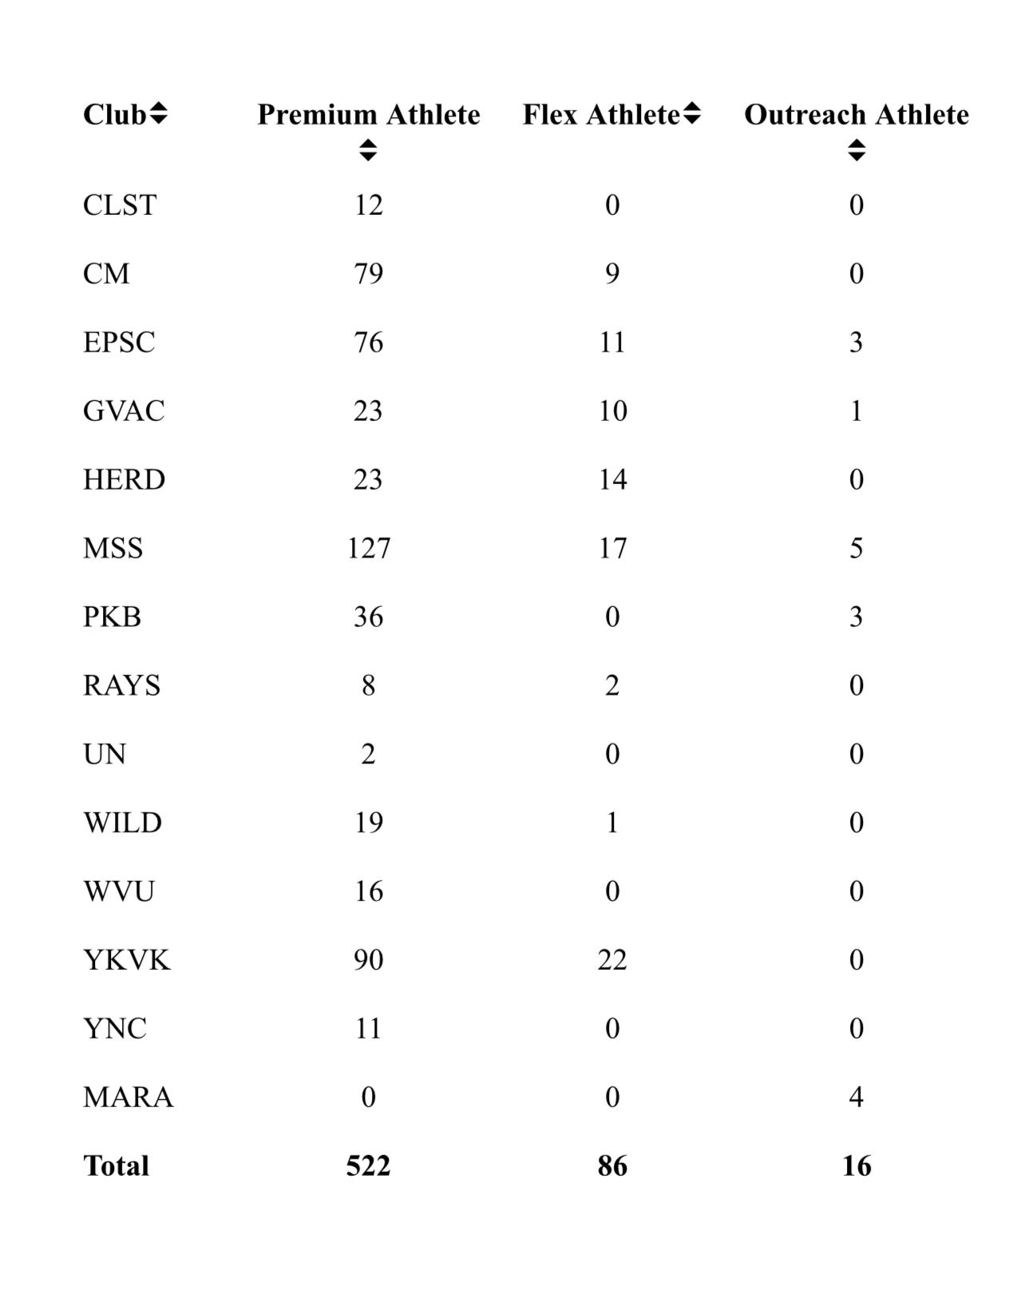

Appendix 4
OUTREACH APPLICATION
WEST VIRGINIA SWIMMING, Inc.

ATHLETE NAME: (L) _____________________________ (F) ________________________ (M) ______
STREET: ____________________________________________________________________________
CITY: ____________________________STATE: _____________________________ ZIP: ____________
BIRTHDATE: ___________________ SEX: __________________
MUST COMPLETE BELOW BY CIRCLING THE QUALIFCATION THAT APPLIES:
QUALIFICATION:
FOOD STAMPS YES
YMCA Scholarship Recipient YES
Temporary Assistance for Needy Families YES
WIC Program YES
Medicaid Medical Card YES
Supplemental Security Income/Social Security Disability Insurance YES
CHIPS YES
Primary Breadwinner Out of Work (more than 6 months) YES

Provide proof or statement of participation in the program circled above.

I understand that in order for me to participate in the USA Swimming Outreach program, I must be a recipient of either Food Stamps, YMCA Scholarship Recipient, Temporary Assistance for Needy Families, WIC Program, Medicaid Medical Card, Supplemental Security Income/Social Security Disability Insurance, CHIPS, or the primary breadwinner has been out of work for more than six months. I certify that I am a recipient of one of these requirements and the above information if true and correct to the best of my knowledge and belief.

SIGNATURE ______________________________________________ PHONE _____________________
(athlete, parent or guardian)

Send athlete form, outreach form, copy of proof of Food Stamps, YMCA Scholarship Recipient, Temporary Assistance for Needy Families, WIC Program, Medicaid Medical Card, Supplemental Security Income/Social Security Disability Insurance, CHIPS, or statement of out of work and $7.00 (Payable to WVS) to:

Ali Walker, WV Swimming Administrative Vice-Chair
400 Forrester Boulevard, Bridgeport, WV 26330
Email: awalker@thebridgewv.com

