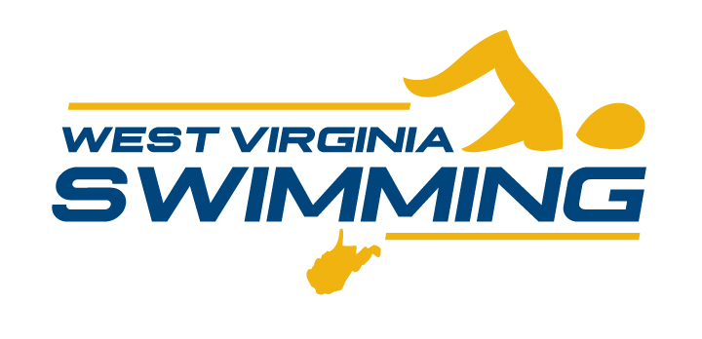 |  |  |  | Meet Name & Date Here
Facility Location
Sanction NO.: | Held under the Sanction of USA Swimming and West Virginia Swimming Inc. In granting this sanction it is understood and agreed that USA Swimming shall be free from any liabilities or claims for damages arising by reason of injuries to anyone during the conduct of this event.
Entries Open
Entries Close
Meet Director | Name: |  |  | Phone: | E-mail:
Meet Entry Chair | Name: |  |  | Phone: | E-mail:
Officials Contact | Name: |  |  | Phone: | E-mail:
Meet Referee | Name: |  |  | Phone: | E-mail:
Meet Admin | Name: |  |  | Phone: | E-mail:
Sessions | Warm-Up Time |  |  |  | Meet Starts
1
2
3
4
5
6
7
8
Events | This meet will be conducted in accordance with the attached schedule of events.
Entry Limit
Entry Fees | Individual Events: |  | $ |  | Relay Events: | $
Entry Fees | Surcharge Travel: |  | $ |  | Surcharge Facility: | $
Mail Checks & Reports To:
Checks Payable To:
Entry Procedures
Deck Entries | All meets will be pre-seeded and deck entries will not be permitted in pursuant of USA Swimming’s October Sanction directive.
Proof of Times:
Scoring | Individual
Scoring | Relays
Awards | Individual
Awards | Participation
Awards | Team
Awards | Relays
USA Swimming Rules | Any swimmer entered in the meet must be certified by a USA Swimming member-coach as being proficient in performing a racing start or must start each race from within the water. When unaccompanied by a member-coach, it is the responsibility of the swimmer or the swimmer's legal guardian to ensure compliance with this requirement.  No swimmer will be permitted to compete unless the swimmer is a member as provided in Article 302.  Operation of a drone, or any other flying apparatus, is prohibited over the venue (pools, athlete/coach areas, spectator areas and open-ceiling locker rooms) any time athletes, coaches, officials and/or spectators are present.” Exceptions may be granted with prior written approval by the Program & Events Committee Chair or designee.  Use of audio or visual recording devices, including a cell phone, is not permitted in changing areas, rest rooms or locker rooms.  Except where venue facilities require otherwise, changing into or out of swimsuits other than in locker rooms or other designated areas is not appropriate and is strongly discouraged/prohibited.  One of the following statements "the competition course has been certified in accordance with 104.2.2C(4). The copy of such certification is on file with USA Swimming" or "The competition course has not been certified in accordance with 104.2.2C(4).
Warm-Up Procedures
Scratch Procedures
Meet Officials Procedures
Concession
Final Results
Contact
Coaches/ Team Rep Meeting
Other Information | Water Depth Measurements:  Statement of standards for athletes with disabilities included **when applicable  USA Swimming COVD Risk Statement: An inherent risk of exposure to COVID-19 exists in any public place where people are present. COVID-19 is an extremely contagious disease that can lead to severe illness and death. According to the Centers for Disease Control and Prevention, senior citizens and individuals with underlying medical conditions are especially vulnerable. USA Swimming, Inc., cannot prevent you (or your child(ren)) from becoming exposed to, contracting, or spreading COVID-19 while participating in USA Swimming sanctioned events. It is not possible to prevent against the presence of the disease. Therefore, if you choose to participate in a USA Swimming sanctioned event, you may be exposing yourself to and/or increasing your risk of contracting or spreading COVID-19. BY ATTENDING OR PARTICIPATING IN THIS COMPETITION, YOU VOLUNTARILY ASSUME ALL RISKS ASSOCIATED WITH EXPOSURE TO COVID-19 AND FOREVER RELEASE AND HOLD HARMLESS USA SWIMMING AND [INSERT THE LSC] AND EACH OF THEIR OFFICERS, DIRECTORS, AGENTS, EMPLOYEES OR OTHER REPRESENTATIVES FROM ANY LIABILITY OR CLAIMS INCLUDING FOR PERSONAL INJURIES, DEATH, DISEASE OR PROPERTY LOSSES, OR ANY OTHER LOSS, INCLUDING BUT NOT LIMITED TO CLAIMS OF NEGLIGENCE AND GIVE UP ANY CLAIMS YOU MAY HAVE TO SEEK DAMAGES, WHETHER KNOWN OR UNKNOWN, FORESEEN OR UNFORESEEN, IN CONNECTION THEREWITH.

