Elements 2013-2017
Solo elements
Required elements 1-5 must be performed in the order listed
- Starting in a Vertical Position, the body rotates through 360 degrees opening to a Split Position. Continuing in the same direction a further 360 degrees rotation is completed while the legs join to Vertical Position. Rotating in the opposite direction, a Continuous Spin of 4 rotations is executed. DD = 2.1
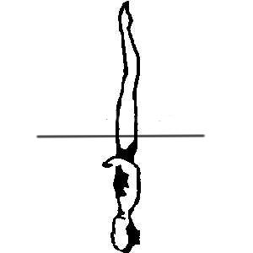 | 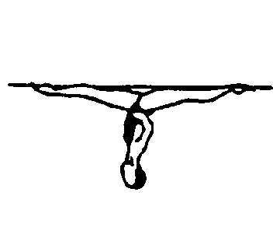 |  | 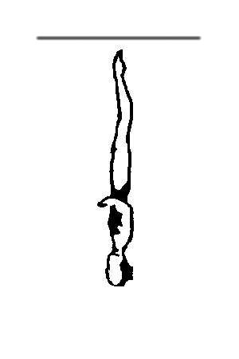 |  |  | Total
NVT= | 19.0 | 21.0 | 29.0 |  |  | 69
PV = | 2.75 | 3.04 | 4.2 |  |  | 2.12

- A Rocket Split is executed to an Airborne Split Position. A Twirl is executed as the legs join to Vertical Position followed by a Vertical Descent. DD = 2.6
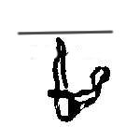 | 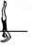 | 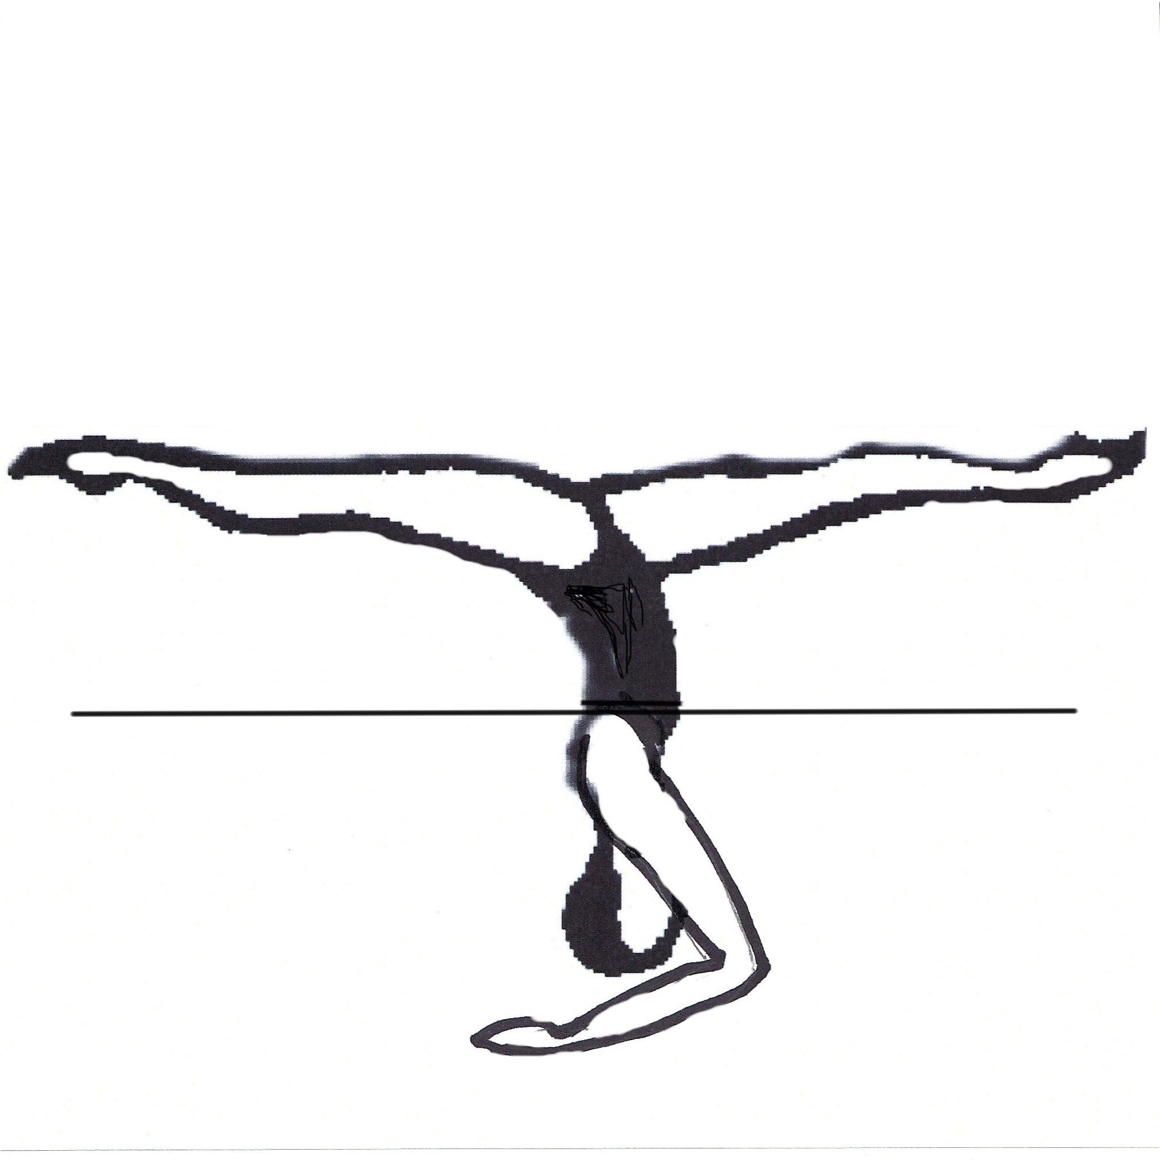 |  |  |  |  | Total
NVT= | 37.0 | 19.0 | 23.0 | 14.0 |  |  | 93
PV = | 4.07 | 2.09 | 2.31 | 1.54 |  |  | 2.56
3. 150 - Knight is executed. Headfirst travel is allowed during the transition to Ballet Leg. DD = 3.1
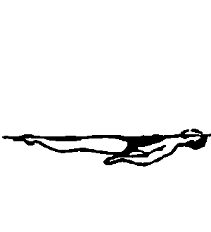 | 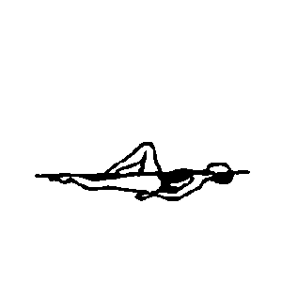 | 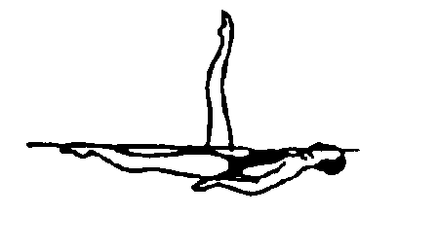 | 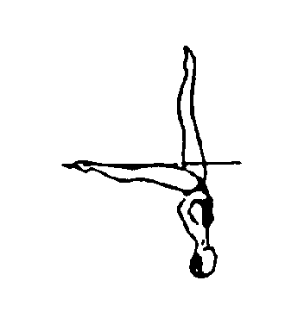 | 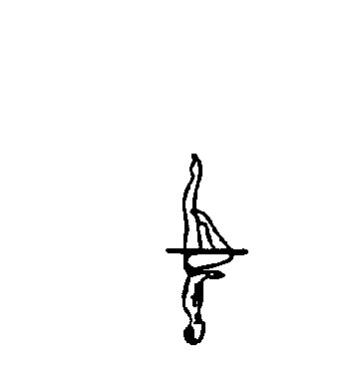 | 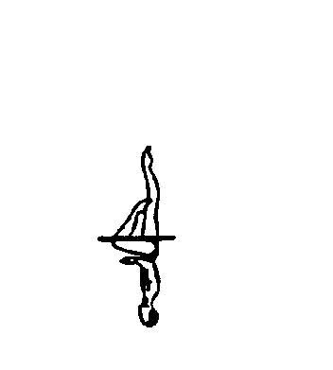 | 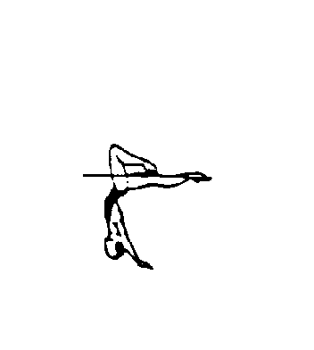 | 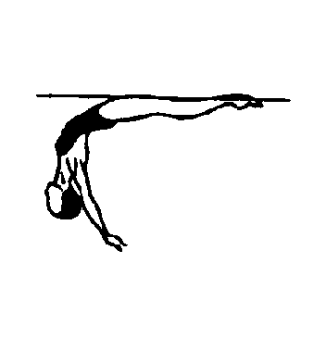 | 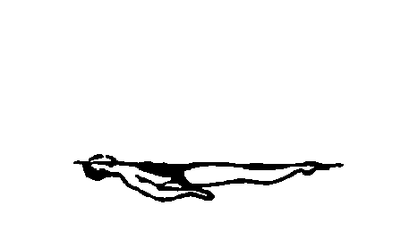 | Total
NVT= | 10.5 | 11.0 | 22.0 | 16.0 | 15.5 | 20.0 | 15.5 | 11.0 | 121.5
PV = | 0.86 | 0.91 | 1.81 | 1.32 | 1.28 | 1.65 | 1.28 | 0.91 | 3.09
4. Starting in a Vertical Position a Full Twist is executed followed by a Combined Spin of 3 rotations followed by a Vertical Descent. DD = 2.4
 |  |  |  |  |  | Total
NVT= | 29.0 | 41.0 | 14.0 |  |  | 84
PV = | 3.45 | 4.88 | 1.67 |  |  | 2.4
5. Starting in a submerged Back Pike Position with the legs vertical, 301e - Barracuda Spinning 360 is executed. DD = 1.9
Back Pike Position (301E Barracuda Spin 360)
 |  | 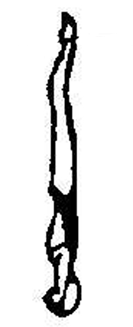 |  |  | Total
NVT= | 37.0 | 21.0 |  |  | 58
PV = | 6.38 | 3.62 |  |  | 1.92

Duet Elements
Required elements 1-5 must be performed in the order listed
- 436 - Cyclone is executed to a Vertical Position. A Full Twist is executed as one leg lowers to a Bent Knee Vertical Position, followed by a Continuous Spin of 3 rotations as the bent knee is joined to a Vertical Position. DD = 3.1
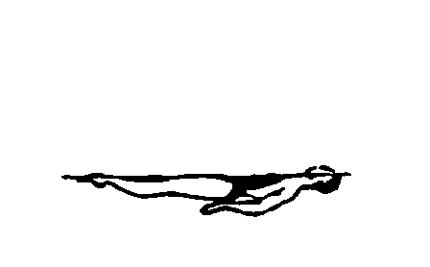 | 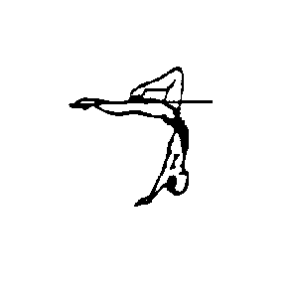 | 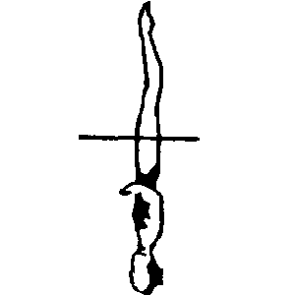 | 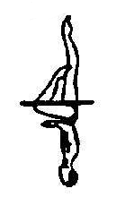 |  |  | Total
NVT= | 19.5 | 39.0 | 24.0 | 37.0 |  | 119.5
PV = | 1.86 | 4.57 | 1.81 | 1.33 |  | 3.05

- From a Back Layout Position, travelling head first, one leg is raised straight to a Ballet Leg Position, followed by the other leg to a Double Ballet Leg Position. Maintaining the Double Ballet Leg Position, a rotation of 360 degrees is executed. The legs are held straight throughout the element. DD = 1.9
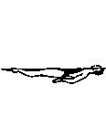 | 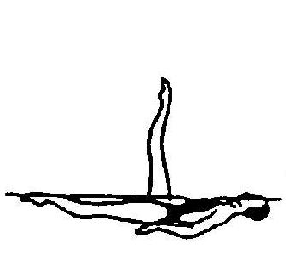 | 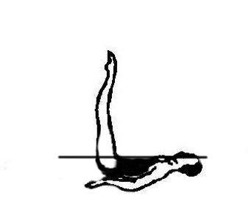 |  |  |  |  | Total
NVT= | 14.5 | 20.0 | 23.0 |  |  |  | 57.5
PV = | 2.52 | 3.48 | 4.00 |  |  |  | 1.91

- Starting and maintaining a Fishtail Position, with the horizontal leg leading toward the vertical leg, 2 rapid rotations (720º) are executed. Continuing in the same direction, the horizontal leg is lifted to a Vertical Position as a Continuous Spin of 720º is executed. DD = 2.1
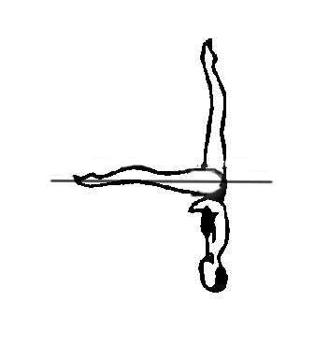 |  |  |  |  |  | Total
NVT= | 18.5 | 48.5 |  |  |  | 67
PV = | 2.76 | 7.24 |  |  |  | 2.08

- Starting in a Front Pike Position, the legs are lifted to a Vertical Position. A Half Twist is executed followed by a further rotation of 180 degrees with the legs opening to a Split Position. A Walkout Front is executed. DD = 2.8
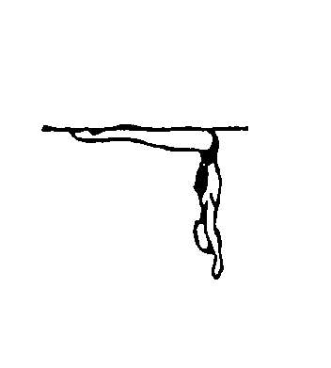 |  | 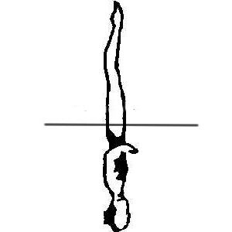 |  |  | 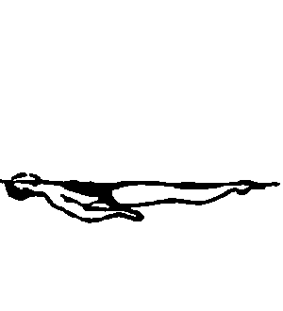 |  | Total
NVT= | 29.0 | 19.0 | 21.0 | 24.0 | 11.0 |  | 104
PV = | 2.79 | 1.83 | 2.02 | 2.31 | 1.06 |  | 2.77

- Starting in a submerged Back Pike Position with the legs vertical, 301c - Barracuda Twirl is executed. DD = 2.4
 |  |  |  |  | Total
NVT= | 37.0 | 35.0 | 14.0 |  | 86
PV = | 4.30 | 4.07 | 1.63 |  | 2.43

- The routine must contain a lift or throw and this can be placed anywhere in the routine.
- With the exception of the deck work and the lift or throw, all elements required and supplementary must be performed simultaneously and facing the same direction. Mirror actions are not permitted

Team Elements.
Required elements 1-5 must be performed in the order listed
- Starting in a submerged Back Pike Position with the legs vertical, 301 - Barracuda is executed. DD = 1.8
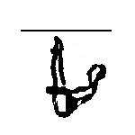 | 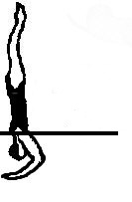 | 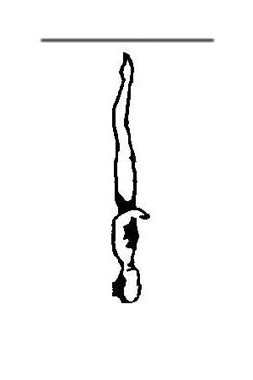 |  |  | Total
NVT= | 37.0 | 14.0 |  |  | 51
PV = | 7.25 | 2.75 |  |  | 1.79

- 435 - Nova is executed to the Bent Knee Surface Arch Position; A rotation of 360 degrees is executed as the legs are lifted to a Vertical Position followed by a Continuous Spin of 720 degrees. DD = 2.4

 | 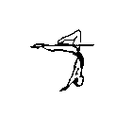 | 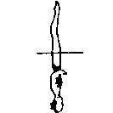 |  |  |  | Total
NVT= | 19.5 | 39.5 | 27.0 |  |  | 86
PV = | 2.87 | 2.88 | 3.97 |  |  | 2.43

- Starting in a Front Pike Position, the legs are lifted to a Vertical Position, A Full Twist is executed, the legs are lowered to a Split Position. A Walkout Front is executed. DD = 2.9
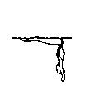 | 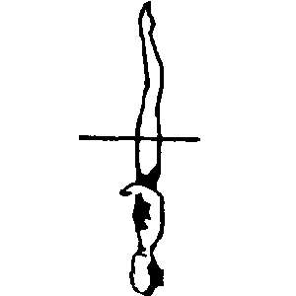 |  |  | 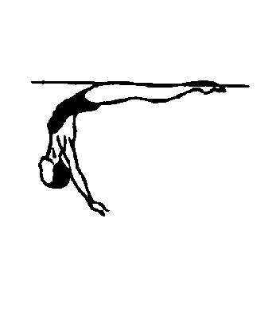 | 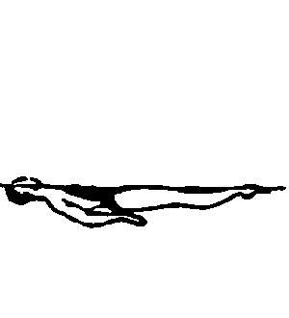 |  | Total
NVT= | 29.0 | 29.0 | 19.0 | 24.0 | 11.0 |  | 112
PV = | 2.59 | 2.59 | 1.7 | 2.14 | 0.98 |  | 2.91

- Starting in a submerged Back Pike Position with the legs vertical, 308 – a Barracuda Airborne Split is executed. DD =2.5
 |  |  |  |  |  | Total
NVT= | 37.0 | 19.0 | 21.0 | 14.0 |  | 91
PV = | 4.07 | 2.09 | 2.31 | 1.54 |  | 2.53

- Travelling Ballet Leg Sequence. Starting in a Back Layout Position travelling head first, a Ballet Leg is assumed, the horizontal leg bends to a Flamingo Position and is then lifted to a Ballet Leg Double Position. DD = 1.7
 | 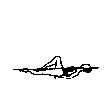 |  | 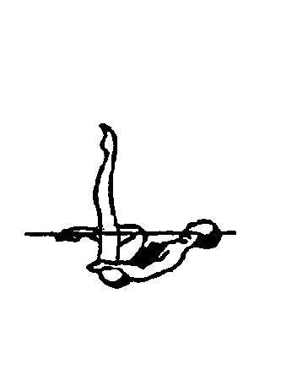 |  |  |  | Total
NVT= | 10.5 | 11.0 | 10.5 | 16.0 |  |  | 48
PV = | 2.19 | 2.29 | 2.19 | 3.33 |  |  | 1.73

- The routine must contain one Headfirst Throw and a Cadence Action with either arms or legs. These may be placed anywhere in the routine.

- With exception of the deck work, entry, the throw and the Cadence Action, all elements – required and supplementary – must be performed simultaneously and facing the same direction by all team members. Variations in propulsion and direction facing are permitted only during pattern changes and underwater actions. Mirror actions are not permitted.

