WRITEEN PERMISSION FOR
MANUAL THERAPY, THERAPEUTIC, AND RECOVERY MODALITIES
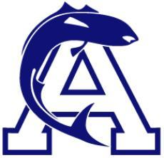

I, , as the parent/legal guardian of , a minor athlete, hereby authorize and consent for said minor athlete to receive manual therapy, therapeutic, and recovery modalities under the following parameters:
Location of manual therapy, therapeutic, and recovery modalities | Frequency of Treatment  (e.g., weekly, monthly, etc.) | Time Period of Consent  (Not to exceed one year)

I understand the following guidelines apply for manual therapy, therapeutic, and recovery modalities:
- Written consent by a parent/legal guardian must be obtained in advance at least annually by the licensed massage therapist or other certified professional which can be withdrawn at any time.
- Parent/legal guardians must be allowed to observe the Massage, except for competition or training venues that limit credentialing.
- Any Massage of a Minor Athlete must be done with at least one other Adult Participant physically present and must never be done with only the Minor Athlete and the person performing the Massage in the room.
- Any Massage of a Minor Athlete must be performed with the Minor Athlete fully or partially clothed, ensuring that the breasts, buttocks, groin or genitals are always covered. Nothing in this section shall be construed to apply to areas of the body exposed while wearing swimwear which conforms to the current concept of the appropriate for the individual’s competition category.
- The provider must narrate the steps in the modality before taking them, seeking consent of the Minor Athlete throughout the process.

Parent/Legal Guardian Name Printed:
Parent/Legal Guardian Signature:
Date:

