Team Unify Swim Meet Sign up Instructions

- Log into your Team Unify account: https://www.teamunify.com/team/waca/page/home
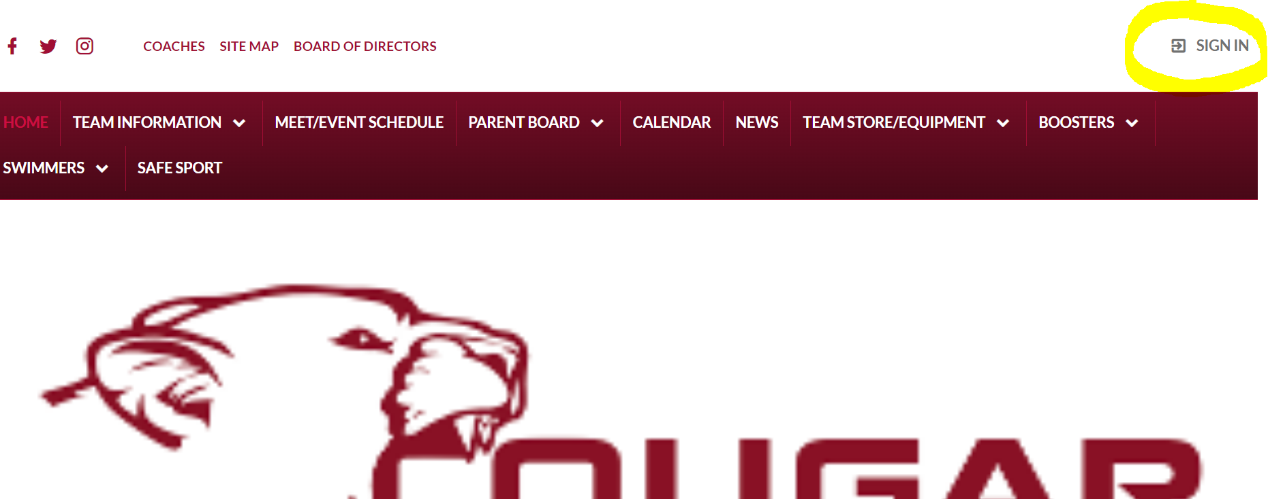

- Scroll down to Upcoming events
- Choose the meet that you would like to sign up for and click “Edit Commitment”
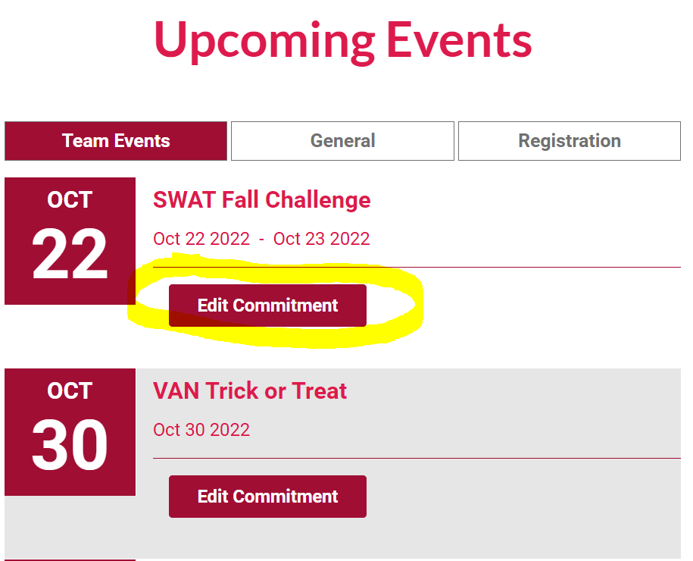
- Click on Swimmers name:
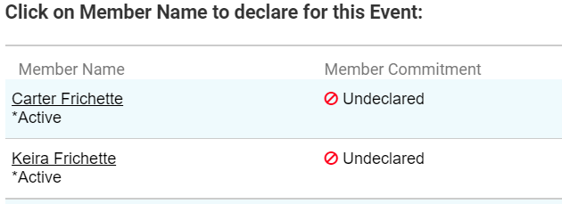
- Choose “Yes, please sign (Swimmer) up for this event” under Declaration drop down box
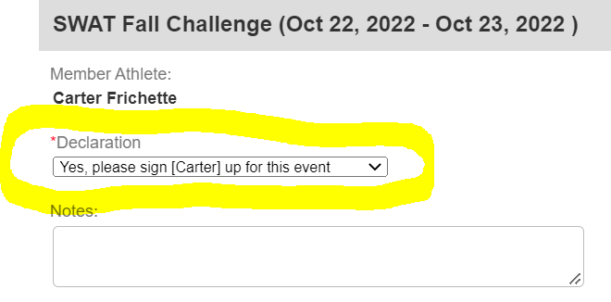

- Then scroll down and put a check next the the box with the event that the coaches have asked you to choose
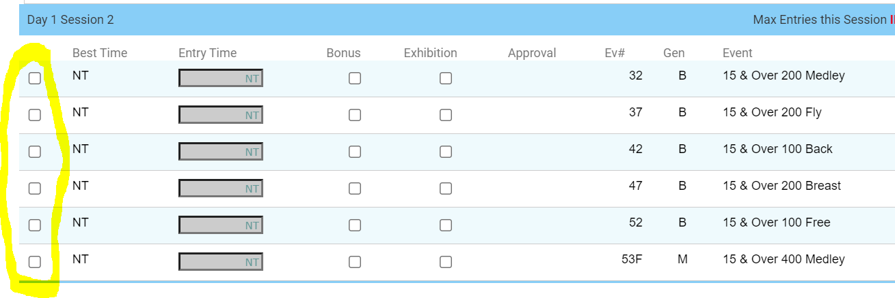
- Unless “NT” is noted please verify that the time listed is in fact the Best Time in that event.

- After all events have been checked; scroll to the bottom of the page and click “Save Changes”
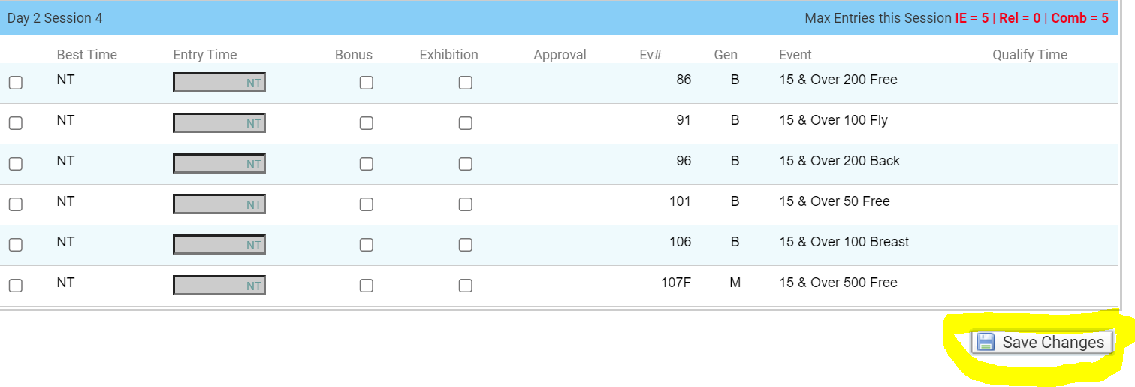
- And You are all done! **Note: If an event is chosen that the Coach has not asked you to sign up for they may deny that specific event.

