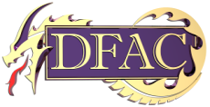
DFAC HAPPENINGS
01/26/24
/23

- STAR

- JAYHAWK MEET
  - Good luck to our 4 swimmers participating in the 8 & under meet in Whitewater.

- FLICK & FLOAT-JAN 28
  - Flick & Float is Sunday!!! Few reminders:
    - Please have your swimmer bring their own drink
    - Parent meeting will kick off the meet. We will discuss board positions up for election. Board Members & Coaches will be there to answer questions as well

- SURVEY
  - The board is conducting a survey on how to better the club. Be on the lookout in your email and please participate.

