DFAC SAFE SPORT TRAINING INSTRUCTIONS
FOR ATHLETES 12 to 17 YEARS OLD

Step 1: Go to https://learn.usaswimming.org and click on “LOGIN”

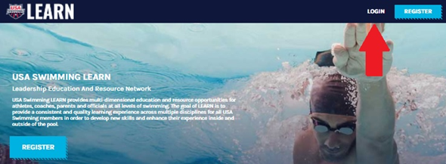

Step 2: Press the blue “START” button on the left-hand side in the “I am a USA Swimming Member” box

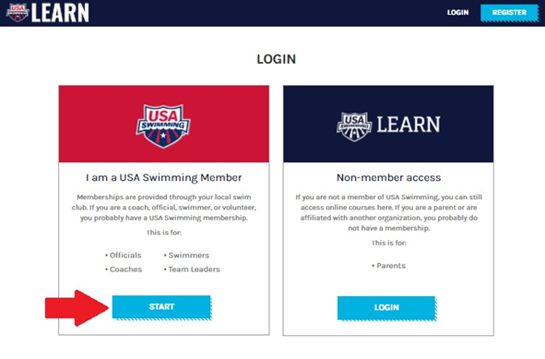

Step 3: At the next screen, scroll down to the “START THE TRAINING” section

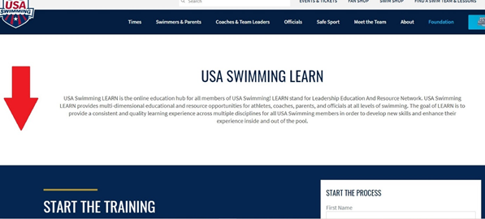

Step 4: Fill in First Name, Last Name, and Birthdate under the “START THE PROCESS” fields and press the red “SEARCH” button.

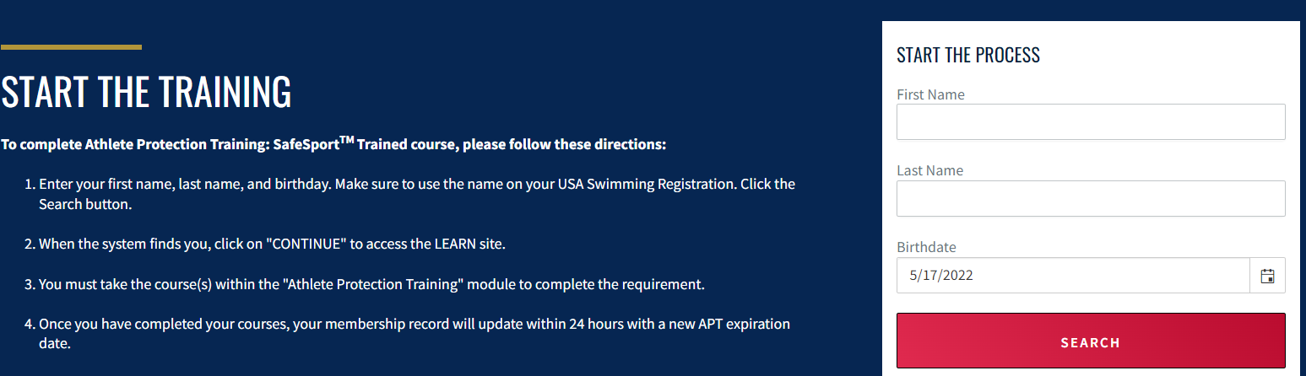

Step 5: Find athlete’s name and press the blue “CONTINUE” link

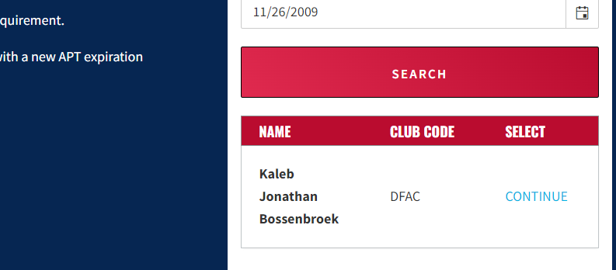

Step 6: After receiving parental consent, check the box verifying you have consent. Then click on the red “GO TO LEARN” button.

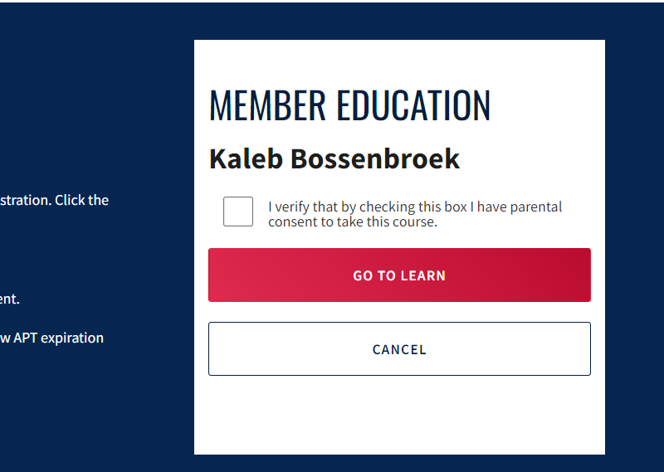

Step 7: When updating your Profile, please select WISCONSIN SWIMMING as your LSC and DFAC Swimming, as your Club Name. Once completed, click on the blue “UPDATE” button

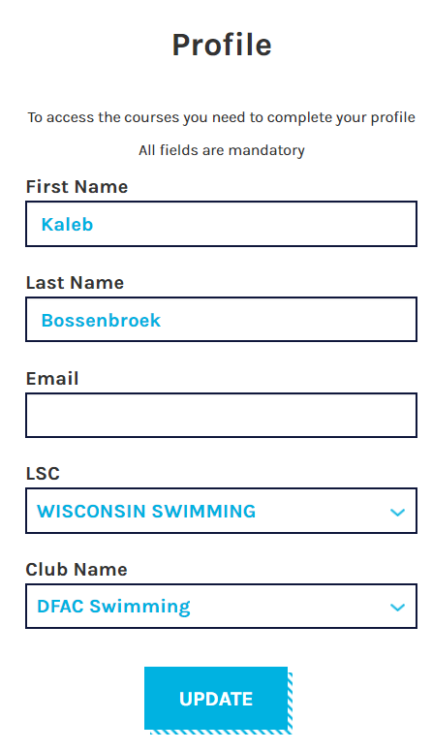

Step 8: After your Profile is updated, select “COURSES” on the top of the screen

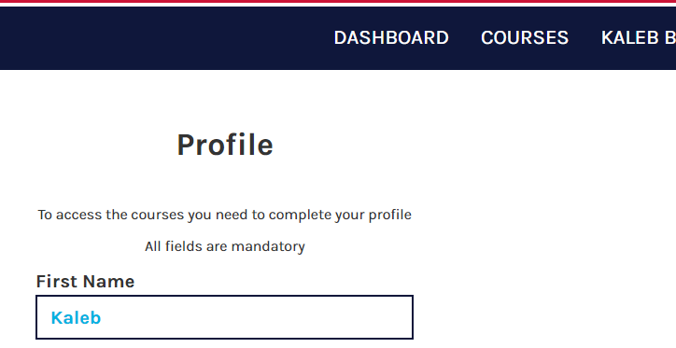

Step 9: On the Courses screen, scroll down until you find the Safe Sport for Athletes course

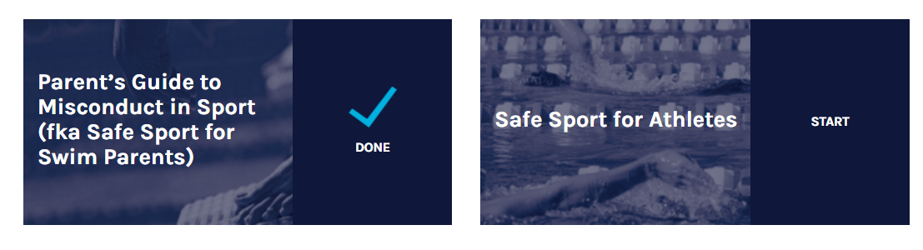

Step 15: Once the course is in your “DASHBOARD,” click on the “START” link and take the course. Once the course begins, there will be detailed instructions regarding how to navigate the course.
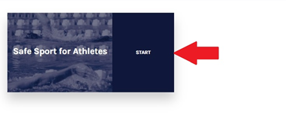

Step 16: At the conclusion of the course, be sure to take a picture of the “CONGRATULATIONS” screen, with your account name in the top right-hand corner. Please email a copy of this screen to president@dfacswimming.org so that a record of your course completion can be kept by the Club.

