DFAC PARENT SAFE SPORT TRAINING INSTRUCTIONS
Step 1: Go to learn.usaswimming.org and click on “LOGIN” (if you already have an account) or “REGISTER” (if you need to create an account).
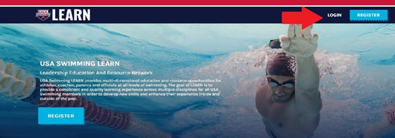

Step 2: To create an account, do so under the Non-Member Access (for parents) portal. Click on “CREATE ACCOUNT”
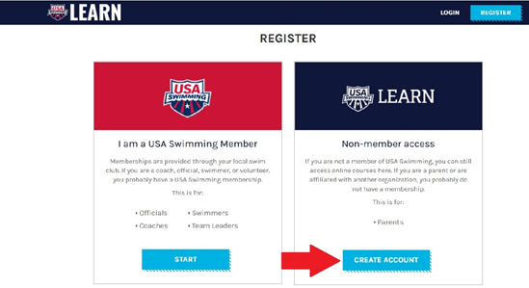

Step 3: At the REGISTER screen, please select “WISCONSIN SWIMMING” for the LSC box. Please select “DFAC Swimming” for the Club Name box. Complete registration process, by clicking on the blue REGISTER button.
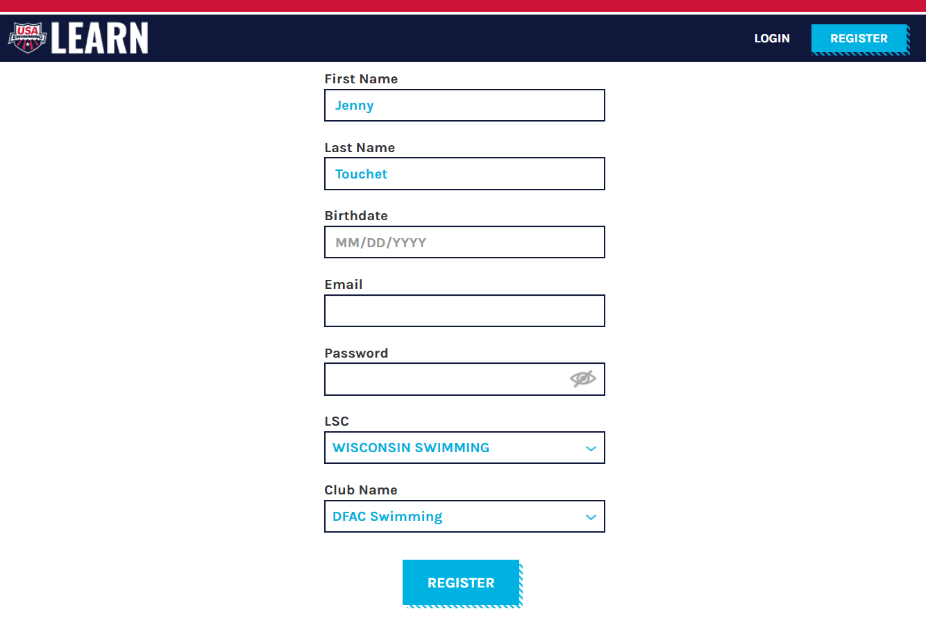
Step 4: After you have an account set up, you will be asked to select a course from the COURSES page. Do so by clicking on the blue “COURSES” button
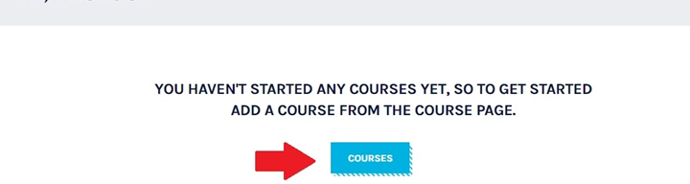

Step 5: Several course options will appear. You will need to scroll down, until you find the Parents Guide to Misconduct in Sport course.

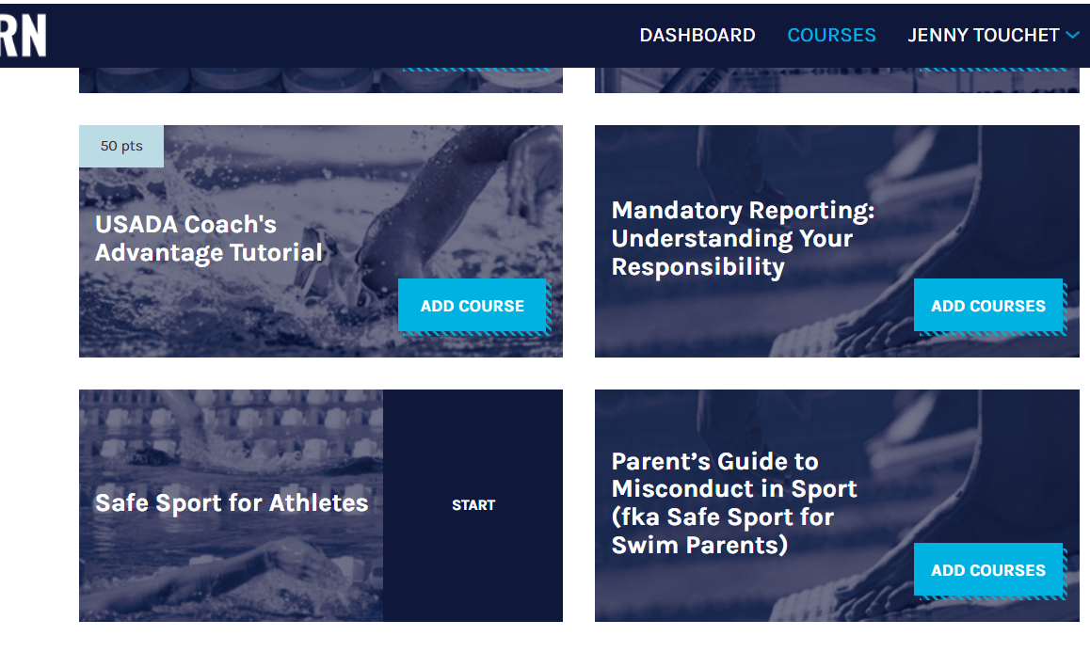
Step 6: Click the blue “ADD COURSES” to add the Parents Guide to Misconduct in Sport course to your “cart.”
Step 7: You should now have Parent’s Guide to Misconduct in Sport (aka Safe Sport for Swim Parents) in your DASHBOARD, you can begin the course, by clicking the START button.
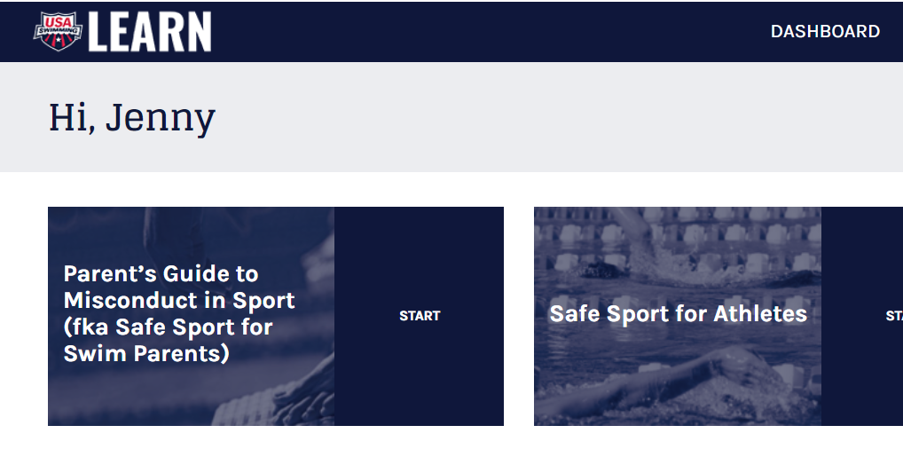

Step 8:The course will start with an introduction, which explains how to navigate the course (specifically the importance of clicking on the red arrows in the course, instead of using your browser back button). There will be a brief 9 question Pre-Test, some short vignettes, and some slides to read. Once completed, there will be a brief 9 question Post-Test. Takes ~ 45 minutes.

Step 9: When done, go back to your dashboard. It should show the course as done, if you click on the course, a certificate of completion will open.
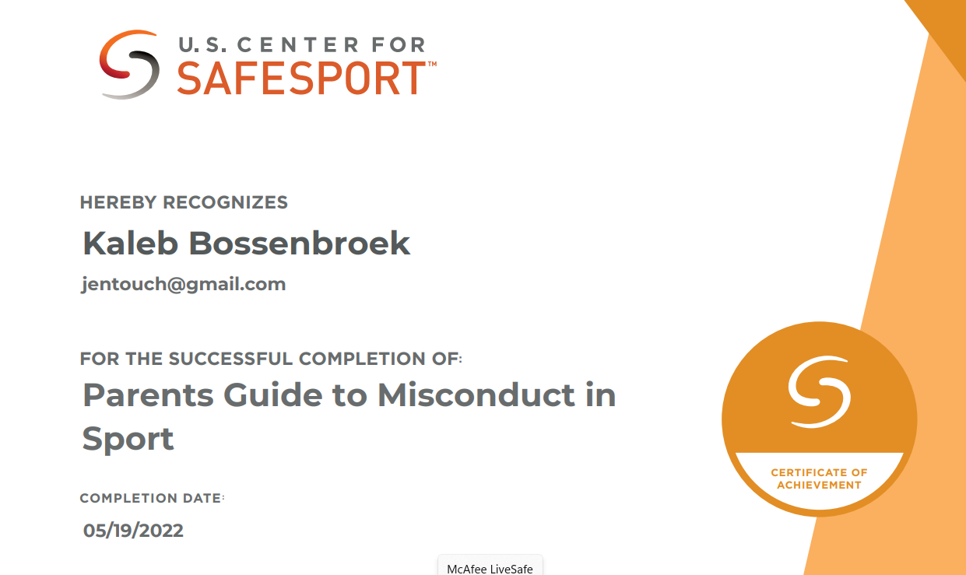

Step 10: Please email a copy of the PDF of your Certificate to president@dfacswimming.org, so the Club can keep a record of you having taken the annual course.

