
SWIM MEETS-HOW TO

Key points:
- You must be logged on to the DFAC website to see all meet information available to members.
- Meets have entry deadlines that can change with little or no notice. Sometimes a meet registration deadline will be later than our team’s registration deadline. The reason behind this is certain meets fill up fast so we want to be able to get our entries in closer to when registration OPENS vs when it CLOSES. Late entries are not processed.
- Some meets have restrictions by age or qualifying times.
- Look at the meet sessions (days/times) for your swimmer’s age group and commit only to those that you can attend.
- Once committed to the meet you are responsible for fees whether or not your swimmer participates in the meet.
- You will be committed to all home meets unless you decline in advance. Home meets are required so you need to meet volunteer obligations regardless of participation.
- Coaches choose meet events for each swimmer. Use the Notes section to enter any preferences to be considered by coaches.
- Do NOT contact the host site for meet information. Information is posted online as soon as it is available.
- Tech suits are not allowed for 12 & Under swimmers. Tech suits may be worn by older swimmers for championship meets.

Meet Information
Go on our team website > sign in to your account >Meets/Events > Events Page
Choose the meet you are wishing to learn more about
Scroll down to find “meet announcement” or “meet information” document. Here you will find the host location, meet fees, swim sessions by age with offered events, estimated time line, admission limitations and fess, heat sheets, parking…
Committing to a Meet
Go on our team website > sign in to your account > Meets/Events > Events. To the right of the meet you should have the option to Attend/Decline. Select button.
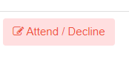
From there, your swimmer(s) should be listed.
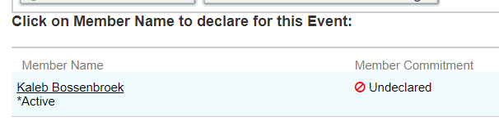
Select Swimmer. On screen that opens next, at the bottom, you can select if they will be attending or declining.
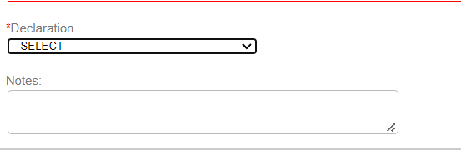
Editing Committment
If you change your mind BEFORE the registration deadline, you can go in and ‘Edit Commitment’
Go on our team website > sign in to your account > Meets/Events > Events > select the meet you are looking to edit commitment for. Select ‘Edit Commitment' button to the right
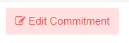
If meet entries have already been sent, you will be responsible for all meet fees regardless of attendance even if you later decline.
Looking at Swimmers Assigned Events
You will be able to check your swimmer’s events also through “Edit Commitment’ once completed by the coach.
Go on our team website > sign in to your account > Meets/Events > Events > select the meet you are looking to edit commitment for. Select ‘Edit Commitment' button to the right
At the bottom, you should see coach approved events with format:
Event Number, (Day ___/Session ___,) Girls or Boys, Age Group, Event (Best time or No Time Approved)
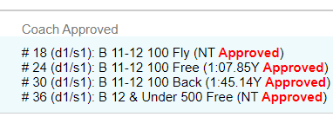
Jot down or print out the event number #’s from our website and bring to meet. This will make it easier to locate their events in the heat sheet on the meet day.
NOTE: The OnDeck Parent app also allows you to declare for meets, edit commitments, provides remote access to view your child's best times, compare times to local and national time standards, and view event entries for your swimmers.

The Day of the meet
Swimmers should wear their suit to the meet to be ready for warm-ups.
Bring team cap, a couple of pairs of goggles, towel, sweats/parka to stay warm on deck, water bottle and healthy snacks. We encourage swimmers to stay with the team between events.
Parents should bring Sharpie to mark swimmer, cash for admission, heat sheet and
concessions- know that his may not be healthy food. if there is a separate area to hang out
between events, you may bring blanket/sleeping bag, chair/s. These items are not allowed
in the bleachers or on deck.
Warm-ups Arrive 10 minutes before the start of warm-ups with your swimmer ready-togo.
To mark your swimmer:
The heat sheet (which may NOT be available to purchase at the meet so if you like a paper copy be sure to print off ahead of time) lists all participants in each event, organized by “heats”, which are the individual races for an event. Search and highlight your swimmer’s
events including any relays! Mark your swimmer’s arm or leg with a sharpie as
follows:
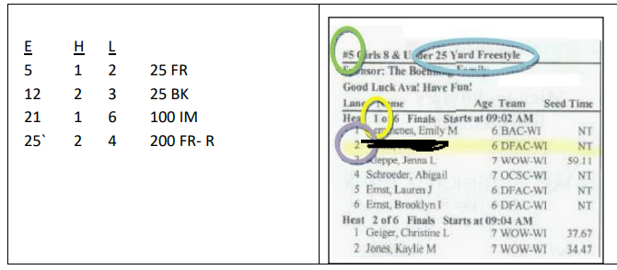
E=Event: Green Circle
H=Heat: Yellow Circle. When more than 8 swimmers in event, multiple heats must be held.
L=Lane: Grey Circle
Lastly list out event: Blue Circle
- The swimmer needs to report to the group coach before AND immediately after each race to get feedback. Swimmers should allow time to see their coach before their race.

- Swimmers need to wait behind the blocks before they swim. We encourage swimmers to be there 2-3 events before they swim. This depends on their age and the event (50s go fast so be there earlier than 500s.)
- Some meets have a special staging area for 8 and Under swimmers.
- Be sure swimmers hydrate and refuel throughout the meet.
- Parents are not allowed on deck while the meet is in session; this is a USA Swimming rule.
- If parents have questions, they should be fielded through the coaching staff at the appropriate time.
- Never approach an official about your child’s swim; rather, please direct all communication through the coaching staff
- Most of all, HAVE FUN AND ENJOY THE MEET! Ask your swimmer if they had fun.
Before leaving the meet or changing out of their suit, have your swimmer check in with their coach. We need to be sure no one had forgotten a relay, and sometimes we add a swimmer to a relay event at the last minute. We also need to be sure that we have counters for our 500 yard and longer swims- as members of a team we need to support each other in these events.
How to check the results?
- Paper results are posted for each event, as the meet progresses.

- After the meet, typically within two days, you can find results on our website under your team account: Events & Competition > Meet Results

Meet Mobile App
- The Meet Mobile App is a GREAT app to track your swimmer and the team but there is a cost involved. The app does allow you to see assigned events for meets, results of meets, etc.

