SWIM TEAM EQUIPMENT

These are simply the recommendations I have for equipment purchases. If you already have purchased other styles of the following equipment, there is no need to purchase new ones.
To find these equipment items:
First log into the equipment store via the swim team website.
On the home page of the swim store there is a drop down tab labeled “SWIM”
Under that drop down tab there are headings, and most of the following equipment will be found within one of the selection options under “Swim Gear” or “Bags and Backpacks”
The following headers for each item will be labeled with the name of the link that you will find the equipment under.

Hand Paddles
For the paddle options, I prefer this style due to the shape and size. I find the contours to help with directing the recovery of the stroke into a certain pattern, and the size make them excellent for building strength in the pull.
PLEASE NOTE: They come in different sizes. Make sure to purchase the size that will fit, or if anything be a little too large for the hand size of your athlete(s).
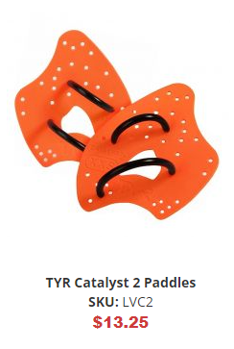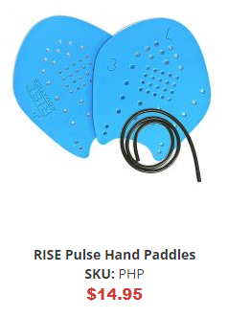
Swim Fins
These specific fins are representative of the style I desire the swimmers to have. They should be snug around the foot and have long extensions beyond the foot. Other brands that look similar to this are fine, the TYR flex fins are more expensive but probably the best performing out of this style. The fins below are the ones I personally use and I have found them more than adequate to perform for me as desired.
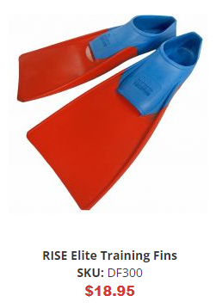
Snorkels and Masks
This piece of equipment is probably the most important to be specific with. The snorkel is generally the most difficult item to learn to use effectively, but it is also one of the most important to have. There are a number of different designs and the option below is one of the most expensive. I recommend this specific one for a few different reasons. First, from experience this is the most secure fitting option available. Second it has an effective burp valve that is very important for new users to have. Lastly the mouthpiece is both rigid and soft for the mouth. *If this option is too much, please make sure that the snorkel you purchase has a burp valve at the bottom.*
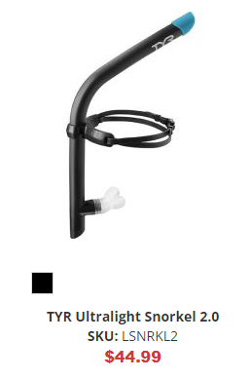
Kickboards
This piece of equipment is again about a specific style and the brand is not important. There are some varying shapes and this is the preferred one for practice.
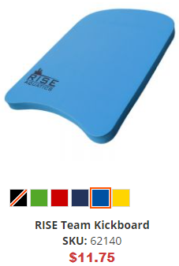

Pull Buoys / Weights
Here both the pull buoy and band are again about style and anything that looks like the ones below will work fine.
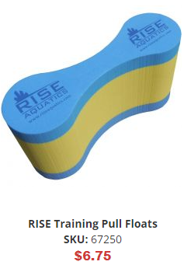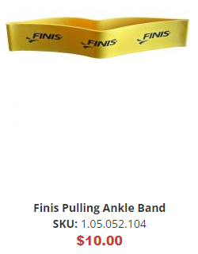

Mesh Bags
The mesh gear back is what the swimmers should bring with them every practice. The bag needs to be big enough to fit all the above equipment, along with extra pairs of goggles, swim caps, a water bottle, and perhaps even an extra suit. It will get wet and should be alongside the pool at the end of their lane during practice.
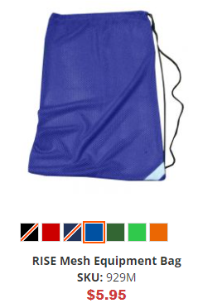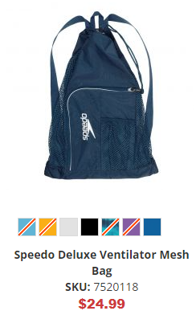

Goggles
Not all goggles are created equal. Below are some recommendations for both practice and competitions. The Speedo Vanquishers are generally considered the best all-around goggle for both practice and competition. However the Speedo Speed Socket, TYR Tracer, and the Arena Cobra are considered high performance competition goggles and are the best performing. Any of the options below are excellent choices.
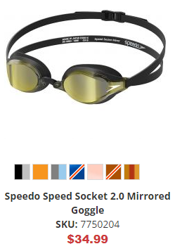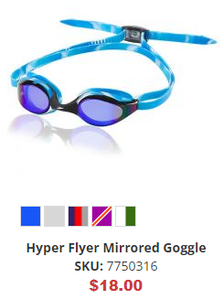
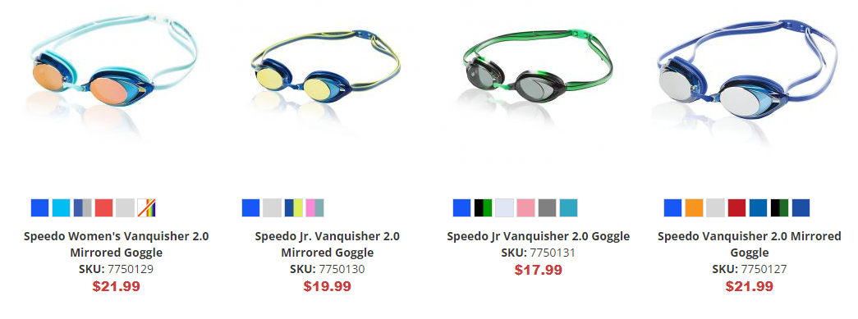
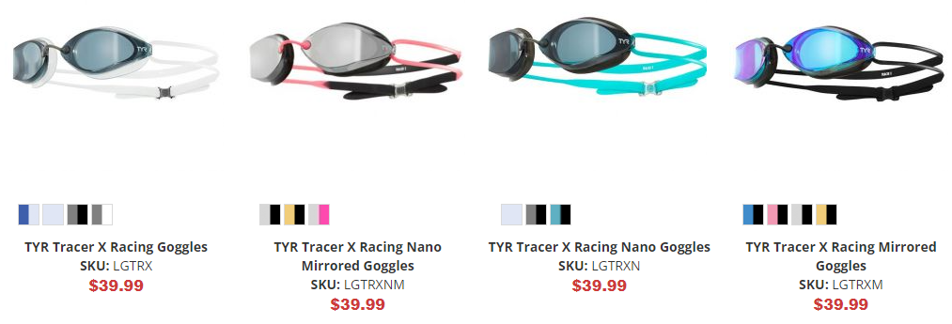

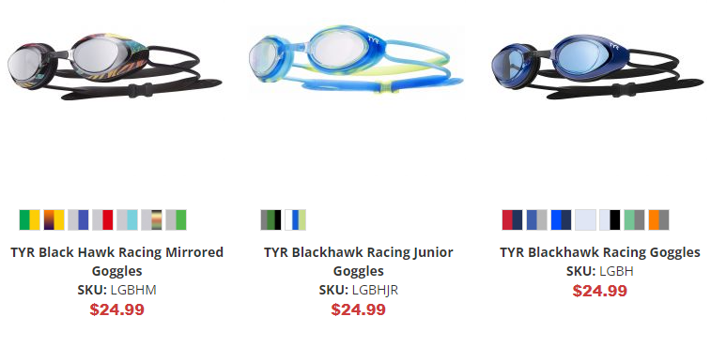
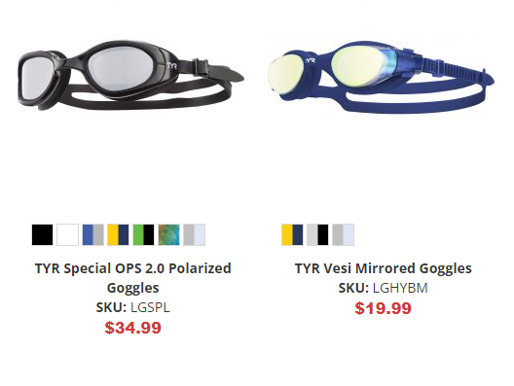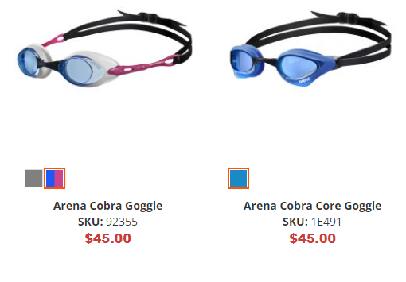
Swim Caps
Caps at competitions should be our Life Time Swim cap. Practice caps should be either latex or silicone.

Practice Suits
For practice we recommend the following styles of suit. We want to reduce drag as much as possible during practice to enable larger workout volume. Below are the style types. You may be able to find cheaper options at Elsmore Swim Shop off 124th St. here in Brookfield, or online on other sites. It is generally a good idea to have a few different practice suits.
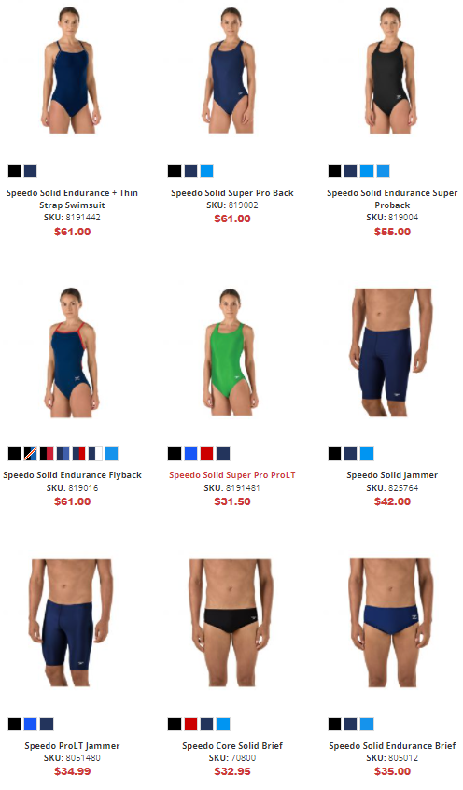
Racing/Tech Suits
These are high performance suits that bring with them a hefty price tag. They are designed to enhance performance beyond “normal” suit performance. They will include features such as compression technology, increased float, and hydrophobic material that repels water. These suits are for races only and lose their effectiveness the more races they are used for. I usually do not recommend these suits unless your athlete is aiming for state qualification times or national level times. *The Arena Powerskin below is not considered a high performance tech suit.*
