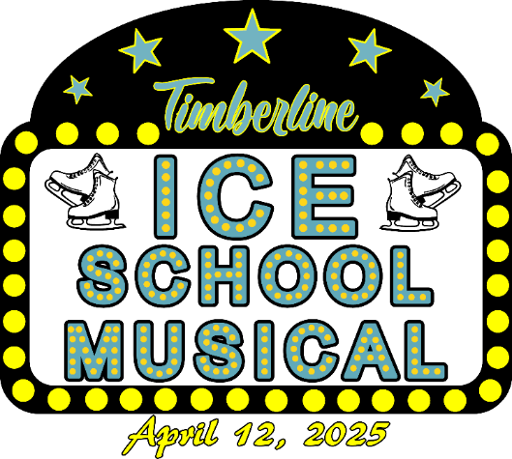
2025 Timberline Figure Skating Club
Annual Spring Show
Saturday April 12, 2025 at 11:00 AM & 4:00 PM
Greenheck Turner Community Center

Hockey Skater Information

Hockey Skater Name __________________________________________
Timberline Partner Name _______________________________________
Hockey Team ________________________________________
Parent/Guardian ______________________________________
Phone _____________________
Parent email _________________________________________

Please sign below that you have read and agree to the following:
- My son is signed up to perform in the Timberline Spring Show with the skater listed above.
- I understand that my son is responsible to get their home and away jersey for dress reheasal and the day of the show.
- I understand that my son is responsible to come to the 3-4 practices that will be scheduled in addition to Tech and Dress rehearsal and both Shows.
- The participant(s), including parents, agree that the Timberline Figure Skating Club, it’s instructors, coaches and Board of Directors will not be held responsible for any accidents or losses however caused and agree to release all parties involved from claim or damage which may arise as a result of or by reason of such accident or loss.

Parent/Guardian Signature _______________________________ Date ________________

