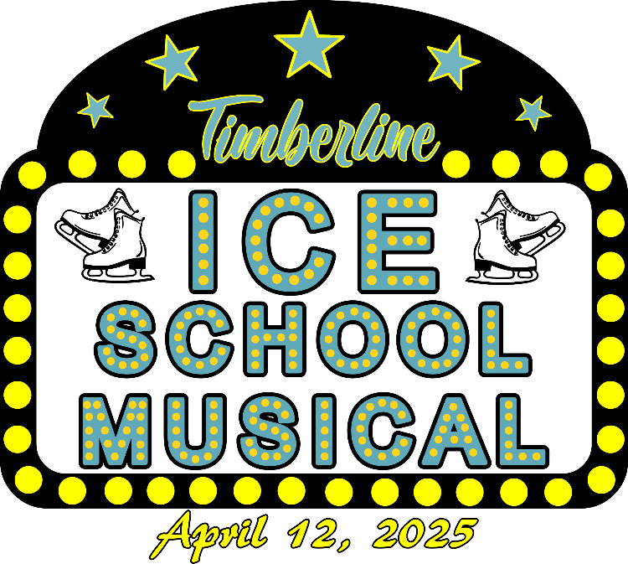
2025 Timberline Figure Skating Club
Annual Spring Show
Saturday April 12, 2025 at 11:00 AM & 4:00 PM
Greenheck Turner Community Center

Show Registration Deadline is December 9, 2024

Skater’s First and Last Name _____________________________________________
Age _______ Date of Birth _________________ Grade _________ Male or Female
Skater’s Address ______________________________________________________
Parent/Guardian Name __________________________________________________
Phone Number ______________________ Email ____________________________
Current Learn to Skate Level ___________________
Each Learn to Skate Class will have a show number plus another show number grouped with another Learn to Skate Class.
Highest USFSA Skating Skills Passed ________________________
Highest USFSA Singles Passed ________________________
Highest USFSA Dance Level Passed _________________________

Show Deposit $60. Circle Cash or Check Payable to TFSC, Check # ___________
Special Features in the Show:
Parent Number (one parent per skater please) YES or NO
Costume TBD
Name of parent participating in show _____________________________________

Hockey Number (only for skaters in grades 9-12) YES or NO
Costume is Hockey Jersey provided by partner – Skater must find their own hockey player from Wausau West, DC Everest or EMU and have them fill out the attached form.
Dance Skills Number (only for skaters who have test pre-preliminary or higher dance test)
Costume TBD YES or NO

Measurements in Inches
Girth
Bust/Chest
Waist
Hips
Show T-Shirt Size
Club ordering Mondor Tights for skater? | YES or NO
Club ordering Body Suit for skater? | YES or NO

Please note: The committee will size items ordered according to measurements taken. However, the costume may not fit precisely, please add a special note by measurement you are concerned with. Should you need to exchange for a different size contact Shelly Hinzman for returns or exchanges.

Please sign below stating that you have read and agree to the following:
- The participant(s), including parents, agree that the Timberline Figure Skating Club, it’s instructors, coaches and Board of Directors will not be held responsible for any accidents or losses however caused and agree to release all parties involved from claim or damage which may arise as a result of or by reason of such accident or loss.
- I agree to sign up to volunteer at the skating show
- I understand that no refund will be given for skaters who don’t participate in the show
Signature of Parent/Guardian ____________________________ Date ___________

