Surviving Your First Swim Meet

Tryouts went well and you made the team. Practices have been going well and you’re seeing improvement. And now the first meet! We want everyone to be successful and have a positive experience at their first meet, so here are a few tips to help you along the way.

1. Prepare the night before. You don’t want to get to the morning/afternoon of the meet and have to remember all the things you should bring. Pack your bags ahead of time to make the day of the meet less stressful. Here is a list of what to pack the night before:
- At least two towels. Your swimmer is going to be in and out of the water up to five times and they will need to dry off and get warm every time.
- Extra warm clothes. All that water can keep a young swimmer chilled so pack shirts, warm-up/sweatshirts & sweatpants, socks, shoes and even a hat if your child is usually cold. The worst case is that you take some clean clothes home with you after the meet.
- Team suit, team cap (at least 2) and goggles (at least 2 pairs).
- Marker for writing events, heats and lanes on their arm or leg. At meets requiring positive check-in, heat sheets will not be available when you arrive, so swimmers will have to do this on deck after warm-up. Coaches will help.

2. Give yourself plenty of time to get to the meet. Coaches want all swimmers on deck ready to swim 10-15 minutes prior to the start of warm-up. Plan to arrive at the pool 15-20 minutes ahead of the start of warm-up so your swimmer has time to check in, change and find their coach/team. The stress of rushing and being late is not good for you or your swimmer.

3. Athletes need fuel. Whether the meet is a couple of hours or all day, all athletes need to fuel their bodies. This starts with proper hydration. Children 5-8 need to drink 5-6 cups of liquid a day, and it goes up to 7-8 cups for 8-17 year olds. Boys need slightly more than girls and athletes need more than normal. Plan accordingly by sending bottles of water, Gatorade or chocolate milk with your swimmer. Make sure they eat a healthy meal before the meet, including complex carbohydrates and protein. At the meet they will need healthy snacks which could include fruit, vegetables, yogurt or some whole grains. Concession stands are not always the best for finding the right kind of fuel for your swimmer. Coaches will remind them to eat and drink throughout the meet.

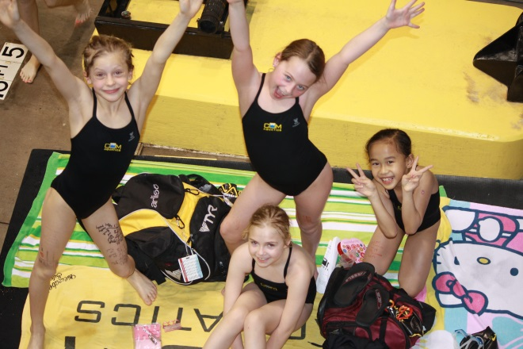

4. Once you are at the meet, make sure your swimmer is ready for a great meet. Make sure they check-in if necessary, get to their coach 10-15 minutes before warm-up, and have all they need for the meet with them on deck. Once your swimmer is situated on deck, you can go back and buy your heat sheet or anything else you may need for the meet.

5. If the meet is at COM and you have signed up for service hours, proceed to the check-in just inside the lobby doors and sign in for your position. If you are not working at this meet, you can head up to the stands to enjoy the excitement of your swimmer’s first meet!

