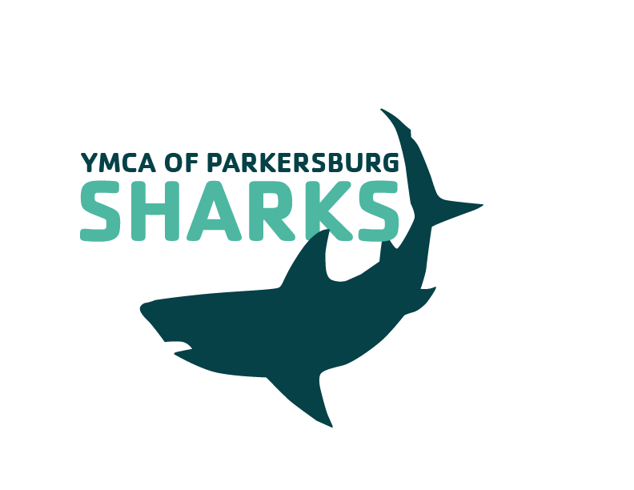

I acknowledge that I have received, read, and understood the Minor Athlete Abuse Prevention Policy and/or that the Policy has been explained to me or my family. I further acknowledge and understand that agreeing to comply with the contents of this Policy is a condition of my membership with the YMCA of Parkersburg Sharks Swim Team.

Name: __________________________________
Athlete (s): ________________________________________________________________

