

Looking for a way to help your swimmer and your swim club?

- Become a USA Swim Official and watch the time at swim meets speed by while enjoying making friends with other parents and volunteers.
- Become an Official today and give the gift of time and talent to the sport of swimming and all of those who swim.
Stroke & Turn Judge: Register as a USA Swimming Official. Once your training is completed register and pay membership dues as a full official.
Steps to Becoming an Official:
- Step 1: Complete the Foundations of Officiating and Stroke & Turn Certification courses.
- Step 2: Complete a Level 2 Background Check
- Step 3: Complete Athlete Protection Training
- Step 4: Complete Concussion Protocol Training Once completed, Please email a screen shot to wyoswimregister@gmail.com.

- Step 5: Complete the on-deck sessions shadowing a certified official.

Officials Certification Standards:
These standards have been established beginning February 1, 2024, to provide a clear and uniform path for members who wish to become officials.
Stroke and Turn Certification Session Tracking Form

Become a USA Swimming Official today!

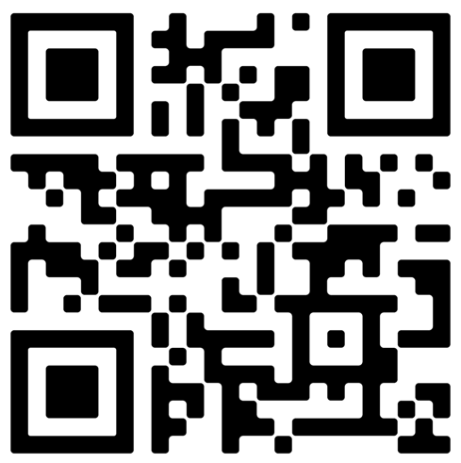

For questions and assistance, please reach out to WYSI Official’s Certification Coordinator (George Mathes) at mathes@trihydro.com Or any WYSI Swimming Official
Or any WYSI Swimming Official
Print this page to use to put on back of Timer Clipboards

Become a USA Swimming Official today by scanning the QR Code  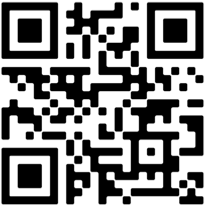 | Become a USA Swimming Official today by scanning the QR Code | Become a USA Swimming Official today by scanning the QR Code
Become a USA Swimming Official today by scanning the QR Code | Become a USA Swimming Official today by scanning the QR Code | Become a USA Swimming Official today by scanning the QR Code
Become a USA Swimming Official today by scanning the QR Code | Become a USA Swimming Official today by scanning the QR Code | Become a USA Swimming Official today by scanning the QR Code

