
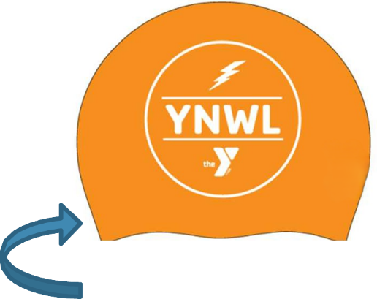

Order Your
Personalized
YNWL TEAM CAPS
ORDERING DEADLINE: Friday, September 5th

Check the Below Box

Silicone: $30.00 (Pack of 2 of the Same Name on Cap)

NAME ON CAP (PLEASE PRINT CLEARLY) ONE CHARACTER PER BOX

Number of PACKS (2 caps come in a pack):

Total Amount Due: $
Your account will be billed for the above amount. DO NOT send checks/cash

ACCOUNT Name (not swimmer):

PLEASE RETURN COMPLETED FORMS TO Danielle Wheeler OR TURN IN TO THE FRONT DESK/Danielle’s MAILBOX)

ORDERS MUST BE RECEIVED BY FRIDAY, SEPTEMBER 5th!!!

ORDERS CANNOT BE ACCEPTED AFTER THIS TIME

