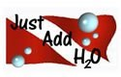
17911 SR 23 South Bend, IN 46635
Justaddh2o.us.com
574-217-7724

BHSJ Order Form ORDERS DUE OCTOBER 12, 2019
Female sizes 22-38 $60.00 SIZE_____ SUBTOTAL:_____________
Male Jammer size 22-38 $41.25 SIZE_____ SUBTOTAL:_____________
7% TAX _______________
BALANCE _______________
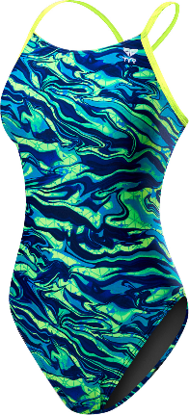 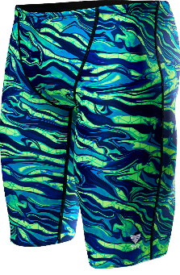http://swim.justaddh2o.us.com/Shop/Category/Team-Store/ProductsList.aspx?Node=1221

Swimmer Name________________________ Parent Name: _________________________

Phone Number_______________________________

Address_____________________________________________________________________
City___________________________ State___________________ Zip___________________
CC#______________________________________________ Exp. Date__________________
Name on CC_______________________________________ CVC# ___________________________________________
*Make checks payable to Just Add H2O Check #_________________________

