NPY Gator Notes: A Word About Goggles

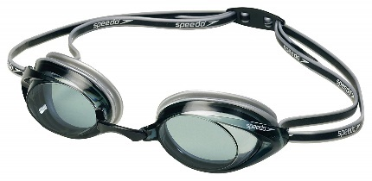
Having proper equipment is key for any swimmer to have productive practices as they work to improve their performance. Other than a competitive-fit swimsuit, proper goggles are the most critical piece of equipment a swimmer can have that will foster those better practice conditions and create a streamlined fit for racing.
Selecting Goggles
Proper quality competitive goggles need not set you back a large sum. Speedo, Tyr, Aquafit, and Arena all make a quality product for a reasonable price. Most models are available through online retailers such as Amazon, Swim Outlet, etc. and will run approximately $18-30. Competition goggles usually have a range of advanced features like UV protection, anti-fog coating, and different size nose pieces that come standard across all brands.
The most commonly used all-around competitive goggle you will see at swim meets is the Speedo Vanquisher, which can be had for $18-25 and comes in Junior and Adult size, clear, tinted, mirrored and optical versions (more on this later).
Do not be swayed by your swimmer that the $50 pair of Arena Cobra goggles will make them faster. They won’t. It might make them feel cool and give them bragging rights, but those dollars will not translate into better times. You are better off using that $50 to buy two pairs of goggles (one for backup) because inevitably your swimmer will leave them in the guest team’s locker room after a meet. If that happens, coaches will be more than helpful in having your swimmer swim a few hundred yards without their goggles to reinforce always knowing where your goggles are.
Size
All goggles are unisex and mostly one size fits all. Do not be fooled by product names. “Adult” goggles fit most swimmers aged 8 and up and come with additional nose-piece parts to aid in that fit. For very small or younger swimmers (usually 7 and younger), they may find that the eyepieces of the “Junior” (sometimes referred to as “Kids”) version of the regular goggles may fit them better.
Strap
The best configuration for goggles are ones with a thin silicone strap that provides for a double strap configuration at the back of the head. That strap should also have a “locking” buckle(s). While fine for play, goggles that use Clip Resistance and Ribbed Resistance strap mechanisms do not hold up to the rigors of competitive practices and events and there is a very high probability that they will fail your swimmer when they are needed most – during a race.
The two pictures below show the goggle strap in the unlocked position. Note that there is no strap in the open split end on each end of the buckle. The unlocked position is used to make adjustments to the goggle strap. Left in the unlocked position, the strap will eventually loosen just through use.
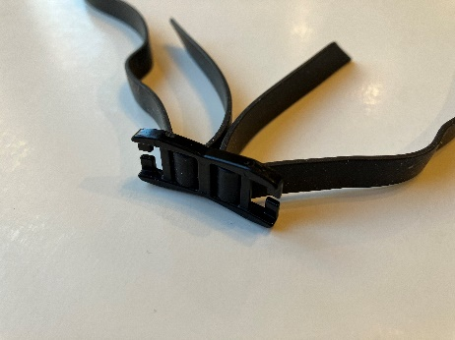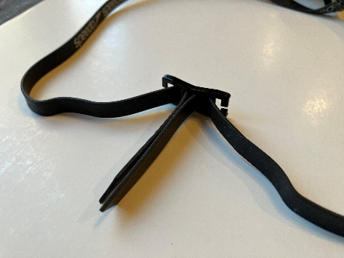
Unlocked Unlocked
The next two pictures show the goggle strap in various states of being locked. The first picture shows the strap in the partially locked position. While one of the straps is locked into the buckle, the strap can still be loosened by pulling hard on the strap. The second picture shows the strap in a fully locked position. Note that both straps on both ends are locked into the buckle. In the locked position, no amount of pulling will loosen the strap. However, pulling on a partially locked or fully locked strap will very likely result in a broken strap.
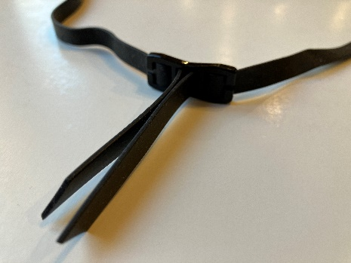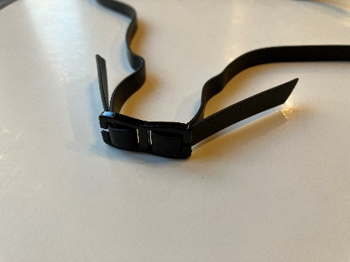
Partially Locked Fully Locked

Lenses
Which lens color and finish to use all depend on when and where a swimmer will wear the goggles. Clear versus tinted (color) versus mirrored, there are a myriad of options for goggles. In the end, choosing lenses is all about clarity of vision for the swimmer. Below are some guidelines in selecting lens type, however, when in doubt go with clear.
Tint/Color
Clear lenses are ideal for any low-light or indoor swimming situations. While clear lenses are the most versatile, some tinted lenses can provide minor benefits in various environmental conditions and can be used in both indoor and outdoor situations. Amber goggles improve vision in low-light areas and decrease glare in conditions of excess light. Lilac colors are designed for optimal contrast against blue or green backgrounds. Blue goggles let an average amount of light in but still shield from glare in bright environments. However, if your swimmer is going to swim in outdoor situations such as Summer Swim Team or where sun glare is a concern, tinted and mirrored goggles can provide a definite benefit. Keep in mind that mirrored lenses dim the light the most and are not recommended for indoor use.
Optical Goggles
For those swimmers that wear corrective lenses every day. They might find that they have issues seeing the pace clock and the workout board. Fortunately, there are Optical goggles (not to be confused with Prescription goggles). Optical goggles only help with nearsightedness and unless the swimmer has a very basic prescription, most optical swimming goggles will not provide the same level of vision as glasses or contact lenses. Using Optical goggles will not harm your vision; however, they will provide adequate vision for swimming. Remember, optical goggles are only for helping the swimmer see well enough while in the pool to read the big pace clock numbers and large print on the workout board. Optical goggles are NOT for reading a book or doing homework or reading the lineup sheet at a meet. There are several brand names that offer optical goggles with the price being $5-10 more than the non-optical version. For example, the Speedo Vanquisher mentioned earlier in the article comes in an optical version.
How to Choose the Strength of Your Optical Goggles
Optical goggles have the same diopter in each lens (you do not select separate lenses) and lenses range in diopters from -1.5 to -10.0 and come in increments of 0.5. To figure out which diopter you select when buying your optical goggles, take the smaller number of your prescription (it will be a negative number) and round down to the nearest 0.5. For example, if one eye is a -2.00 and the other eye is a -1.75, you would take -1.75 and round to the nearest -0.5 and chose goggles with a -1.5 diopter strength. Remember, Optical goggles will not match your prescription. Once your swimmer has their goggles, it may take a few minutes for your eyes to adjust to the new lens, but after a short adjustment period, you should be able to use them adequately in the pool for the purposes of practicing.
Two Significantly Different Eye Strengths
Usually correcting closely to the less powerful diopter is enough for the swimmer in an aquatic environment (remember underwater is an already blurry environment). However, some individuals have prescriptions where the eye strengths are significantly different. In such cases, if necessary, you can make a custom pair using most optical goggle brands by buying two sets. Although this might seem expensive at first - ultimately, you'll end up with two pairs of goggles perfectly tailored to your unique eye strength. To do this, take each diopter strength of your prescription and round down to the nearest 0.5. For example, if one eye has a diopter of -7.75 and the other eye has a diopter of -1.5, you would buy one pair of goggles with a diopter of -7.5 (-7.75 rounded to the nearest -0.5) and a second pair with a diopter of -1.5. Then swap lenses between the two pairs taking care to make sure to keep the left and right eye lenses in the correct positions when you restring the strap and reconnect the bridge between the lenses. Tip: you can use blue painter's tape to label left from right while you’re making the switch.
Prescription Goggles and Contact Lenses
True prescription goggles are very expensive, more expensive than regular corrective lenses. Unless you are a serious triathloner and swim in open water outdoors, it is an unnecessary expense, especially given how easy it is for a young swimmer to misplace their goggles.
Regarding contact lenses: A swimmer should never wear contact lenses under their goggles. This poses a danger for injury if a contact lens pops out, as the loose contact lens would be trapped against the eye and could potentially cause harm to the eye. Also, wearing contact lenses while in the pool is a great way to lose one or both lenses and you will never find them in a competition sized pool.
Proper Fit
Whether swimmers are continually stopping to empty leaking goggles or having their goggles pulled from their eyes when doing competitive dives, improperly fitting goggles frustrate swimmers and coaches alike. Here’s how to perform a basic fit test for goggles that will be used in a competition environment. Most goggles also come with an instruction pamphlet for insuring a proper fit.
Basic Fit Test
Step 1: Check to see if the nose piece is comfortable on your nose. Swimming goggles typically come with switchable nose pieces. Change the nose piece so that the goggles fit comfortably across the bridge of the nose and where the goggle lenses fit properly over the eyes.
Step 2: Test the seals of the eye pieces with your face shape. Place the goggles over your eyes without fitting the straps around your head. Use your fingers to press the goggles gently onto your eyes. If they have enough suction to seal to your face for 3 to 4 seconds, they're a good fit. If they pop off, usually it is because of one of two things. First make sure the nose piece is the correct size; too narrow or too wide can push the goggles off center from the eye socket preventing a seal. Second, if the swimmer is very small, you may need to consider “junior” sized goggles (this usually only occurs for swimmers under the age of 7).
Note that one of the most common mistakes swimmers make when putting their goggles on is if the seal of the goggle overlaps the edge of their swim cap. If this is the case, it is unlikely that the goggles will form a seal. Be sure to check that the entire goggle seal is in contact with skin.
Strap Positioning
The two strap parts should be separated by 1-2” at the upper back (or crown) of the head. If the swimmer has long hair under their cap, the straps can go one to either side, above or across the bump created by the hair under the cap. Your swimmer can ask any of the older swimmers or a coach if they have questions.
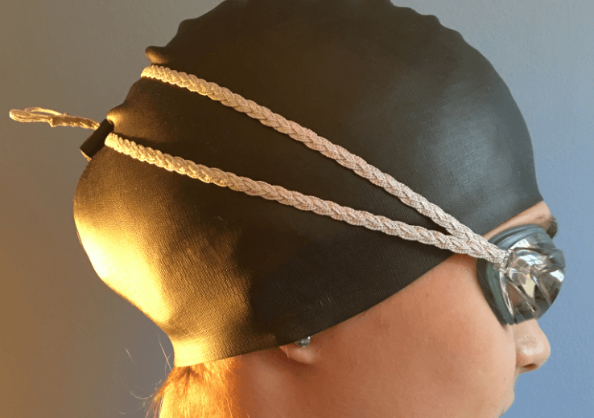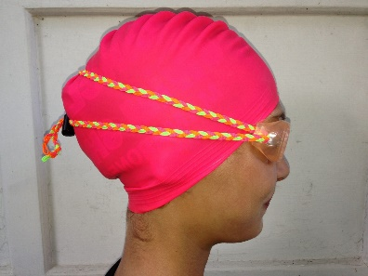
Note that whether you put the goggle strap over or under a swim cap is swimmer’s preference.
Proper Care for Goggles
If goggles are properly cared for, a quality pair of goggles should last an entire season of practices and meets.
Don’t stretch goggles away from your face. This almost always leads to broken straps. If you are using goggles with the proper locking mechanism described above, the strap will not loosen.
Do not rub your goggle lenses with your fingers. Most goggles today come with an anti-fog coating. Rubbing the goggle lenses will quickly wear off the anti-fog coating. If the goggles do fog, simply dipping them in the water of the pool will clear them. Also, the more a swimmer plays with their goggles, the more likely they will fog.
Over time goggles do wear out through use or breakage. When this happens, save the good parts (e.g. the strap, nose bridge pieces, good lenses, etc.). Most parts from all goggles are interchangeable to a degree. Also, replacement bungie straps can be purchased and those make for excellent practice goggles.

