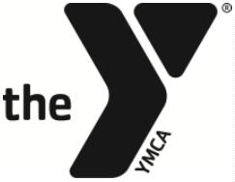
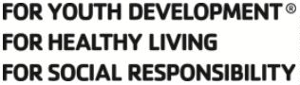

YMCA OF CENTRE COUNTY

SWIM TEAM PARENT ADVISORY COMMITTEE POSITION DESCRIPTION –
CONCESSIONS COORDINATOR

Responsible to:
Head Swim Team Coach, Aquatics Director, and Committee Chair

Term:
2 year and may be renewed for successive 1-year terms

Purpose:
The Concessions Coordinator is responsible for leading the concessions stand during home swim meets. They arrange the menu, organize and solicit parent/family donations, coordinate the concessions volunteers, track and consolidate concessions funds after each home meet.

Responsibilities:

- Work with swim team families to ensure appropriate donations are provided for concessions.
- Organize and lead development of concessions menus.
- Organize set-up and break-down of concessions stand/area at home meets.
- Work in conjunction with the Treasurer to track concessions funds raised and used.
- Attend monthly Committee meetings to provide updates and communicate current issues.

Personal Attributes:

- Exemplify the Y’s core values of caring, honesty, respect, and responsibility.
- Commitment to the YMCA mission and impact.
- Interest in the objectives and programs of the organization.

Intended End Result:

• Take the lead in running successful, effective concessions stands at home meets.
• The YMCA’s and Swim Team’s image and impact are enhanced.
• Take an active role in the committee to work with other members effectively.
• The resources of the swim team continue to expand in an effort to more effectively serve the team as a whole.

__________________________________ ____________________
Volunteer Signature Date

