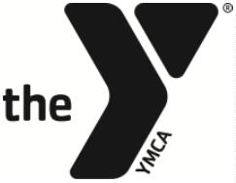
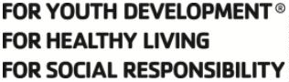

YMCA OF CENTRE COUNTY

SWIM TEAM PARENT ADVISORY COMMITTEE POSITION DESCRIPTION –
MEET COORDINATOR

Responsible to:
Head Swim Team Coach, Aquatics Director, and Committee Chair

Term:
2 year and may be renewed for successive 1-year terms

Purpose:
The Meet Coordinator is responsible for working with the Volunteer Coordinator to make sure that all meets that occur can legally happen. It is important that the Meet Coordinator has a strong understanding of how swim meets run.

Responsibilities:

- Work with regional trainers to coordinate annual officials' training sessions.
- Track all team officials’ certifications, expirations, and needed sessions/trainings.
- Ensure proper set up and operation of all meet equipment before, during, and after meets.
- Work in conjunction with the Volunteer Coordinator to achieve all meet official needs to ensure that home swim meets run legally and effectively.
- Attend monthly Committee meetings to provide updates and communicate current issues.

Personal Attributes:

- Exemplify the Y’s core values of caring, honesty, respect, and responsibility.
- Commitment to the YMCA mission and its impact.
- Interest in the objectives and programs of the organization.

Intended End Result:

• Lead parent officials to run successful, efficient swim meets.
• The YMCA’s and Swim Team’s image and impact are enhanced.
• Take an active role in the committee to work with other members effectively.
• The resources of the swim team continue to expand in an effort to more effectively serve the team as a whole.

__________________________________ ____________________
Volunteer Signature Date

