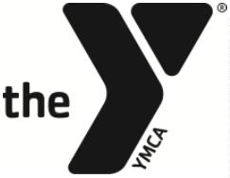
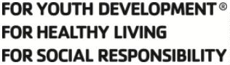

YMCA OF CENTRE COUNTY

SWIM TEAM PARENT ADVISORY COMMITTEE POSITION DESCRIPTION –
PARENT REPRESENTATIVE

Responsible to:
Head Swim Team Coach, Aquatics Director, and Committee Chair

Term:
2 year and may be renewed for successive 1-year terms

Purpose:
The group Parent Reps assist in communicating with swimmer families, building team morale and inter-group bonds, and in celebrating our swimmers and team.

Responsibilities:

- Communicate with parents in responsible group, providing schedule updates, answering questions, and news.
- Act as point of contact between committee and swim team groups or coach and group parents.
- Attend practices on occasion to provide opportunities for group parents to meet you and hold discussions.
- Help grow bonds and relationships between swim team parents.
- Organize occasional social outings/activities for your group.
- Attend swim meets and committee meetings, providing assistance as needed.

Personal Attributes:

- Exemplify the Y’s core values of caring, honesty, respect, and responsibility.
- Commitment to the YMCA mission and its impact.
- Interest in the objectives and programs of the organization.

Intended End Result:

• Take the lead in engaging swim team parents and help groups form bonds outside of practice/meets.
• The YMCA’s and Swim Team’s image and impact are enhanced.
• Take an active role in the committee to work with other members effectively.
• The resources of the swim team continue to expand in an effort to more effectively serve the team as a whole.

__________________________________ ____________________
Volunteer Signature Date

