  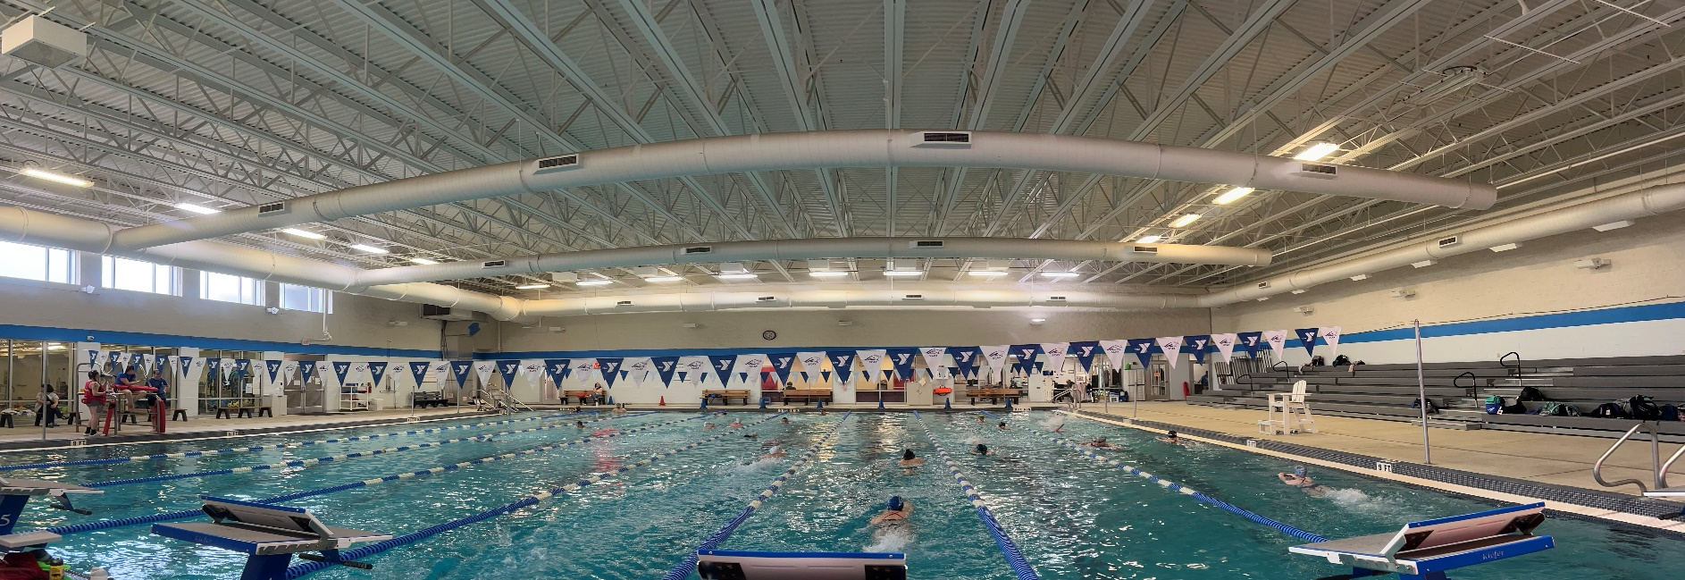  SCAY NEWS  The latest updates from the Aqualions |  | 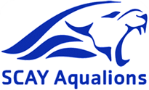  October /2025/ Issue 2.3
Shark Tank Meet Summary!  At the Shark Tank Invite, the Aqualions made a splash! As a team (51 swimmers), the Aqualions:  - Swam 125 personal best times  - Swam 55 District Cuts  - Set 10 Meet Records  Congratulations to our high point scorers:  - Avery Bishop 3rd 8 and under girls  - Crysal He 5th 9-10 girls  - Liam Burmeister 1st 9-10 boys+ Meet Record Breaker!  - Odin Leonard 3rd 9-10 boys  - Gracin Valentine 1st 11-12 girls  - Mariano Fernandez- Murillo 3rd 11-12 boys + Meet Record Breaker!  - Sophia Werle 2nd 13-14 girls  - Emme Podgurski 3rd 13-14 girls  - Shelby Bowersox 4th 13-14 girls  - Lucas Mercier 1st 13-14 boys+ Meet Record Breaker!  - Liam Reimherr 3rd 13-14 boys  - Odin Leonard 5th 13-14 boys+ Meet Record Breaker!  - Lily Behler 1st 15 and over girls  - Jack Wolfe 1st 15 and over boys51  - Eli Mercier 5th 15 and over boys |  | Upcoming Events
USA Meets
Arena Holiday Cup December 11-14
Y MEETS
River Valley & Clearfield @ SCAY December 6
Team Events
TBA

Coach’s Corner  A few reminders:  Please make sure your swimmer is bringing a water bottle to practice!  Please make sure your swimmer is rinsing off before getting into the pool!  The CENKEY League now has a website! Visit https://sites.google.com/view/cenkey-swim-league/home.  Team uniform orders have shipped! We expect them to arrive at the Y next week. Please keep an eye out for uniform distribution details.  Please check the SCAY website for all updates. Practice times/ cancellations will be emailed and updated on the calendar.  Upcoming Practice Changes:  - SCAY will not have practice on Thanksgiving or the day after (November 27-28). A practice will be emailed to the Blue and White Groups for November 29th |  | Update from the Parent Advisory Committee:  Reminders from the Parent Committee:  - Parent and Swimmer Codes of Conduct should be turned in by December 1. They can be left inside the Parent Committee’s folder in the Family Folder cabinet in the lobby. The Committee will get these to the coaching staff.  - If you are scratching the day before/night before/ day of a meet, please email Coach Mike (mblacksten@ymcaocc.org ), Coach Tori (toria89@yahoo.com ) and Stephanie Hettinger (scayteamcoordinator@ymcaocc.org)  - The Parent Committee Meeting Agenda is posted on the website. Feel free to email the committee with any questions or topics of discussion. The schedule of committee meetings is also posted to the team calendar.

