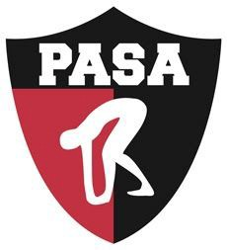
PASA PASA/Menlo Park Kick-A-Thon

PLEDGE SHEET

Name: Coach Name:
Pre-Event: My goal is to kick _______ laps
Post-Event: I ended up kicking _____ laps

- Donations will benefit PASA-Menlo Park (listed as a non-profit under PASC).
- All contributions are tax deductible (Tax ID #94-1549738).
- You may donate via:
Cash
Check (made out to PASC – in memo state PASA – MP site)
PayPal (state PASA – MP)
Venmo (State PASA – MP site)

 | Sponsor Name | Flat Donation Amount | Donation Per Lap | Amount Due (donation per lap x total laps, or flat donation) | Matching Company | Receipt Needed

Total without Matching Gifts:

Total with Matching Gifts:

